**Banner ID - 001121802**

**Comp – 1649**

**Human Computer Interaction design**

Table of Contents

1. Introduction 4

1.1 System Scope 4

2. Framework 4

1. User-Centered Design 4

2. Goal-Directed Design 4

3. Justification for the framework 5

3. Analysis 5

3.1 Research about Android principle 5

3.1.1. Ergonomic 5

3.1.2. Clear 5

3.1.3. Consistent 5

3.1.4. Responsive 6

3.2 Research about design principle 6

3.2.1. Visibility of System Status 7

3.2.2. Match between system and the real world 8

3.2.3. User control and freedom 8

3.2.4. Error Prevention 9

3.2.5. Help users recognize, diagnose and recover from errors 10

3.2.6. Consistency and Standards 11

3.2.7. Flexibility and efficiency of use 12

3.2.8. Aesthetic and minimalist design 13

3.2.9. Help and Documentation 14

3.3 Research about cognitive psychology 15

3.4 Research about design issues 18

3.5 Research about Questions 18

4. Research 22

4.1 Research about user's requirement 22

4.2 Research about user 22

4.2.1. User Categories 22

4.2.2. User Type 22

5. Design 23

5.1 Conceptual model for smart hub 23

5.2 Low Level Prototype 24

5.3 High Level Protype 31

6. Evaluation 64

6.1 Design Evaluation 64

6.1.1. Visibility of System Status 65

6.1.2. Match between system and the real world 65

6.1.3. User Control and freedom 66

6.1.4. Consistency and Standards 67

6.1.5. Help and documentation 67

6.2 Cognitive Walkthrough 68

6.3 Personal Evaluation 69

Bibliography 70

References 71

# 1. Introduction

## 1.1 System Scope

According to the course work, they made us to the prototype for the smart devices. So, I decided to make Air-con, Television and Coffee maker. The reason behind I did this is they were easy to design and I wanted to make better than the real-world design. For, air-con, there will be functions, that can be controlled by voice which is not available to the real-world yet. It will be also the same to the left devices. Moreover, there are more functions such as timer, can increase or decrease temperature which detail will be explain later. There will functions even for accessibility that include that can be control with voice, the voice and hearing system, subtitles and captioning, Visual and color filter.

# 2. Framework

## 1. User-Centered Design

An iterative design process for designers where they can concentrate on the clients and their needs in each step of the design process. So, in UCD, the design teams include the clients all through the design procedure via of an assortment of research and design methods, to make profoundly usable and open items for them.

(Bill Moggridge, 1980), (Gladkiy, n.d.)

## 2. Goal-Directed Design

A methodology that focus on behavioral design and put the clients design that put the clients at the center of the design process and places tremendous accentuation on understanding the necessities and objectives of those clients and converting that goals into tasks and then into more usable products. And then the goal directed design is broken into seven steps Project Planning, Research, Modelling, Requirements Definition, Framework Definition, Detail Design and Implementation Support.

(Dalrymple, 1999), (Vaughn, 2001), (Ireland, 2000), (Chen Wai, 2008)

## 3. Justification for the framework

In User-Centered design, the users will be more interacted with the developers which means the developer can directly know whose products for and what will use it foe. Also, while building the design, in each step, it will meet their needs. So, it can reach the business goals in short time and less money. It has benefits both for the users and the developers. The process is relied on the user's feedback so the iteration can keep the design process and responsive. In user-centered design, it is a thinking method that present in research stage like the goal-directed design. Also, it has the important role in the way of understanding to the user. It increases the competitiveness so that the clients will choose your products than other's products because your products meet their needs more effectively. And it also saves the time and money by testing things with end-clients when it is as yet financially effective to make changes.

# 3. Analysis

## 3.1 ­Research about Android principle

### 3.1.1. Ergonomic

Ergonomics is to guarantee a solid match among individuals and what they interface with. Ergonomics must be considered in the structure of any item, framework, or condition. Ergonomics utilizes anthropometric information to decide the ideal size, shape, and structure for an item, making it simpler for individuals to utilize. Applying ergonomics from the get-go in the structure procedure frequently recognizes open doors for development.

### 3.1.2. Clear

An away from of visual progressive system guides individuals to significant substance or activity. The visual chain of importance, regardless of whether advanced or printed, decides the request where the data on a page is caught and prepared. This is a significant piece of making the ideal client experience. This is an exceptionally helpful approach to make a durable and deliberate client experience while expanding your odds of accomplishing key results.

### 3.1.3. Consistent

A conflicting UI can make befuddling and disappointing clients, and even the most encouraging items can prompt disappointment. Consistency makes it simpler for clients to explore and utilize the application since they don't need to learn new ropes. Utilize visual consistency to organize content, make it safe, and feature significant pieces of the substance. Normally, this helps give the client solace and satisfaction and urges them to keep utilizing the application.

### 3.1.4. Responsive

A definitive objective of responsive plan is to evade superfluous resizing, looking over, zooming or panning that can happen in applications that are not improved for various gadgets. Responsive design likewise replaces the past need to structure a committed portable for cell phone clients. The advantages of picking a responsive plan are: Cost-viability, Adaptability, Improved client experience, Advantages of site design improvement and Simplicity of the executives

## 3.2 Research about design principle

Heuristic evaluation is a convenience assessment technique for PC programming that distinguishes ease of use issues in (UI) plan. In particular, it includes the evaluator looking at the interface to decide consistence with perceived standards of ease of use ("heuristics"). Among those, The Jakob Nielsen heuristic is likely the most utilized convenience heuristic in UI structure.

(Google, 2005), (Ireland, 2000), (RIVA, 2004), (webfx, 1996),

### 3.2.1. Visibility of System Status

|  |  |
| --- | --- |
| MI Remote Controller | Samsung Smart Controller |
| Figure (1.1) | Figure (2.1) |
| the air con temperature (27*C) is the most visibility and most important part in the design. User can know now to increase or decrease the temperature. | also the air con temperature. Morevoer, in this figure, the increase(plus sign) and decrease(minus sign) are more visbile than MI cotroller. So that, user don''t have to find the buttons. |

### 3.2.2. Match between system and the real world

|  |  |
| --- | --- |
| MI Remote Controller | Samsung Smart Controller |
| Figure (1.2) | Figure (2.2) |
| the design is similar to the real world because it shows all the button and functions in a single page without leading to the other page. | it can say it's a slight deffierent from the real world. The design is also complicated for who don’t have enough good interactio with the design. |

### 3.2.3. User control and freedom

|  |  |
| --- | --- |
| MI Remote Controller | Samsung Smart Controller |
| Figure (1.3) | Figure (2.3) |
| users can control the app in thei wants so that it can give the user a famliar feelings while using them. | the user control and freedom are more realistic because of the functions. |

### 3.2.4. Error Prevention

|  |  |
| --- | --- |
| MI Remote Controller | Samsung Smart Controller |
| Figure (1.4) | Figure (2.4) |
| It shows that error message will be appear if left it with the blank. This will be good for user who forget to fill something. | The message box will be appear when connention is lost like the above figure. The alert box is good for the user when something is wrong with the system so user might know what to do. |

### 3.2.5. Help users recognize, diagnose and recover from errors

|  |  |
| --- | --- |
| MI Remote Controller | Samsung Smart Controller |
|  | Figure (2.5) |
| it does not have it | It let user know that he needs to type the new password in the box. It helps user recognize for what needs to be done. |

### 3.2.6. Consistency and Standards

|  |  |
| --- | --- |
| MI Remote Controller | Samsung Smart Controller |
| Figure (1.6) | Figure (2.6) |
| The icons are labled with the definitons and explained what the logo means. And the logo are also already familiar with the users so that even without the explanation, they might know it. | It also shows the description of the logo and the logo image are more familiar than MI Controller. |

### 3.2.7. Flexibility and efficiency of use

|  |  |
| --- | --- |
| MI Remote Controller | Samsung Smart Controller |
|  | Fig (2.7) |
| It does not have the auto fill system. | When user fill the email and password, the system auto fill the box from the record data of the phone. |

### 3.2.8. Aesthetic and minimalist design

|  |  |
| --- | --- |
| MI Remote Controller | Samsung Smart Controller |
| Fig (1.8) | Fig (2.8) |
| It does not have the unccessary icons or content and all the things are related to it some degree. | When the air con is off, it does not show any realated content. It is not the same as the design when it is power on. |

### 3.2.9. Help and Documentation

|  |  |
| --- | --- |
| MI Remote Controller | Samsung Smart Controller |
| Fig (1.9) | Fig (2.9) |
| It display about the user manual for who doesn’t know how to operate the app. | It isn't about the user manual but it's also prepared tutorial for the user. It will be a good thing to practice before operating the real app. |

(Nielsen, 1998), (Nielsen, 2008)

## 3.3 Research about cognitive psychology

Cognitive psychology research is the logical investigation of brain and mental capacity, including learning, memory, consideration, observation, thinking, language, theoretical turn of events, and dynamic. Current research on insight depends on the presumption that the cerebrum can be comprehended as an unpredictable registering framework. "Cognition" alludes to any procedure by which tactile sources of info are changed, decreased, expounded, put away, reestablished, and utilized. In any event, when they work without related boosts, similar to pictures and fantasies, they are applicable to these procedures given such an extreme definition, they know about everything people may do. Specialists gauge that your short memory keeps going 20 to 30 seconds and is 5 to 9 components. Longer data move Much increasingly steady and durable memory. (Cherry, 2004)

**Attention**

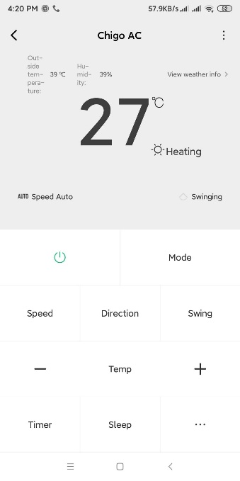

Figure (3.1)

In this figure, the main attraction is the letter of the temperature. It is also the main point of the system so it makes is obvious with the large letter. So in my design, I will also include the attention.

**Perception and recognition**

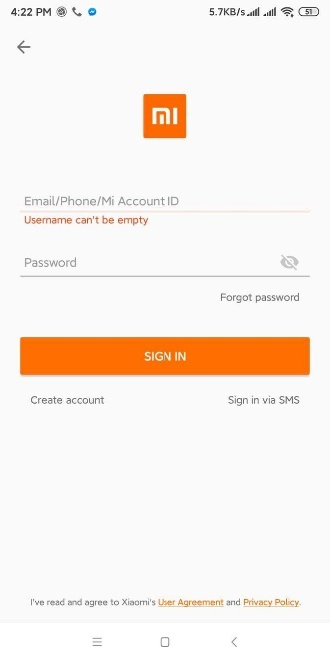

Figure (3.2)

In this figure, it makes the user recognize the mistake they made while login to the app. It shows the message with the red color. So that, users might notice easily. I will include this in my object.

**Memory**

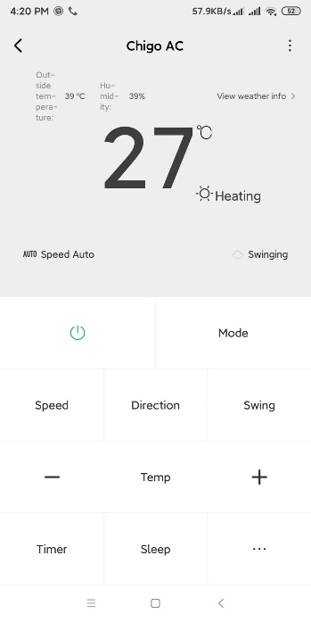

Figure (3.3)

The logos that used in the figure are already familiar with the users. These might the user know without labeling the icons. This will also include in my system.

## 3.4 Research about design issues

While researching for the design issues, I will also follow the design principle of Jakob Nielsen's which is also called Usability. Accordingly, such programming can't be utilized without the client's comprehension of the interface. UI implies that both the client and the PC can collaborate with one another. For instance, an information gadget draws in both a PC and a client to one another. The fundamental sorts of UI are: Command line and Graphical UI (GUI) order.

**Use of Color:** In the event that the foundation shading is light, at that point the shading ought to be typical. Both must be as opposed to one another. For instance, if the foundation is dark, you can't write in dark. You can write in white. Since the difference among highly contrasting is acceptable. On the off chance that the content shading is exceptionally light, this issue can happen if the content is mixed up.

**Look and feel Issue:** Appearance implies what the client sees the interface and how the client feels when they take a gander at the interface. On the off chance that the information is sorted out like Google's structure and there is no scattered information, this makes it simpler for clients to comprehend the showcase and works. on the off chance that the site is clean including the promotions, the client should seriously think about to utilize the site.

**Guidelines Issues:** The client must clarify all prerequisites and the product engineer must follow careful rules. From the past, interface creators have attempted to record rules to manage future architects' endeavors. These rules are conclusive.

## 3.5 Research about Questions

Before prepartion for questions, I think from how to ask the questions to the users. Among those, I think of interview, survey, foucus groups and usuability tests and I choose survey. For survey, I choose to survey from using google form.While asking for the customer feedback, I prepared 10 questions. In those, there are 8 multiple choices and 2 paragraph questions.

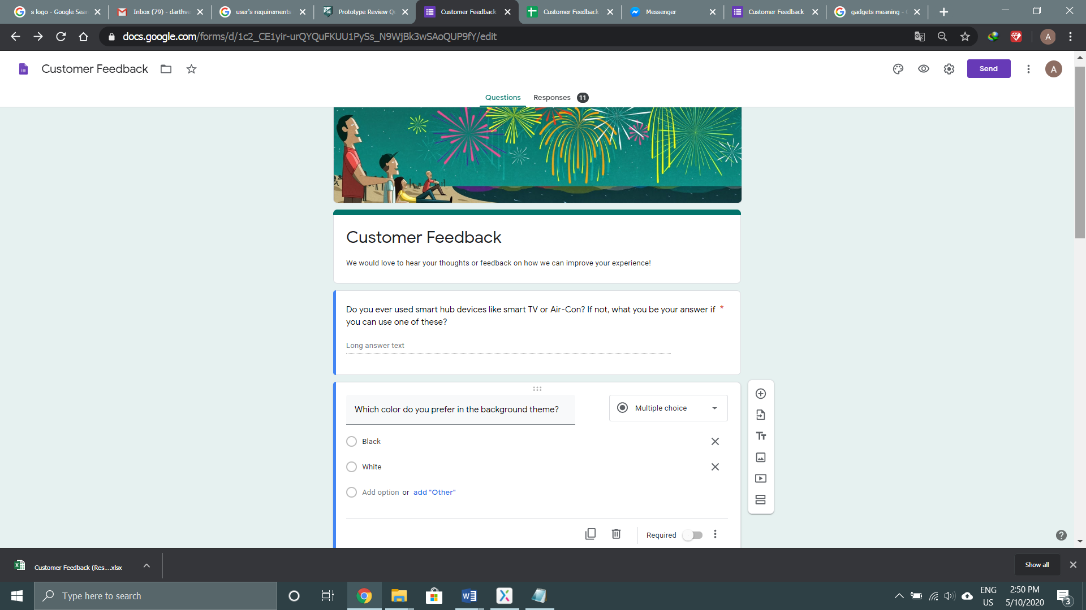

Figure (1.1)

In the first question, I asked the user if he ever use the IOT devices and explain with the examples with the examples. I asked this question because I am doing about the smart devices. In feedback, 6 users replied that they had used IOT and 5 others replied they haven't.

In second question, I asked for the background theme color. This is because user have different taste in color. Some like black and some like white. In feedback, 6 users show that they like white theme and other 5 said they like black theme.

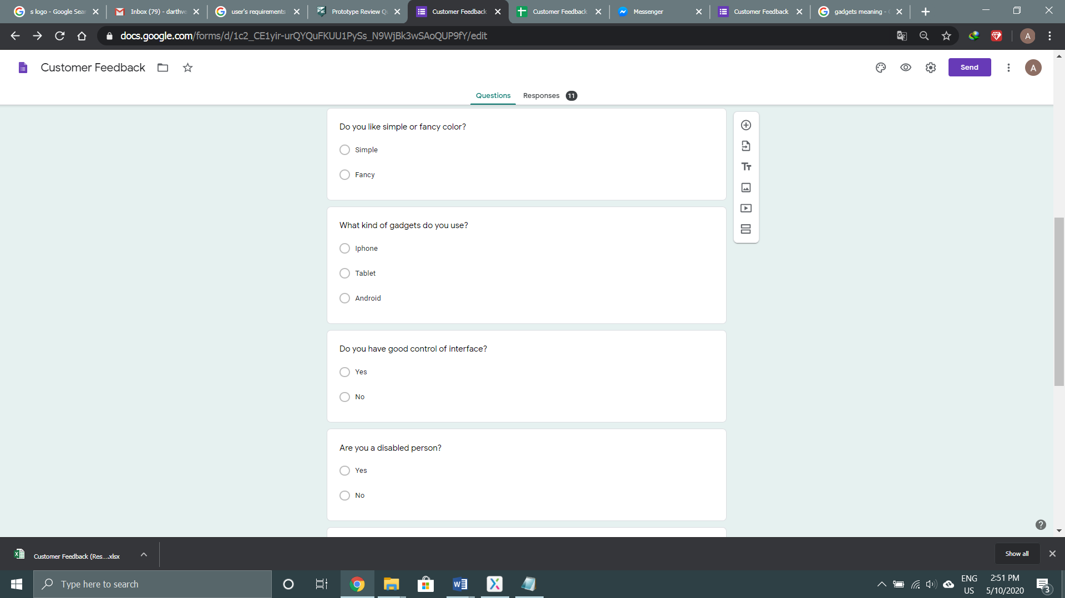

Figure (1.2)

In third question, I ask for the design of color, that will be decorated in the design phase. This is because some people like the site with fancy color though some like simple. So, I ask them whether to use simple or fancy color. In feedback, 10 users said they like simple colors.

In fourth question, I ask for the gadget they used because my protype will be based on their used of the gadgets. In feedback, 10 users said they used android while the left one use android.

In fifth question, I ask them for if they have the good control over interface. This is for whether the reason that I have to keep the design simple for beginner or normal. In feedback, All of them say yes to the questions.

In the sixth question, I ask them if user are disabled person bacuse I was going to prepared for the accessbility for the disabled person. But in feedback, they all said they were not.

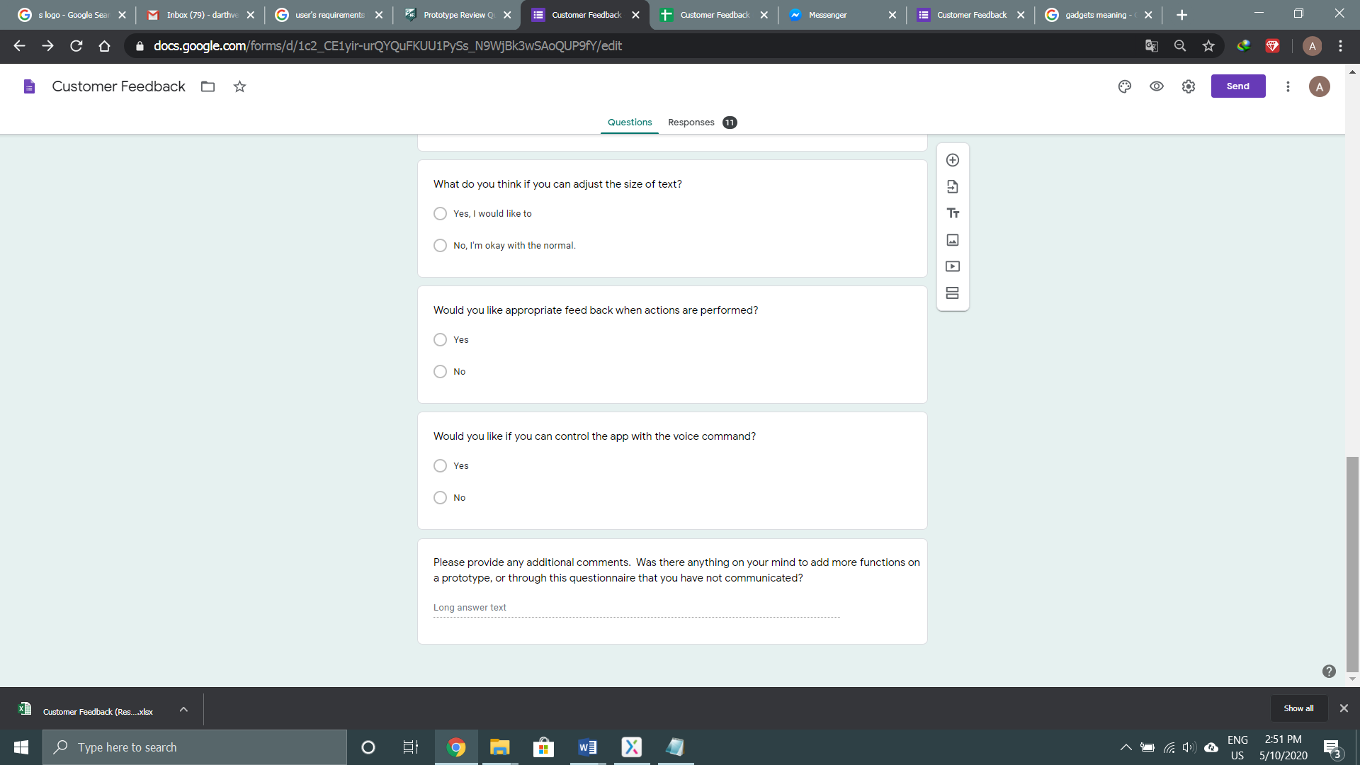

Figure (1.3)

In the seventh question, I ask them to customize the size text on their won if there a chance that they can't see the standard one. And feedback, 9 users said they are okay with it and 2 users said they would like to adjust.

In the eight question, I ask this question for the reason when user did some action and proper feedback will be displayed that are related with the actions. So in the feedback, all of the users said yes to the question.

In the ninth question, I ask them if they want to control the app with the voice command system. The reason, they might want to control the app like 'Apple Siri'. It might bring convenient to the user. In feedback, they all say yes to this question.

In last question, I ask the use if they have comment for the above question and any idea for more functions. In feedback, 9 users didn’t answer, 2 users said they would like to have parental control and customize app UI.

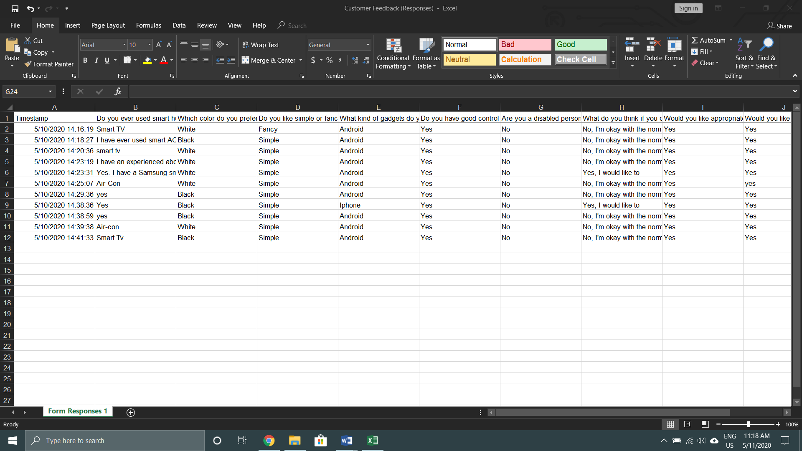

Figure (1.5)

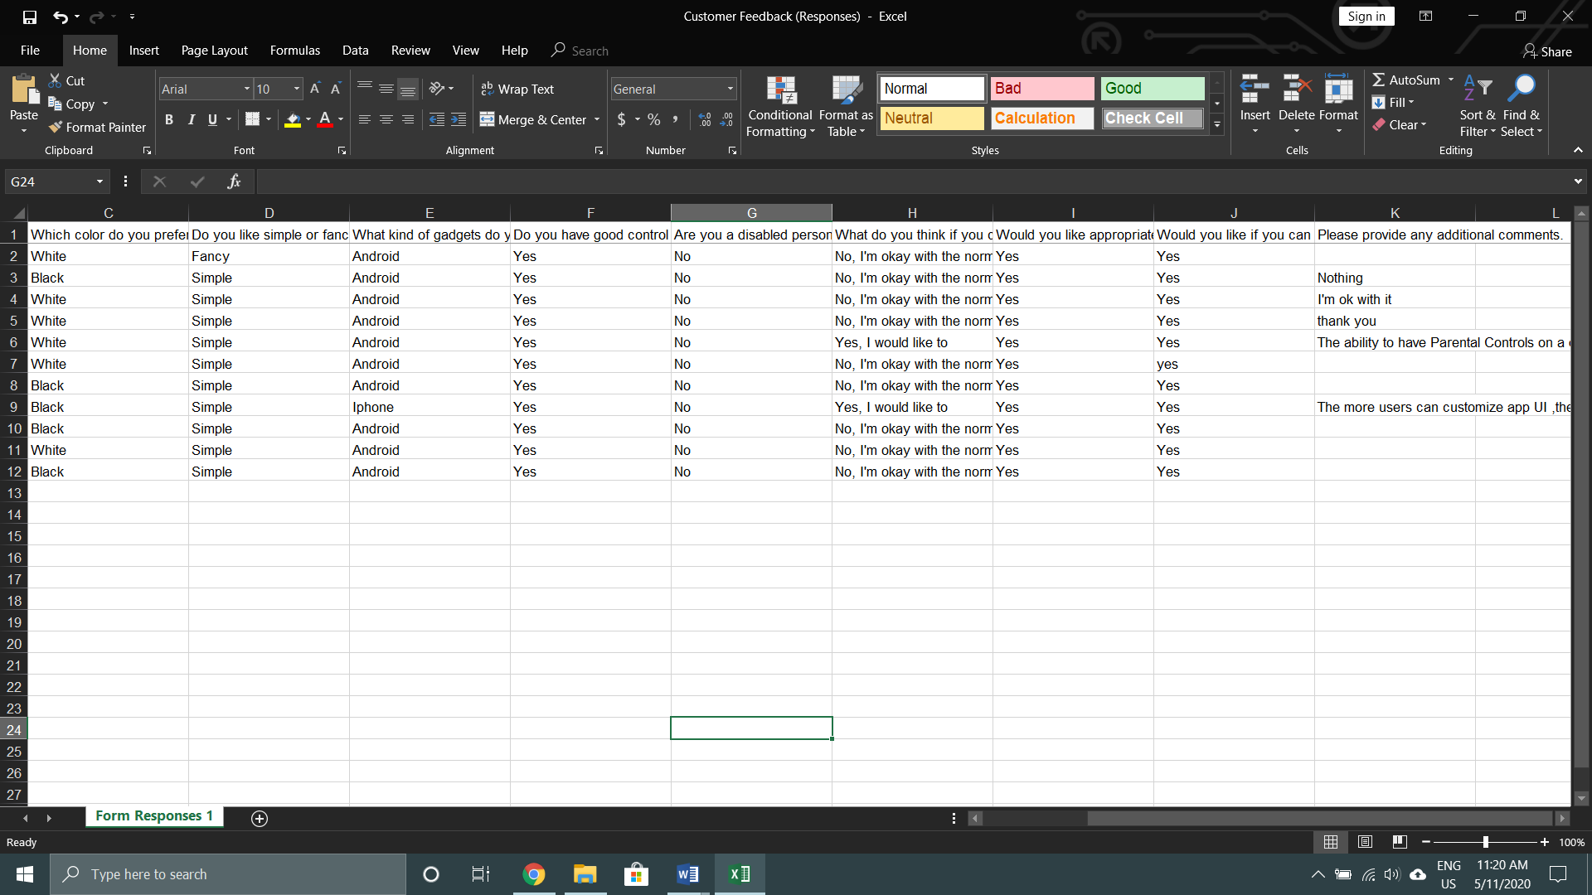

Figure (1.6)

# 4. Research

## 4.1 Research about user's requirement

My article is expected for significant clients who consistently need switches for different purposes, for example, Air conditioner, coffee maker and TV. The principle ones are ordinary clients who need to utilize the switch at home and individuals who need to utilize the switch in processing plants, shops and administrations.

## 4.2 Research about user

### 4.2.1. User Categories

In Myanmar, the education rate is 89.5%. Among them, there are 92.6% of men and 86.9% of ladies. So, most of them can speak, read and write English in an intermediate. But that is the main point for the protype because the use English in protype will so intermediate. As per my overview, Myanmar has 53.13% cell phone clients, 45.76% work area clients and 1.11% tablet clients. For the gender, Myanmar has 49.3% men and 50.7% ladies Since the cell phone users have more percentage, they will be my target users. And the age group will be between 18 and 30. But the gender type won't be differentiated since both will use the object.

### 4.2.2. User Type

Since I have three objects such as Air-con, Smart TV and Coffee maker. The primary user will be from organizations, school, universities, mall and family. They might use the objects in their ways.

# 5. Design

## 5.1 Conceptual model for smart hub

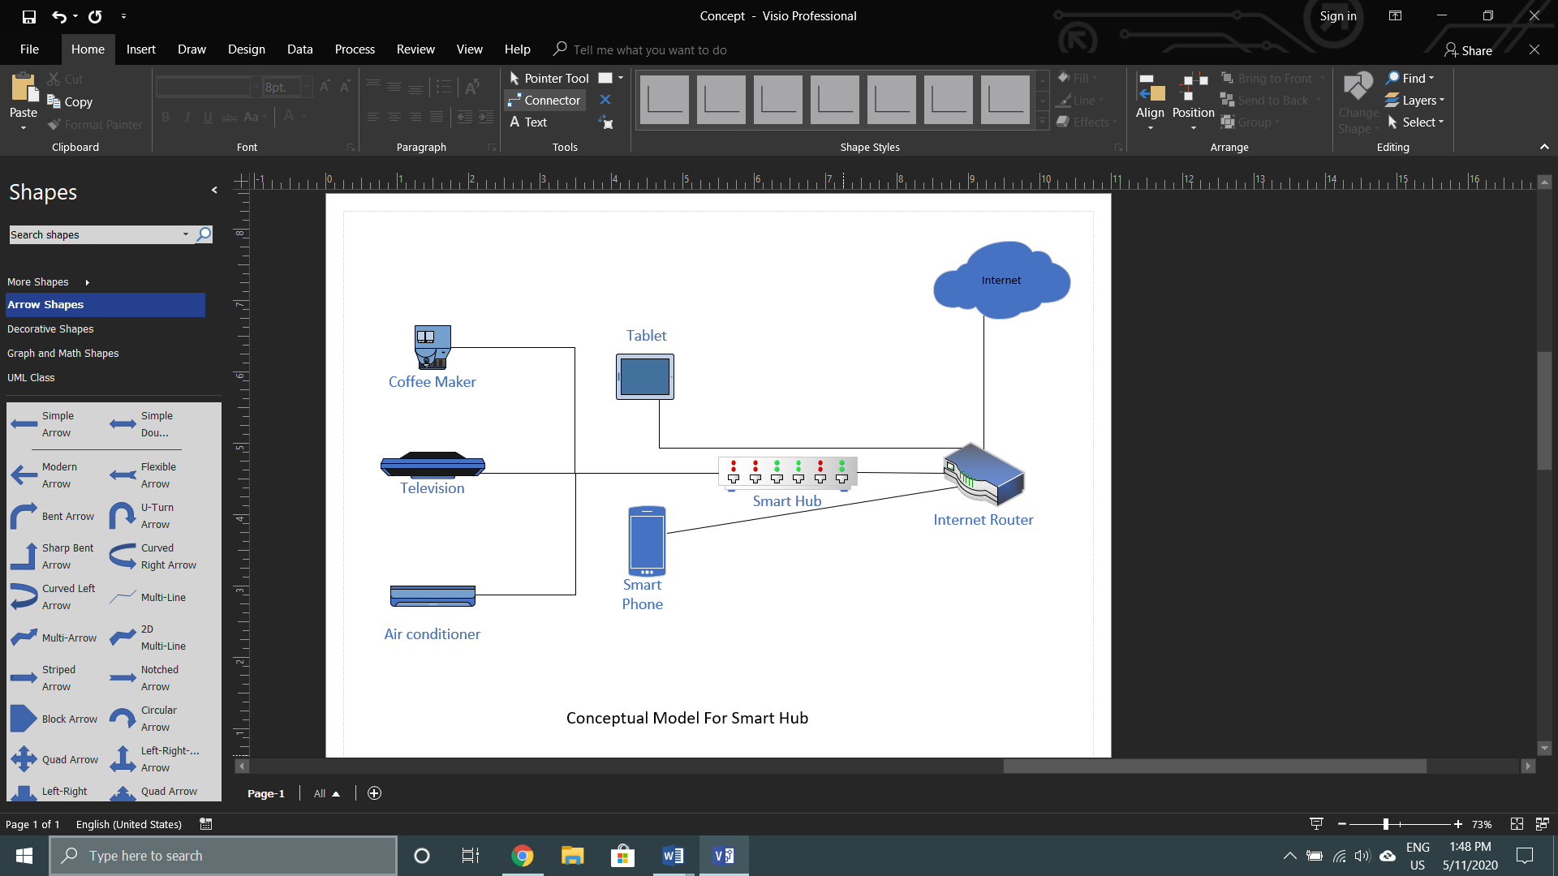

Figure (1)

A theoretical model is a portrayal of a framework that utilizes ideas and thoughts to shape the above portrayal. Applied displaying is utilized across numerous orders, from science to economics to programming improvement. In this figure, the objects are connected to the smart hub. The smart hub is connected to the internet router. Then, the devices that joined the internet router will be able to control the objects. Finally, the internet router is connected to the internet which will make possible for them to control.

(Powell-Morse, 2010)

## 5.2 Low Level Prototype

The detail of the low protype will be explained in the high level prototype.

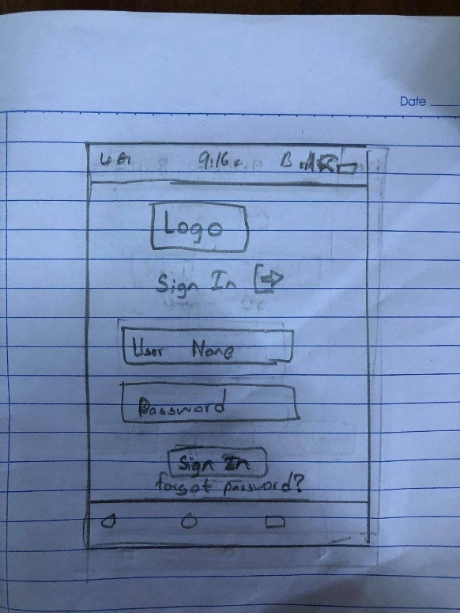

Figure (1.1)

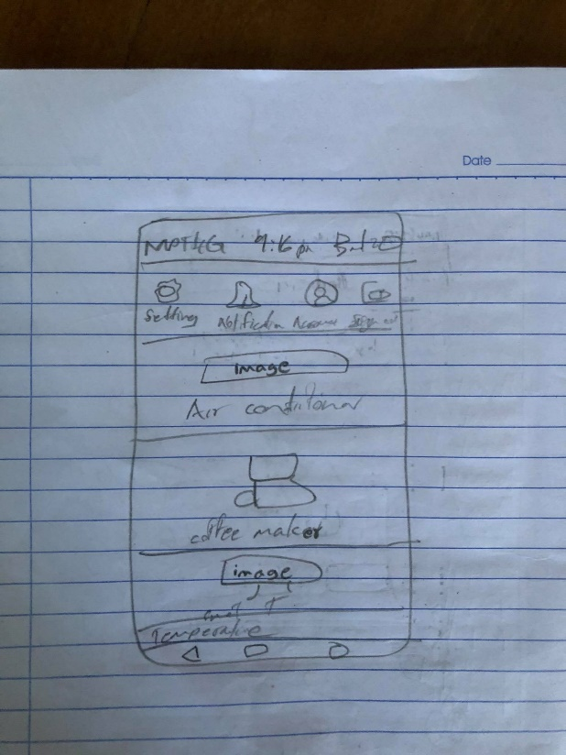

Figure (1.2)

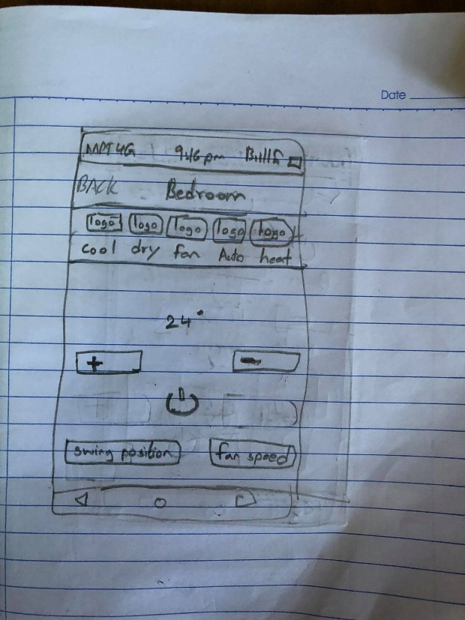

Figure (1.3)

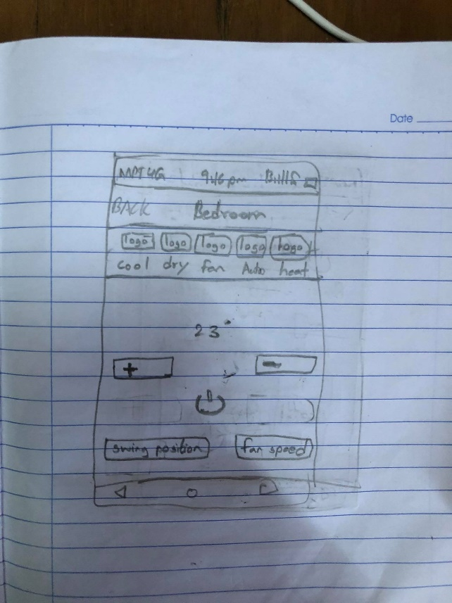

Figure (1.4)

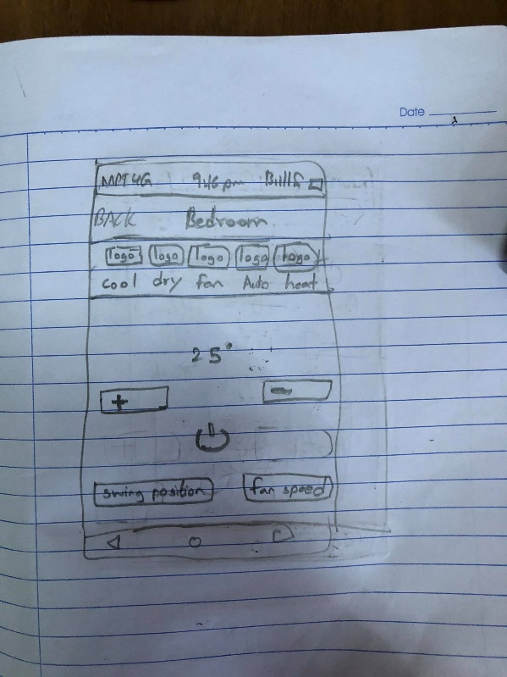

Figure (1.5)

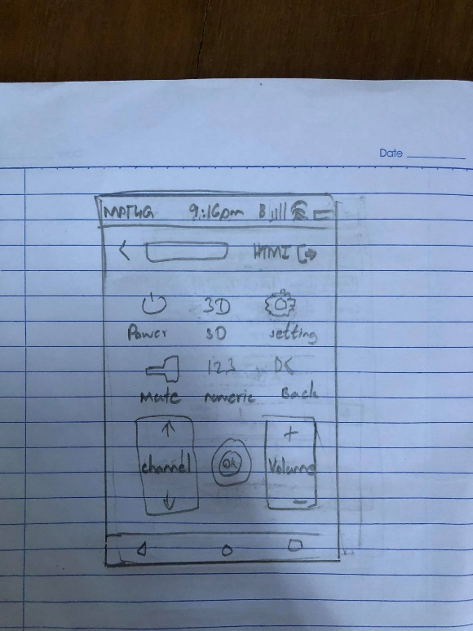

Figure (1.6)

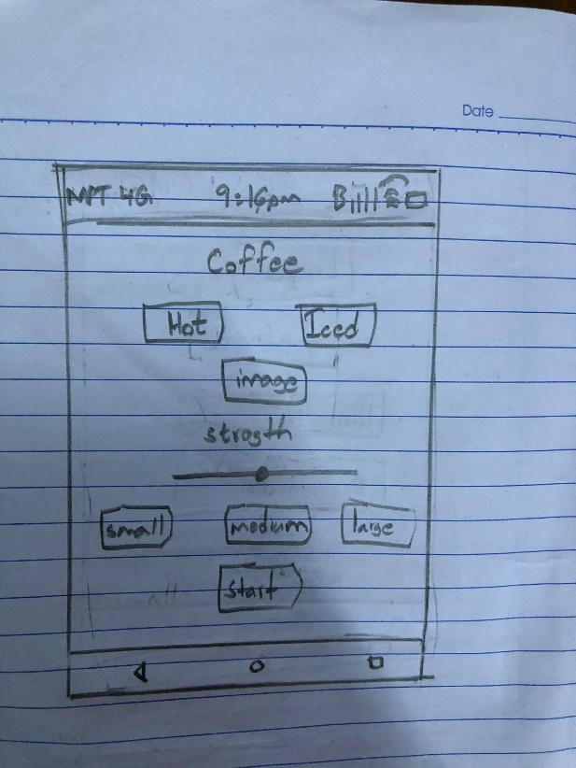

Figure (1.7)

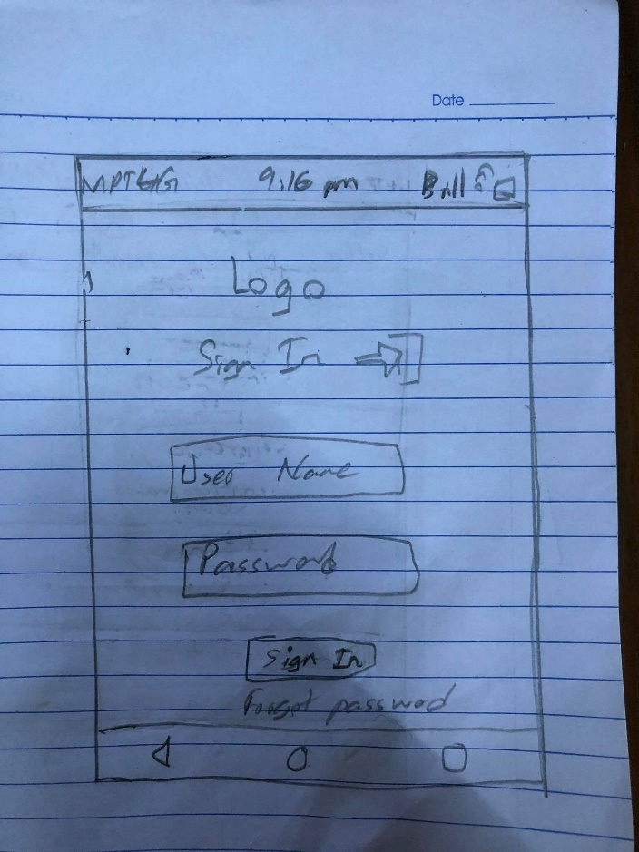

Figure (1.8)

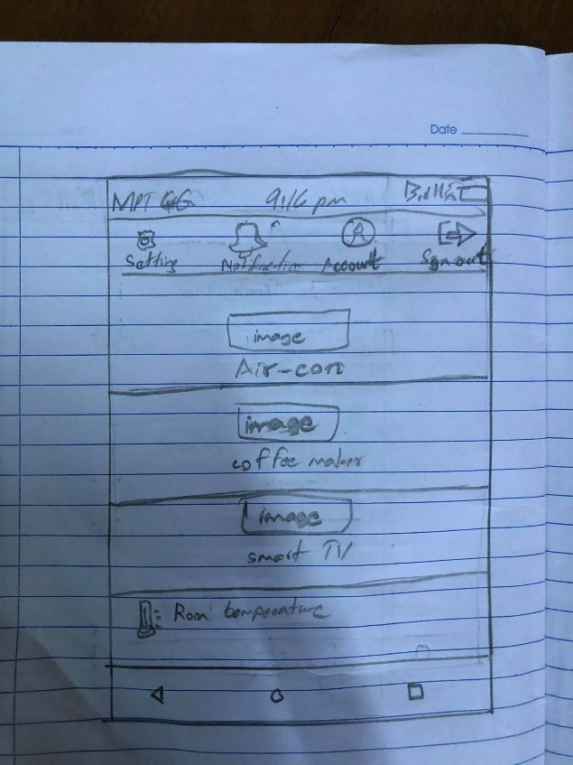

Figure (1.9)

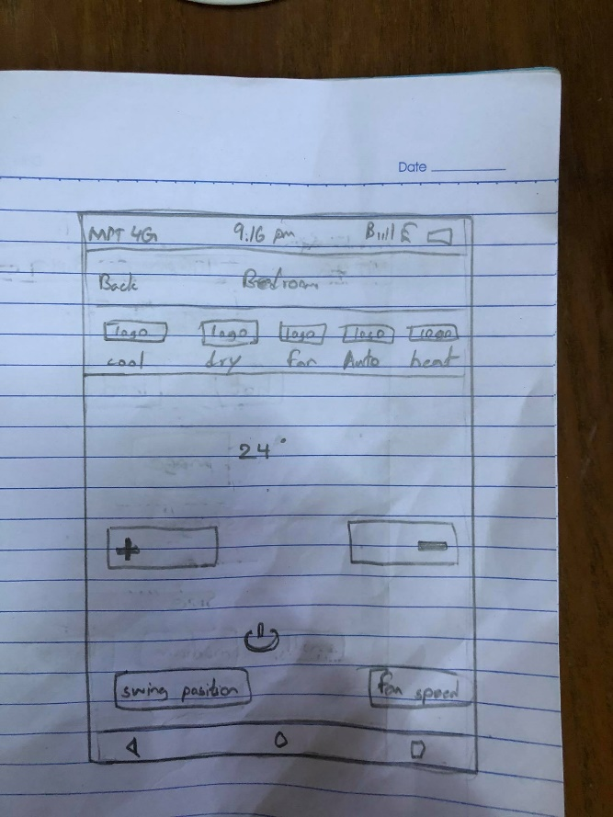

Figure (2.0)

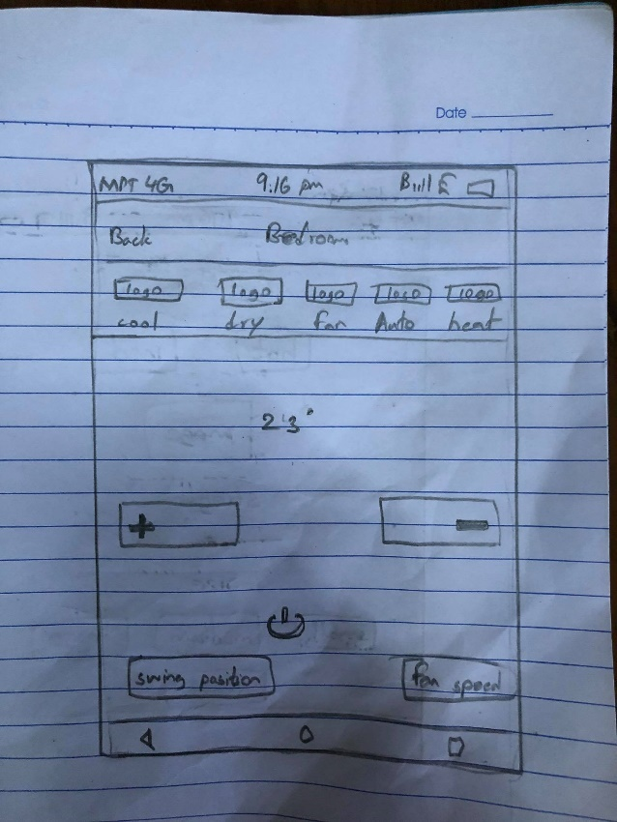

Figure (2.1)

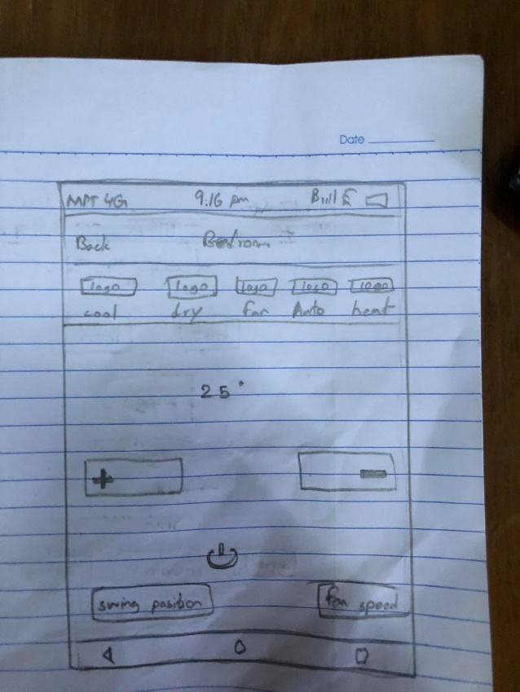

Figure (2.2)

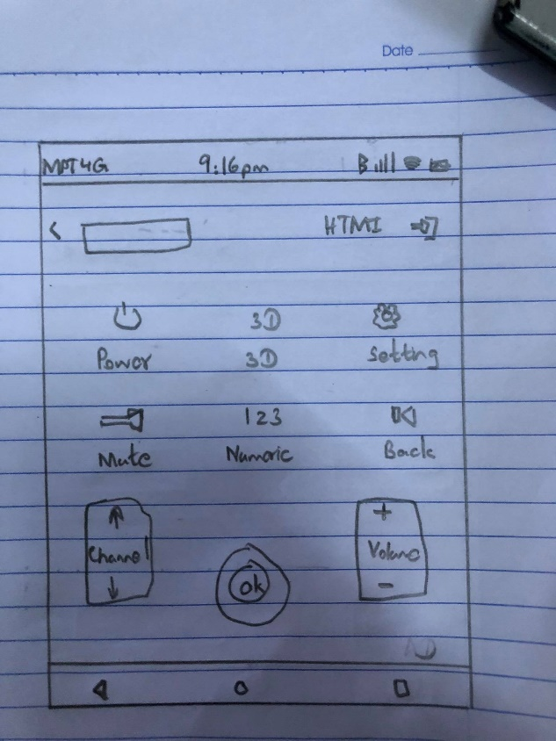

Figure (2.3)

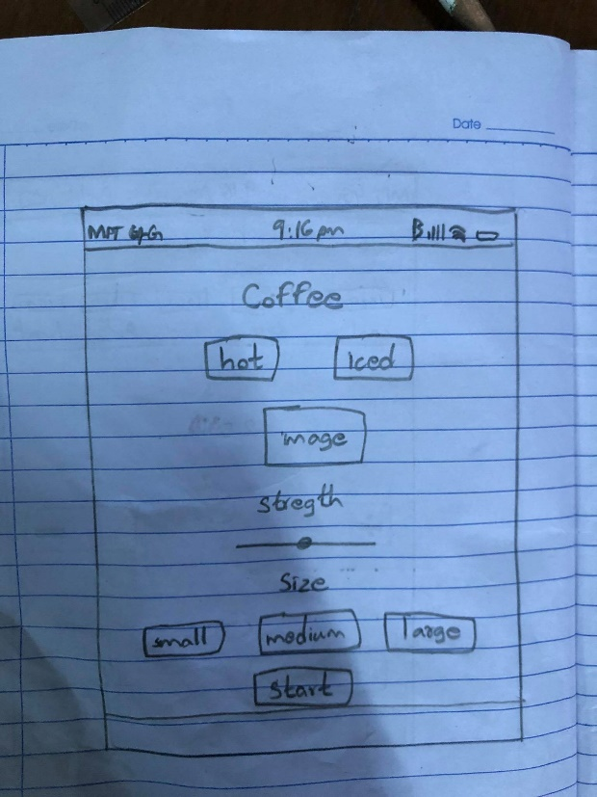

Figure (2.4)

## 5.3 High Level Protype

This is the high level prototype that was done from the low level protype. It include of aircon, tv and coffee make. The detail of the object will be explained with respected diagram. I will lable the core cognnitive process in the figure. And aslo the survey of users that I collected from google forms are included in the following figures.

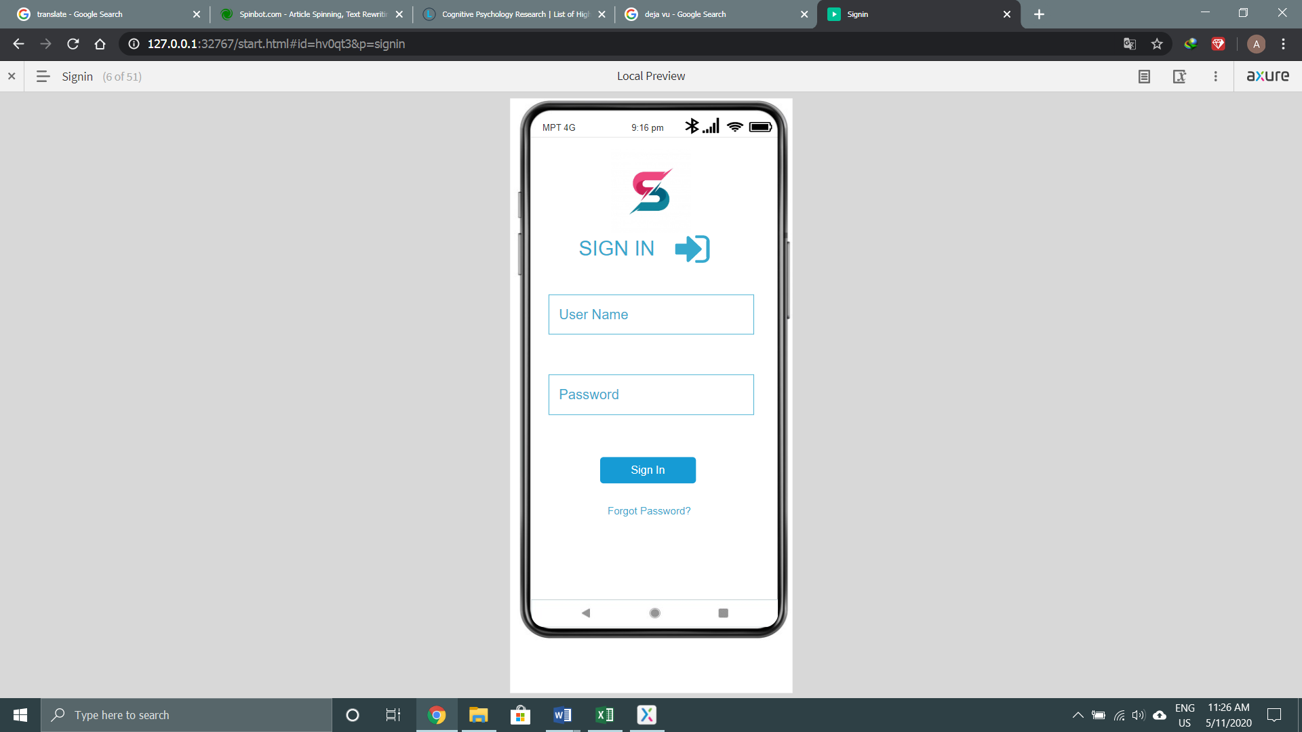

Figure (5.1)

This is the sign in page of the app. User have to fill user name and password that registration given to them to sign and use the object.

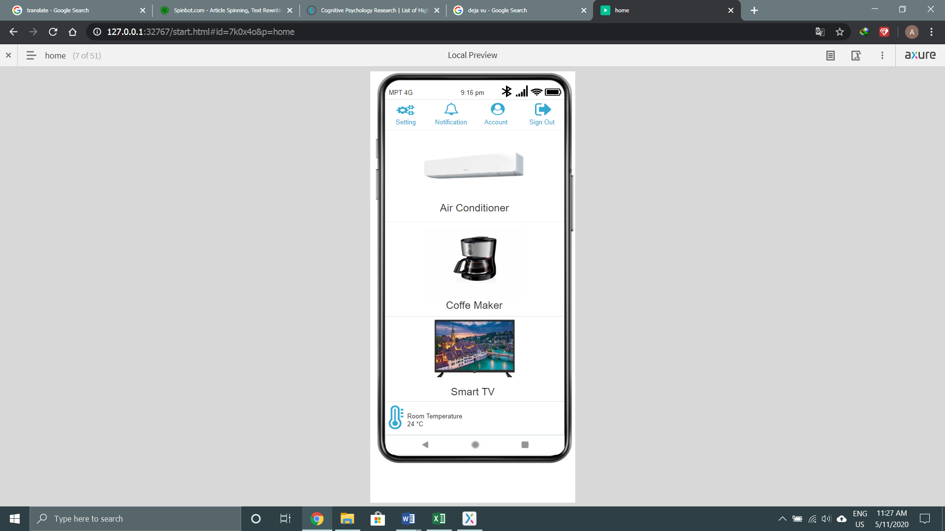

Figure (5.2)

After successfully login in the app, this will be seen which is called the home page. There are setting, notification, account and sign out in the top of the page. in setting, user can find the accessibility. Next to setting is notification. When messages are sent from the app, it will appear there. User can see that message when they click that notification. Next to notification is account where user can change their profile and password. Next to account is the sign out. When user feel unsafety, he can logout from the app. Under the nav is the objects, you can control. The detail will be explained in the below diagram.

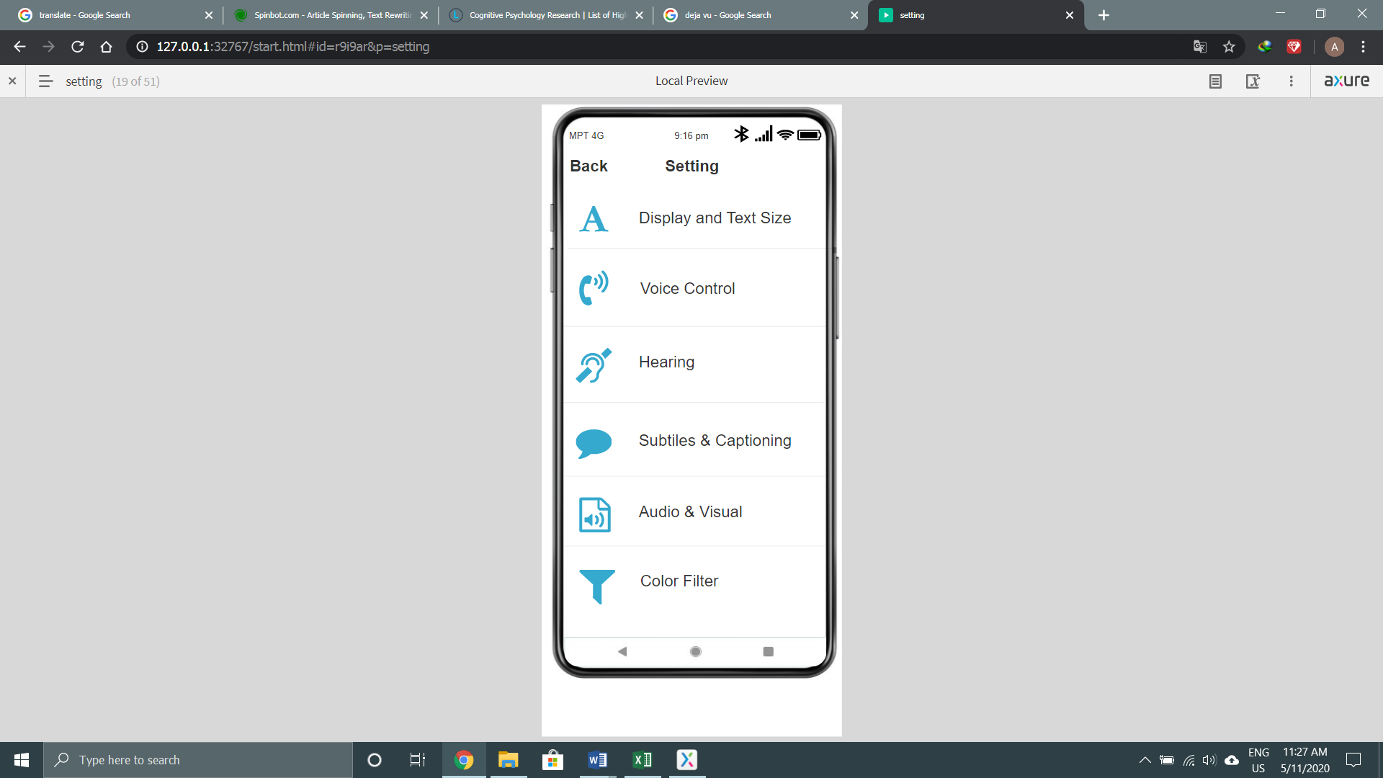

Figure (5.3)

This is the setting page of the design where user can customize in their need. When they want to adjust, they must click the function and it will be changes in color. The changes are shown in figure (5.4).

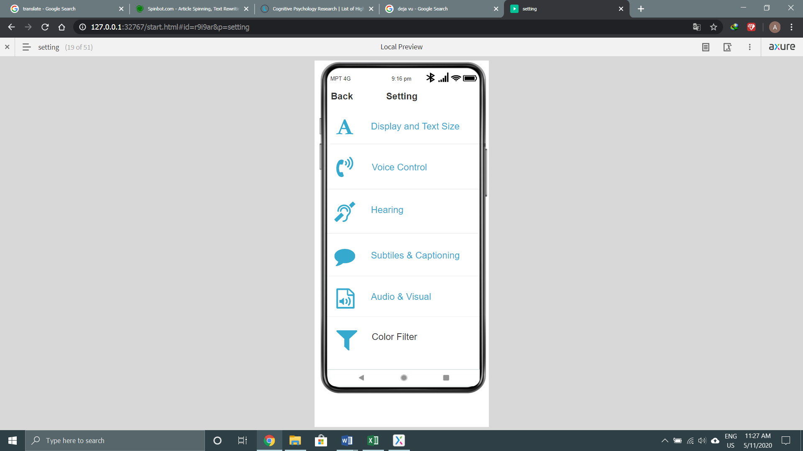

Figure (5.4)

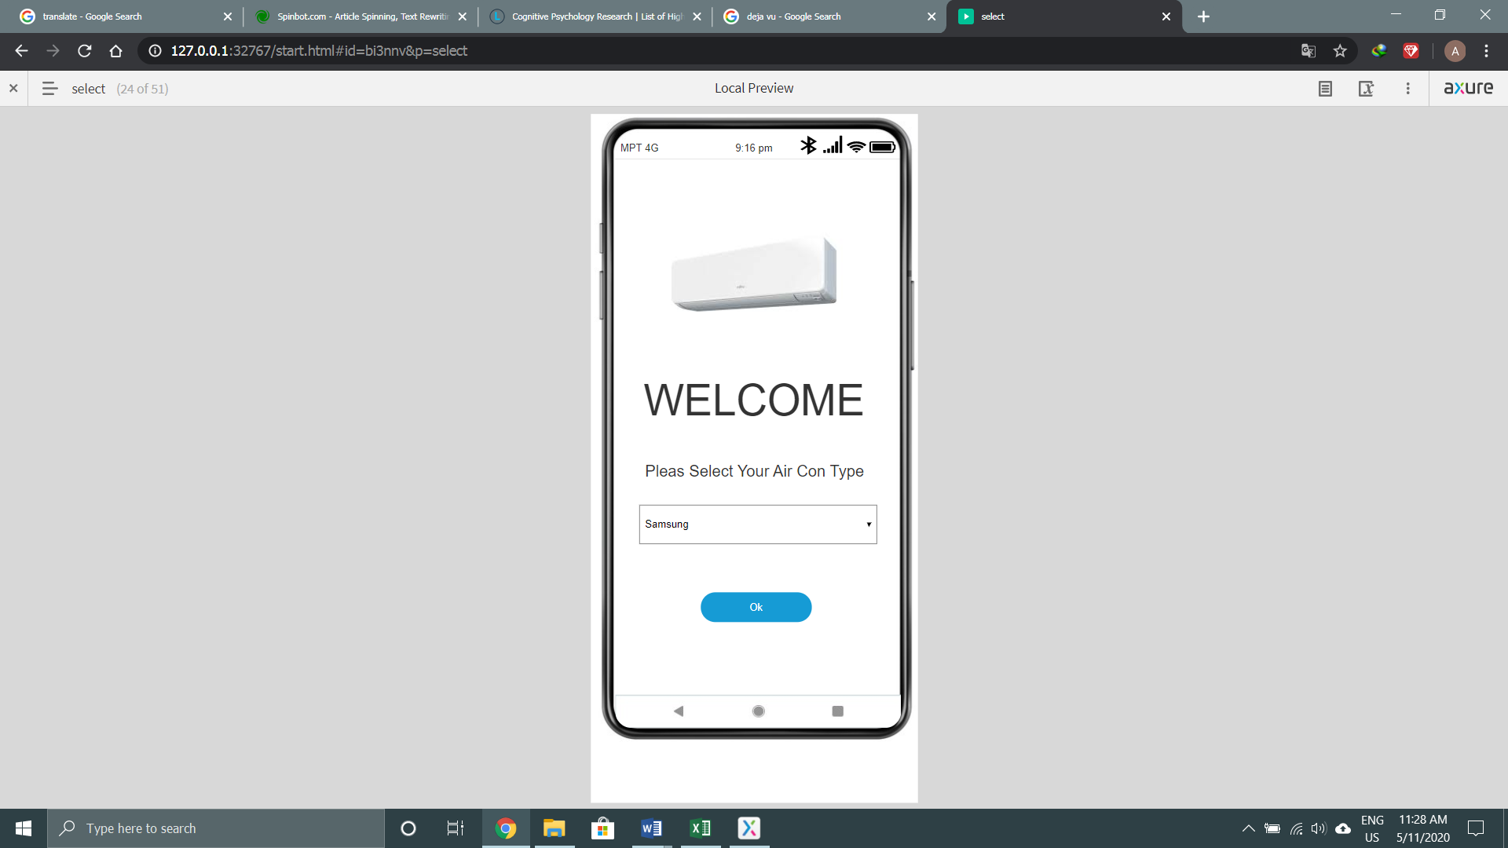

Figure (5.5)

This page appears when user click the air con in the home page. User can select the device by clicking in the given select box. In the figure (5.6), it shows the selection that user have to make. User have to choose the right object and if not, it won't work.

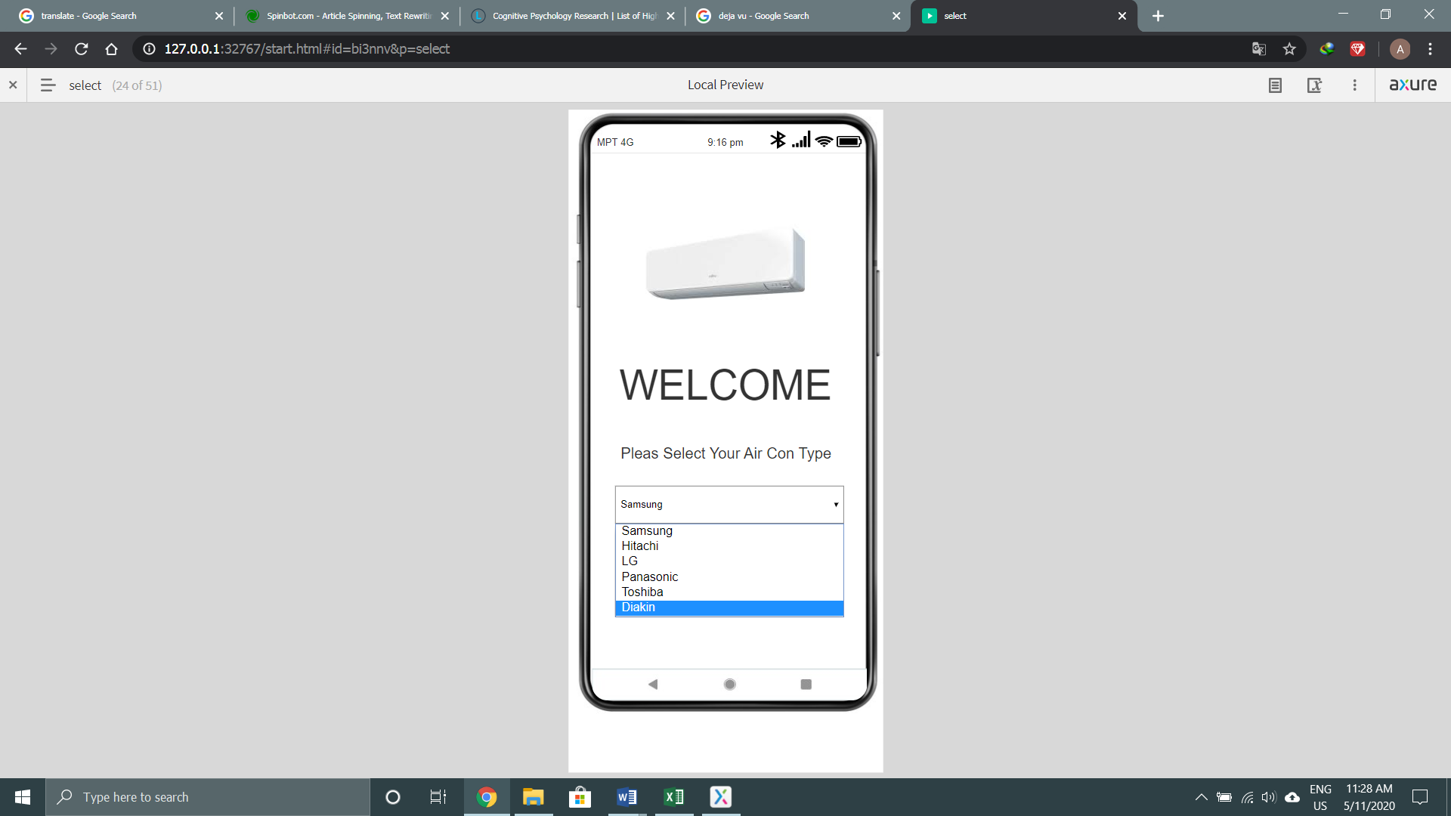

Figure (5.6)

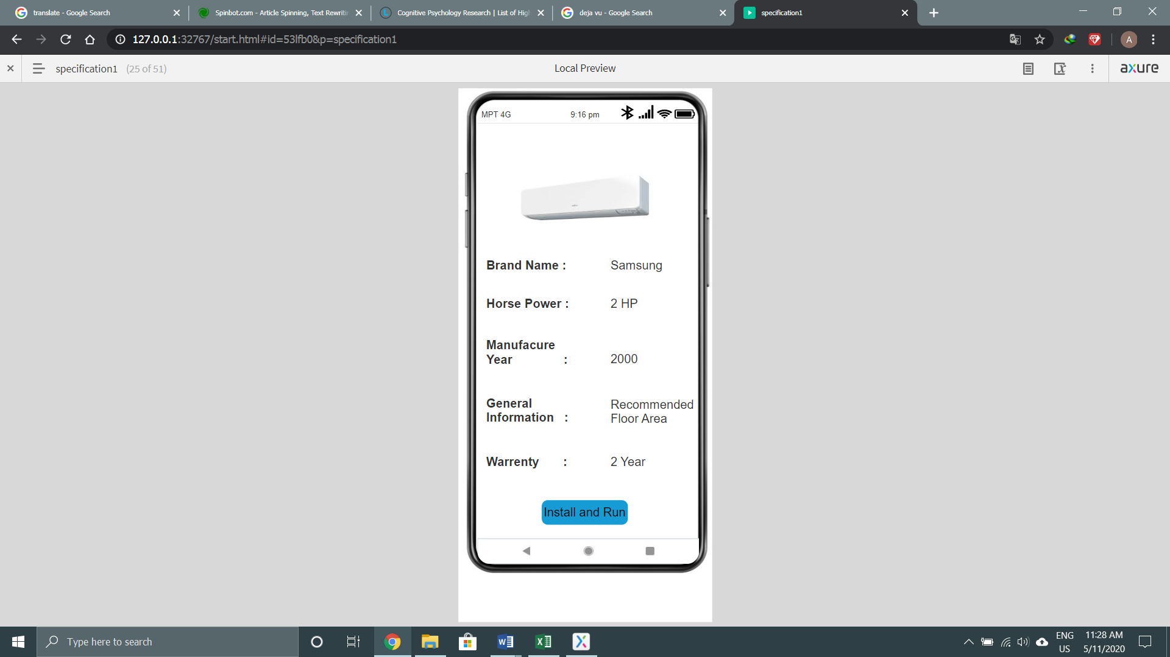

Figure (5.7)

This page is the specification of the aircon based on the device user chooses but it also has to be registered unless it won't show. when the device is chosen, it must be installed and run to be successfully use.

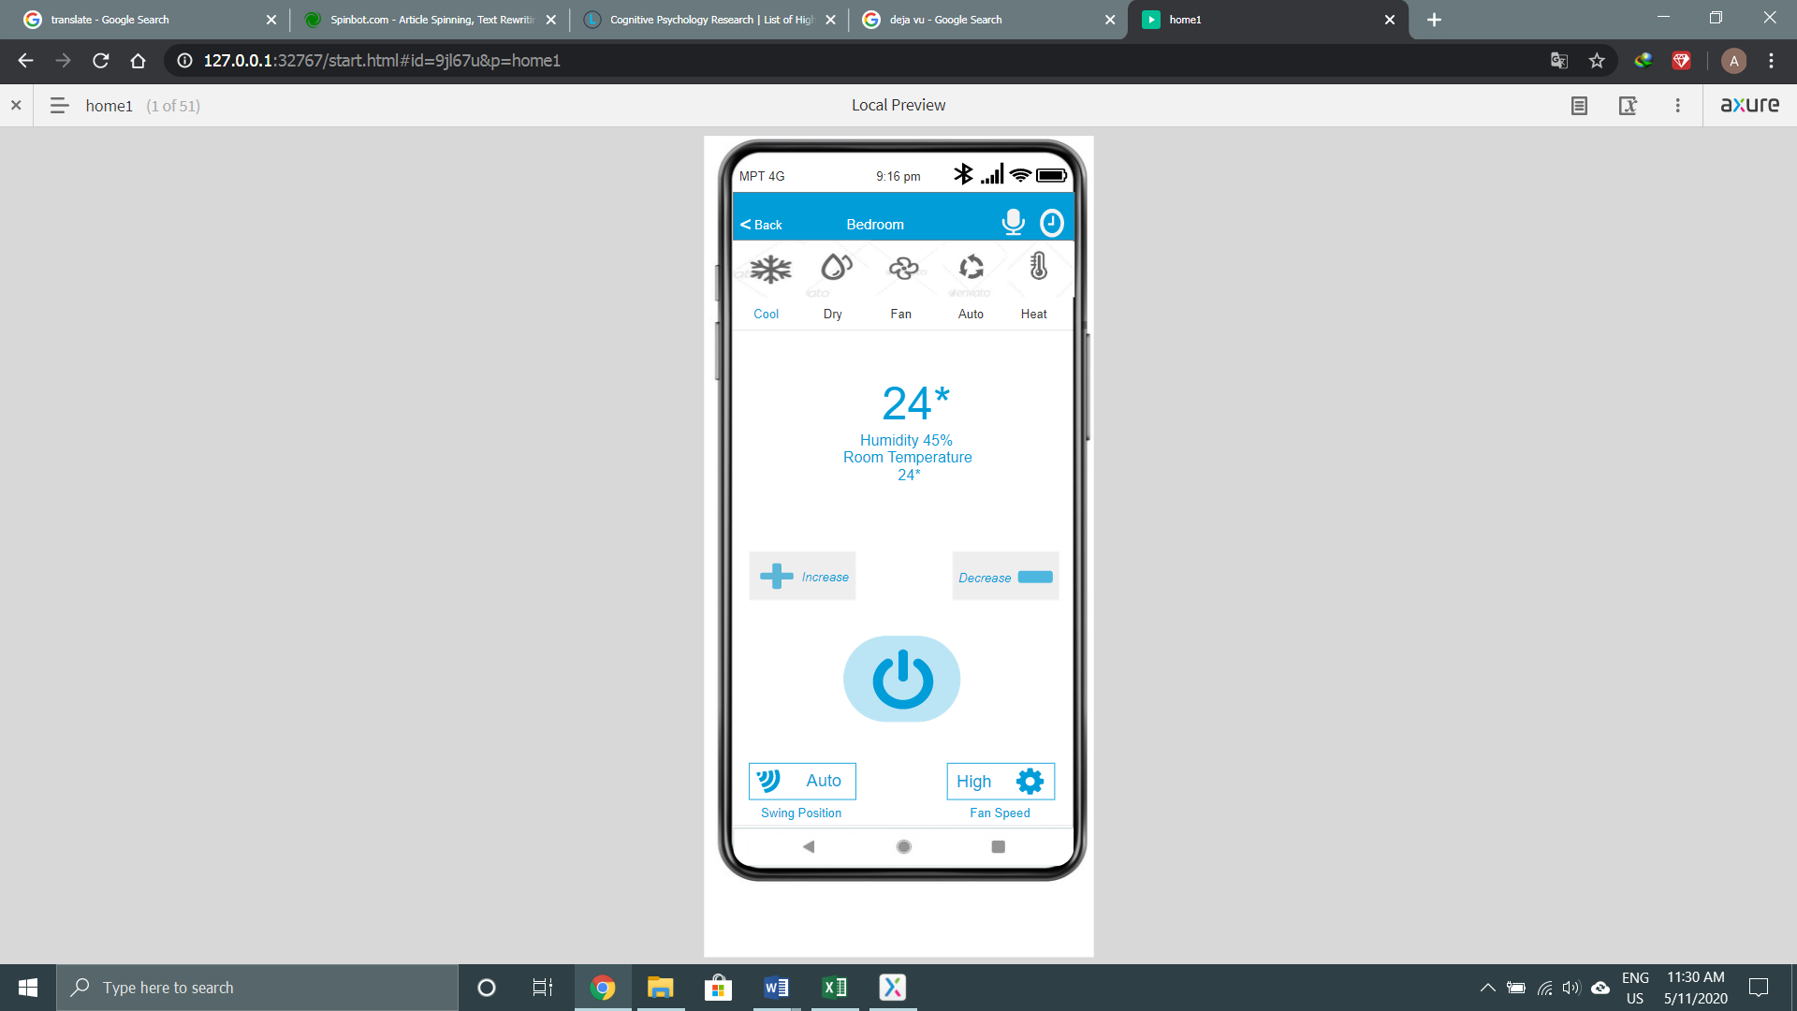

Figure (5.8)

After installation and running, the user will reach his destination, the home page of the air con where he can control the air con. In this page, you can see the mode from the nav. The changes of mode are shown in the figure (5.12). It let the user see the swing position and fan sped. He can increase and decrease the temperature. Changes of temperature are shown in the figure (5.9) and (5.10). Moreover, he can set the timer of the air con and control it with the voice command. The action of the functions is shown in the figure (5.13) and (5.14).

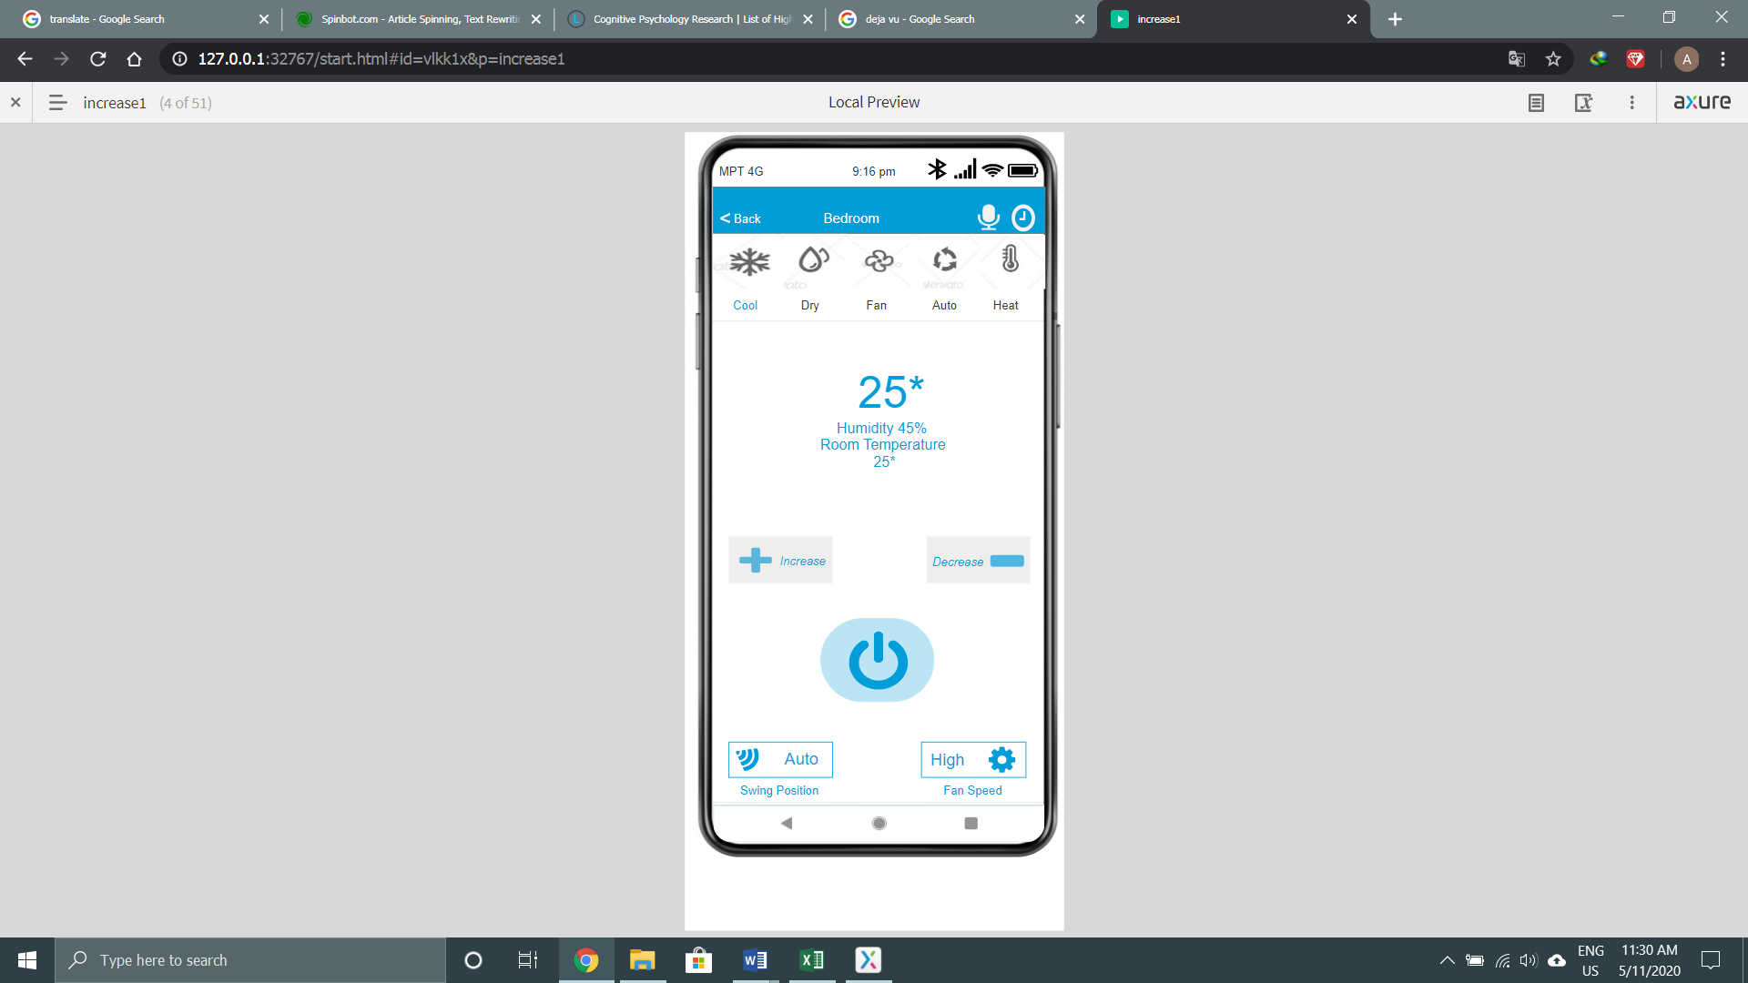

Figure (5.9)

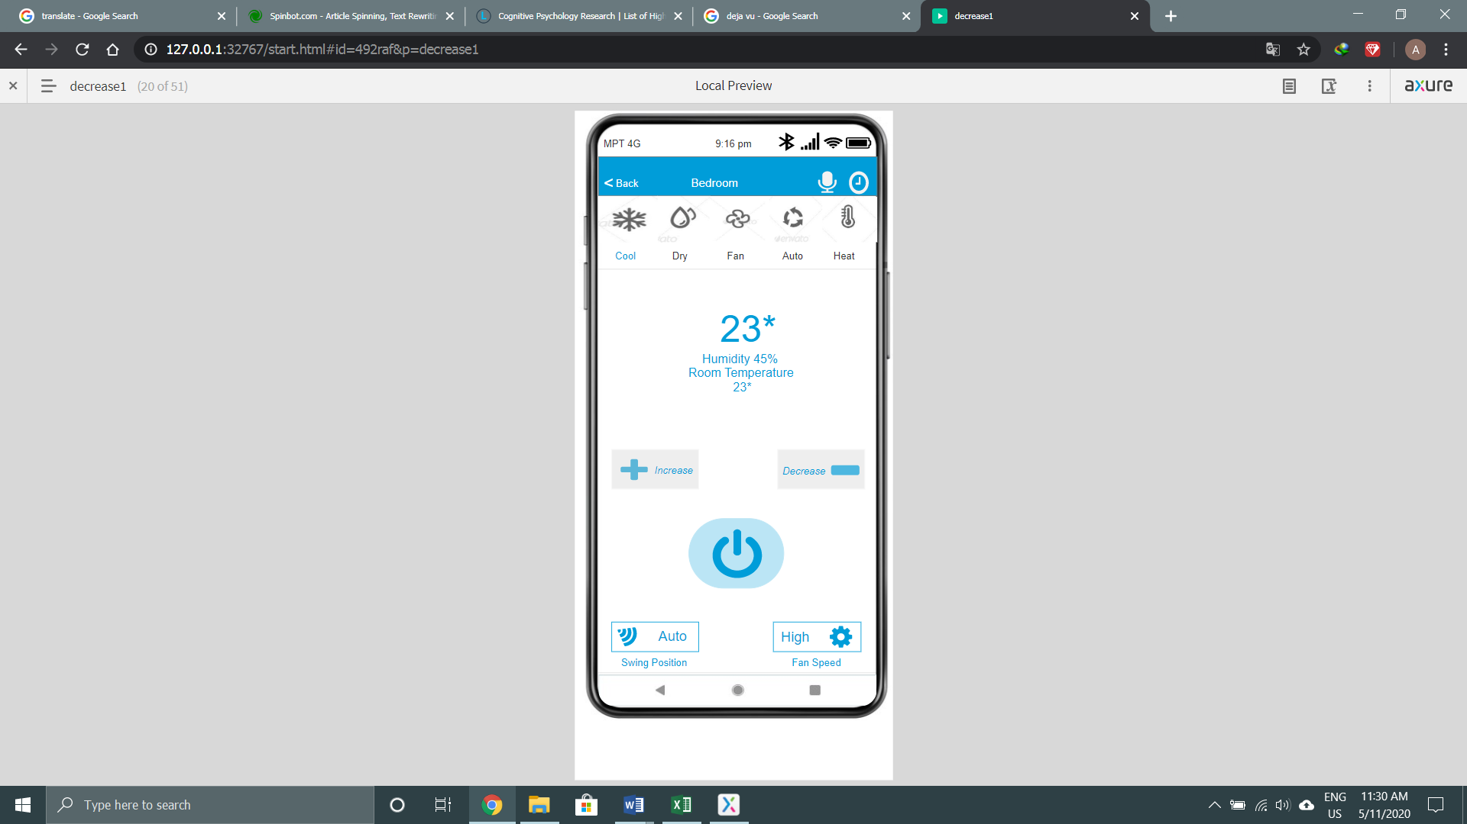

Figure (5.10)

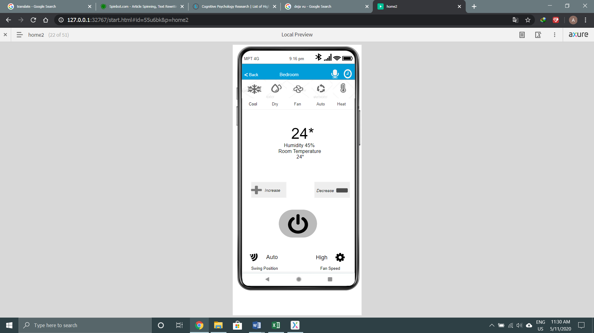

Figure (5.11)

When user done with the things he wanted, he can turn off the air con. In order to do that, he must press the power button in the middle. The color will be faded when he do that.

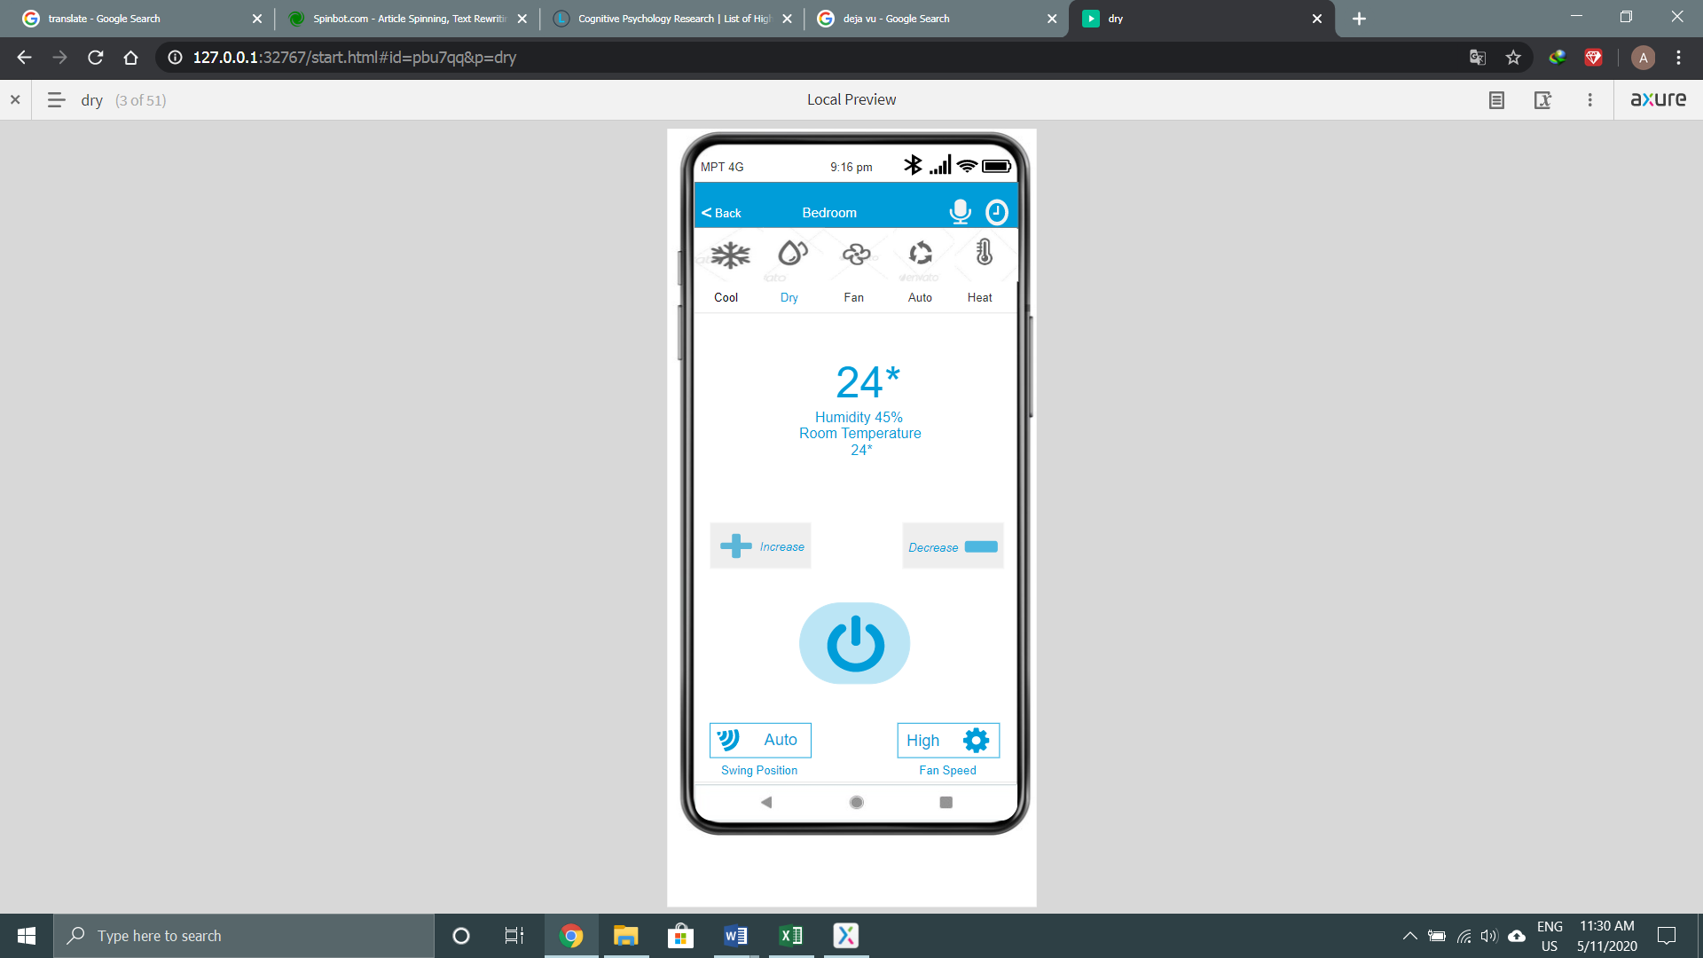

Figure (5.12)

When user wan to control the app with the voice command, he can long press the voice command logo next to the time logo. When he do that, the massage will be appear in the middle as shown in figure (5.13).

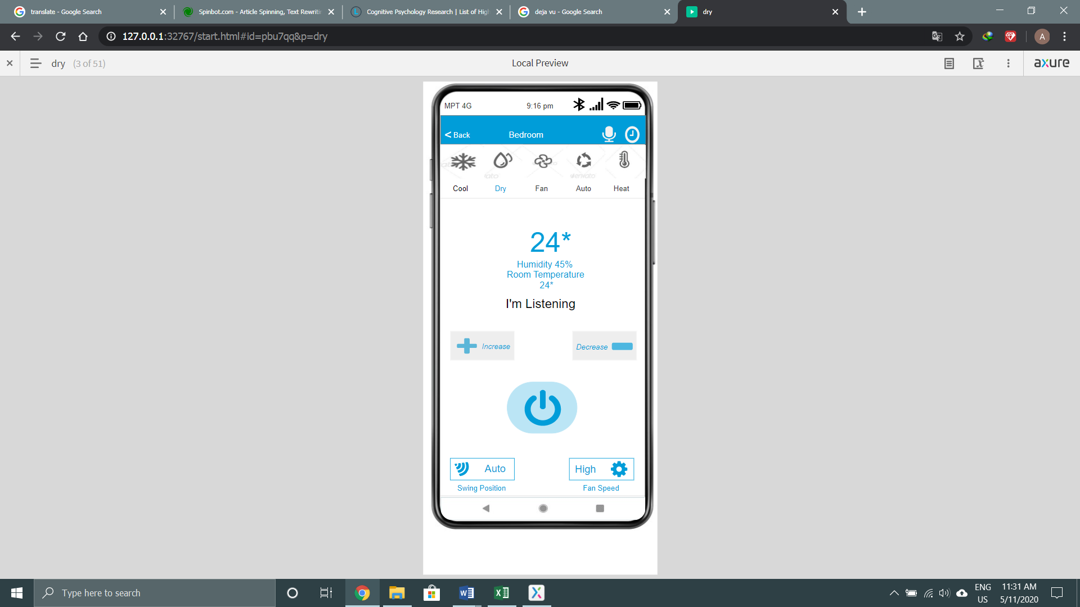

Figure (5.13)

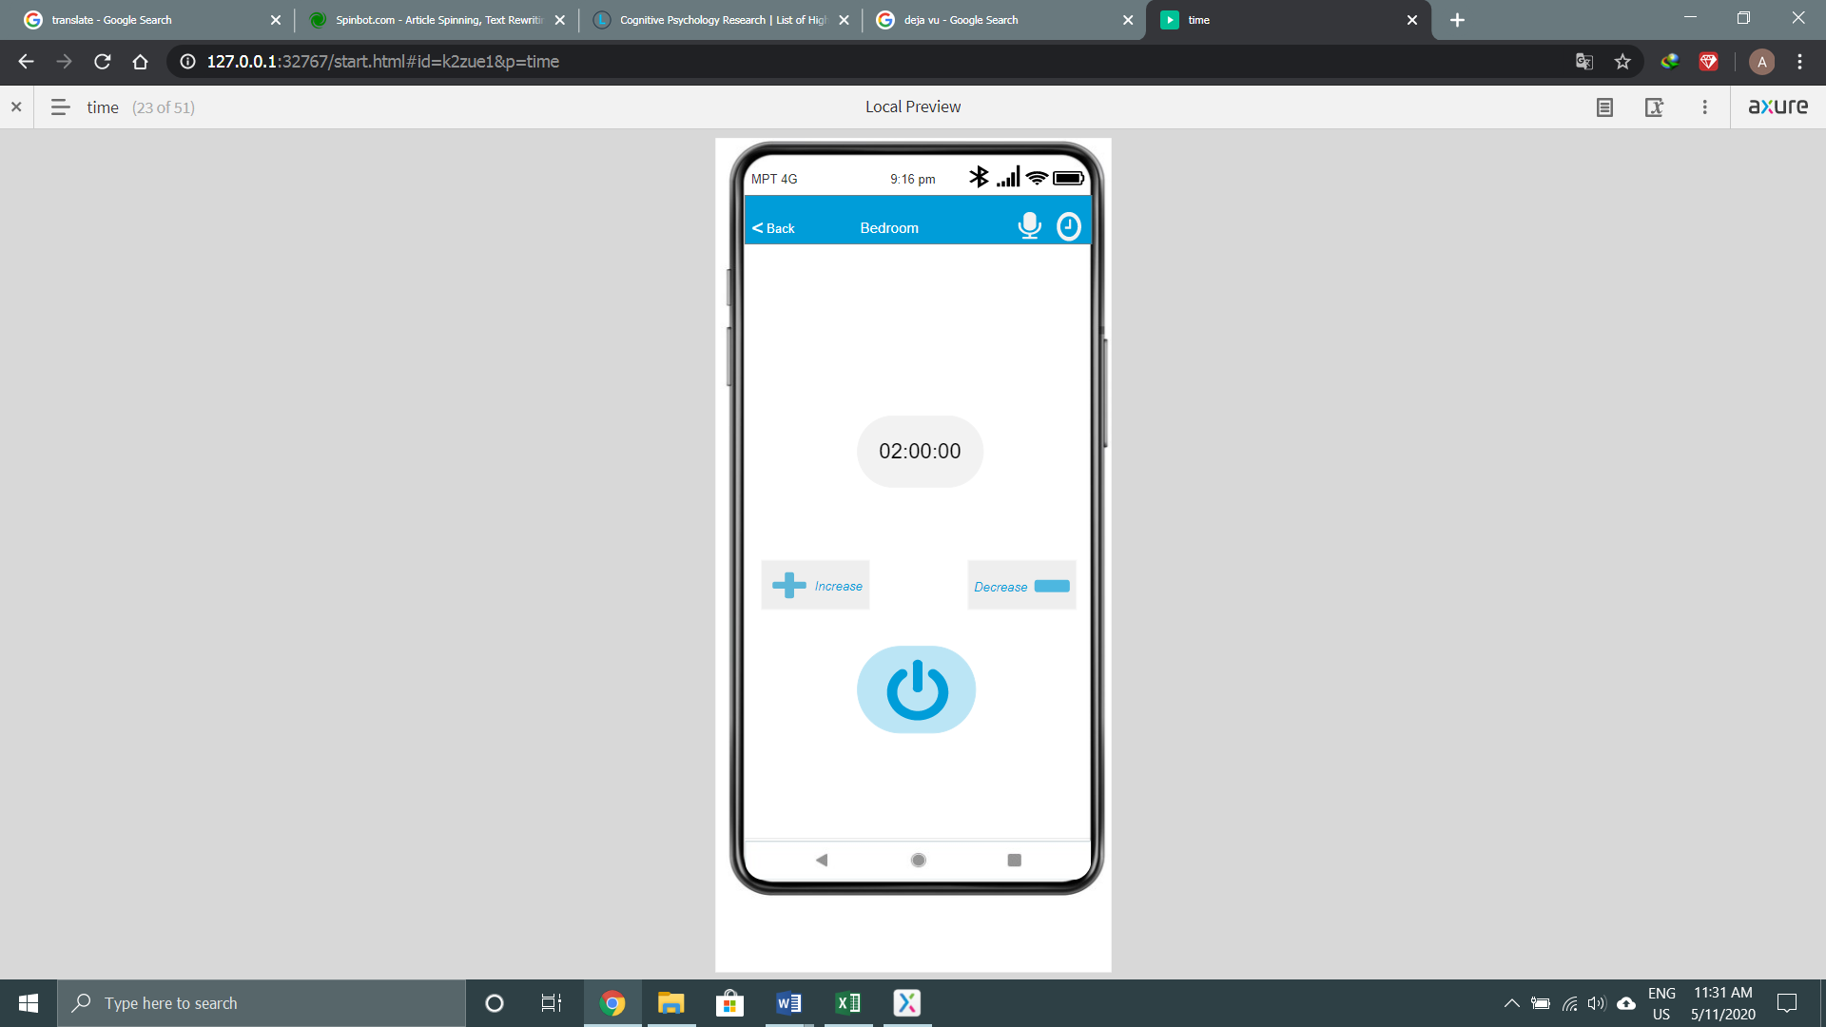

Figure (5.14)

User can set the timer of the air con by clicking the timer button next to the voice logo. When he does that, he can see this page and set timer for it. The default time of the timer is two hours. Moreover, he can increase or decrease the time. The changes are shown in figure (5.15) and (5.16).

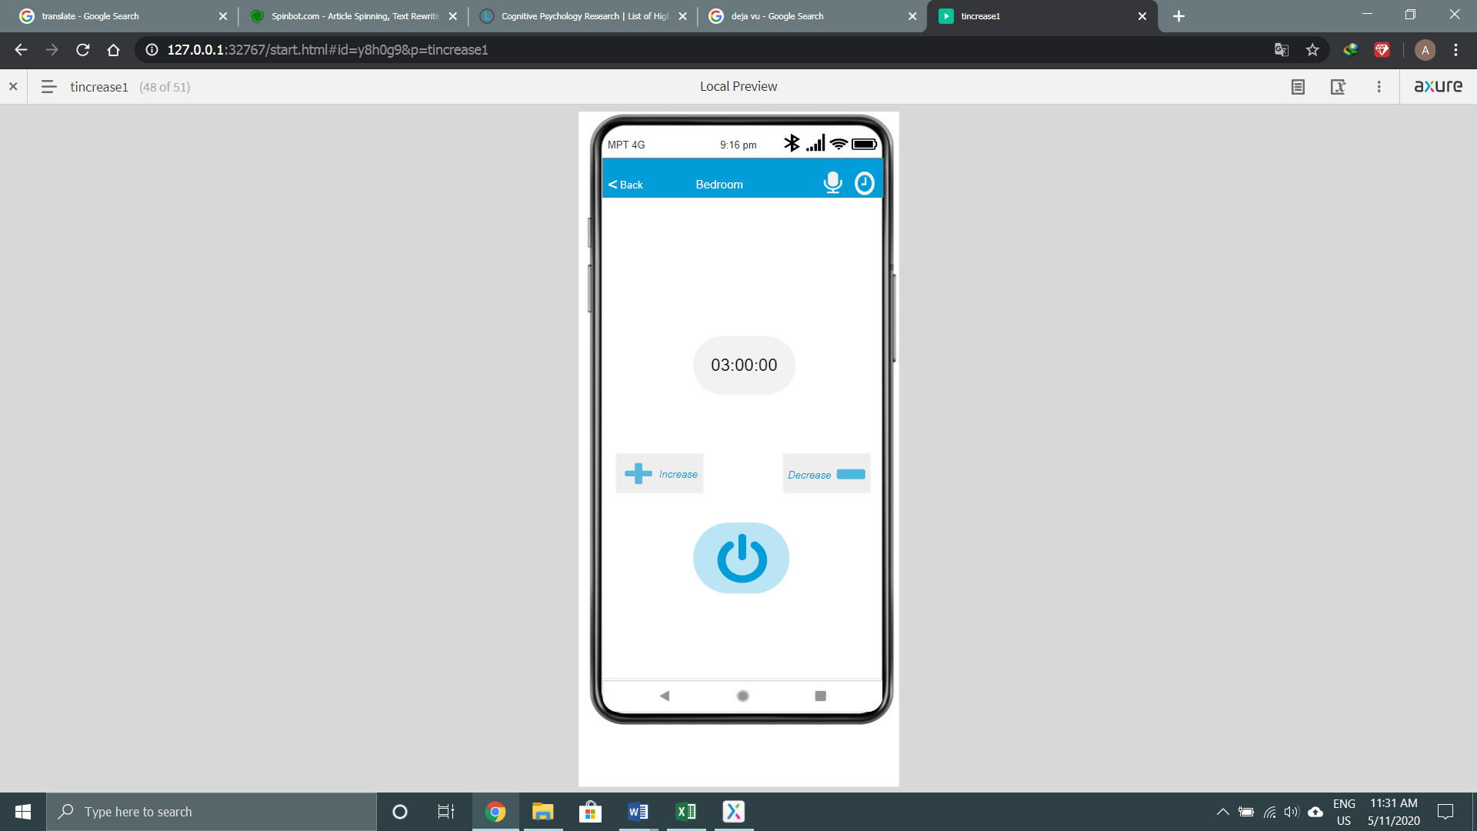

Figure (5.15)

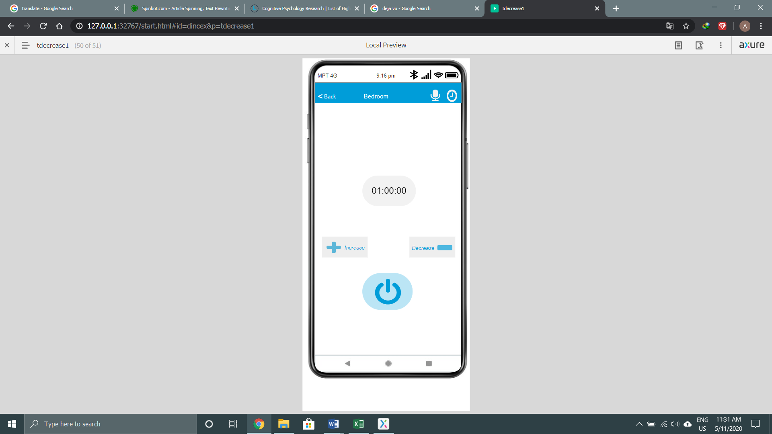

Figure (5.16)

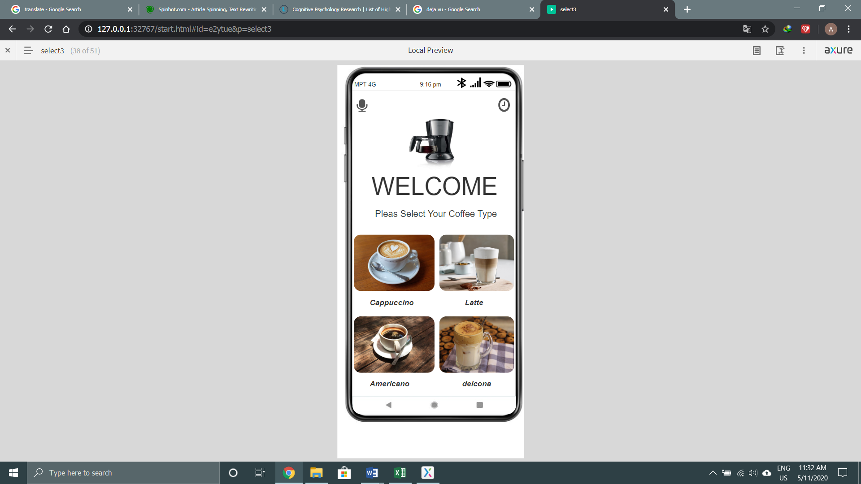

Figure (5.17)

This is the home page of the coffee maker. User can enter this page by clicking the coffee make from the home page. User can choose the coffee type by clicking the image. Moreover, he can command by the voice command and set timer.

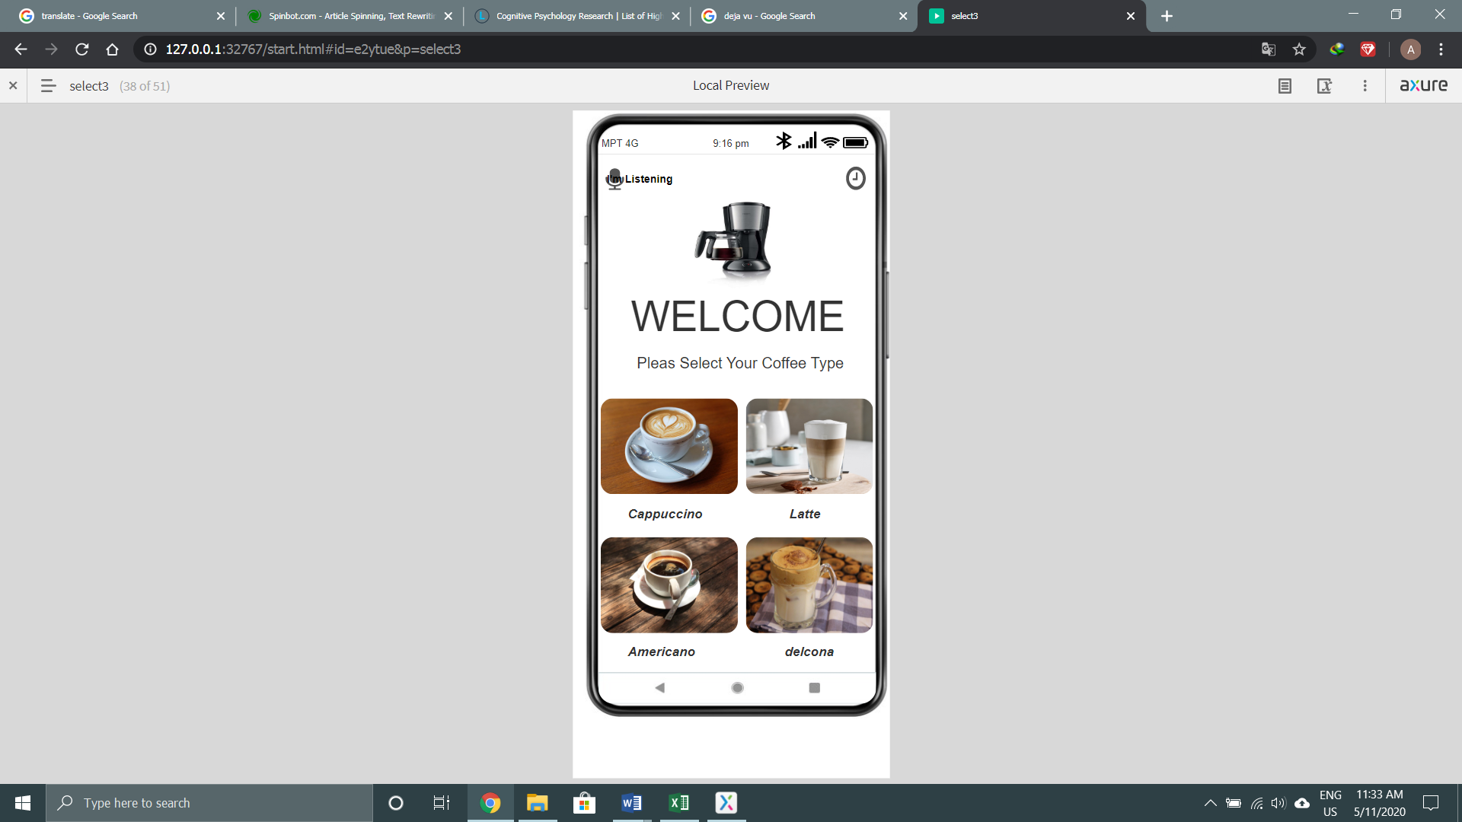

Figure (5.18)

The user has to long press the voice command logo to command the app and changes will be shown as the figure.

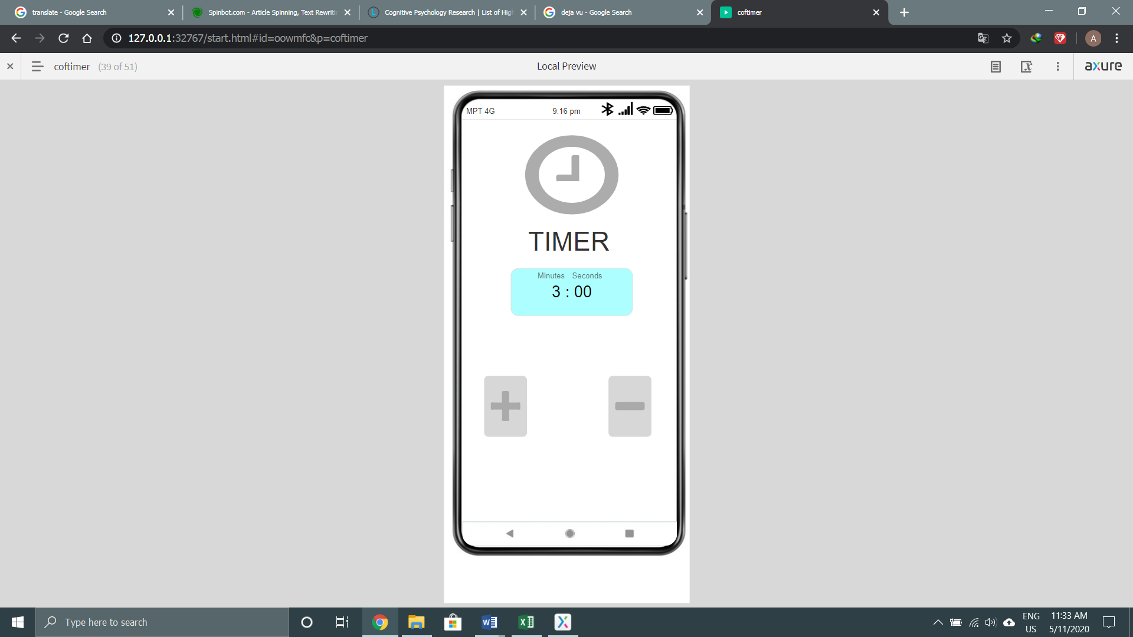

Figure (5.19)

User have to click the timer logo when he wants to set timer for the coffee. if he clicks it, he will see this page and he can increase or decrease the time. Changes are show in figure (5.20) and (5.21).

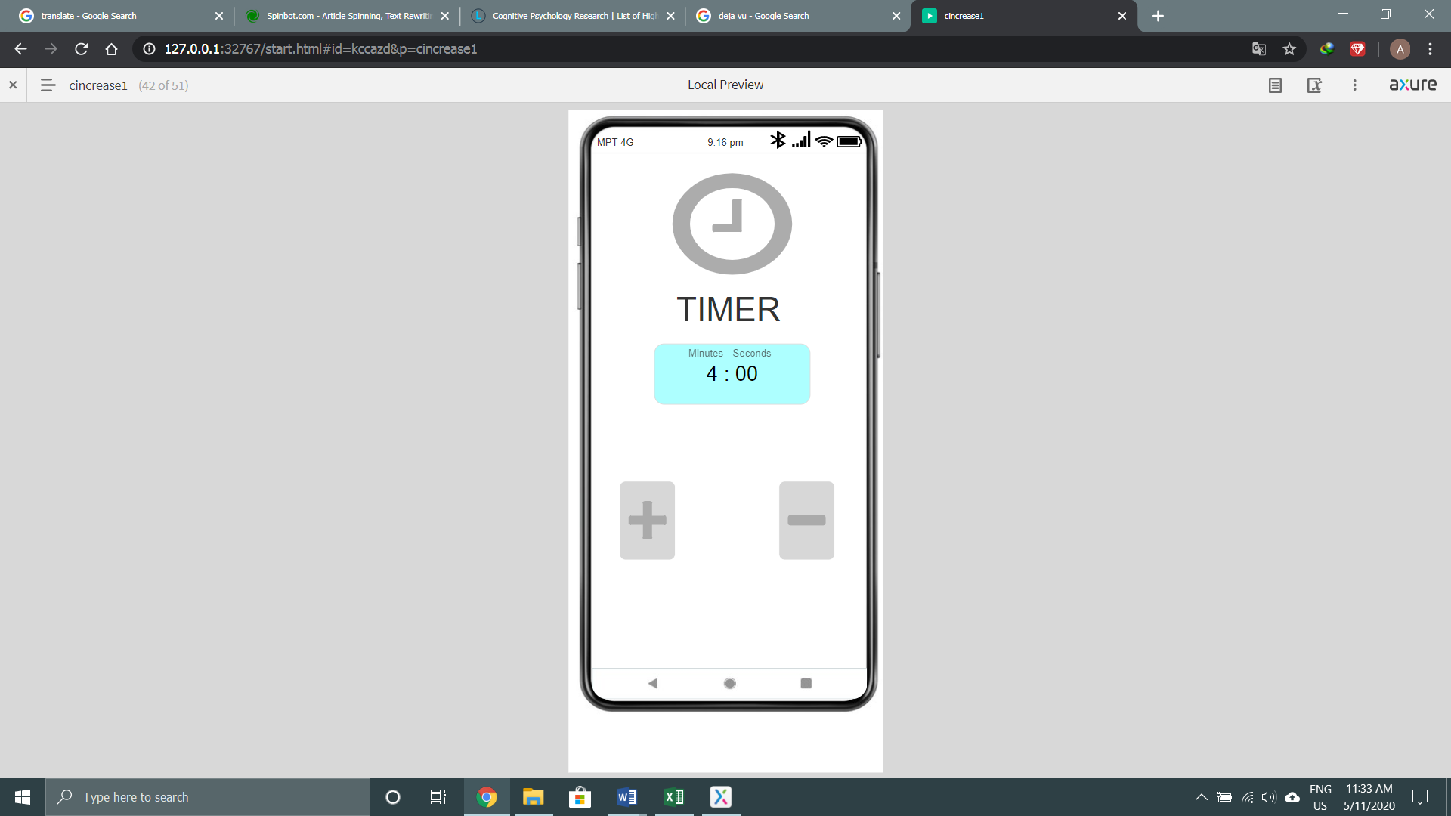

Figure (5.20)

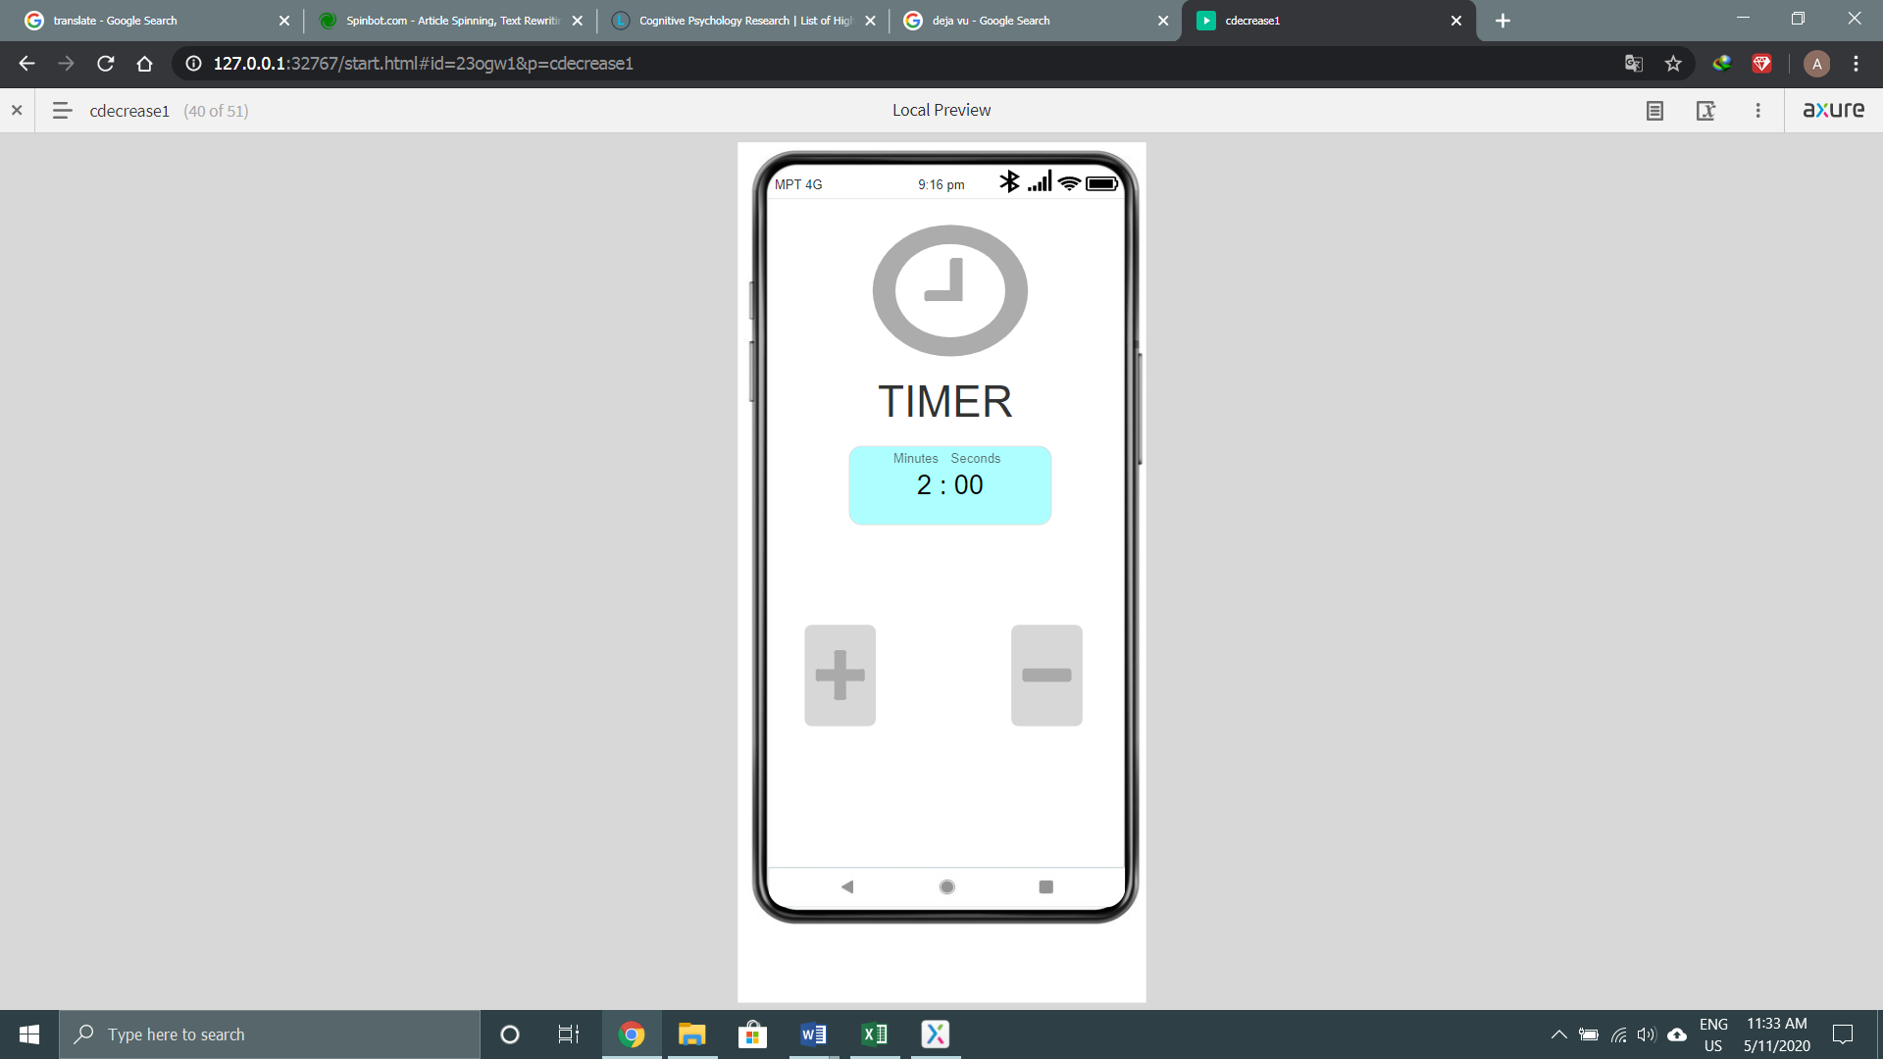

Figure (5.21)

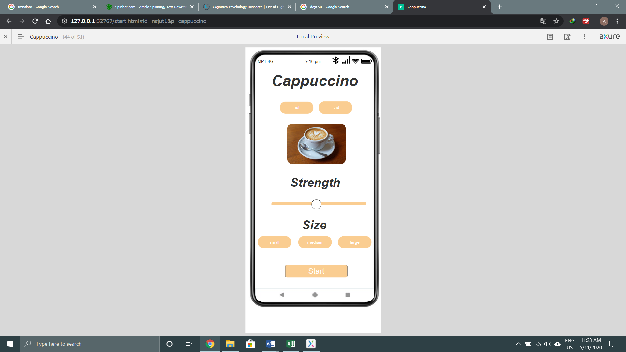

Figure (5.22)

When user choose the cappuccino from the coffee home page, he will see the detail of the coffee in order to make a complete cappuccino. He can choose hot or iced, strength and small or medium or large. If he finishes with that he can press the button start. The choice he made will be shown by changes in color. These are in figures (5.23).

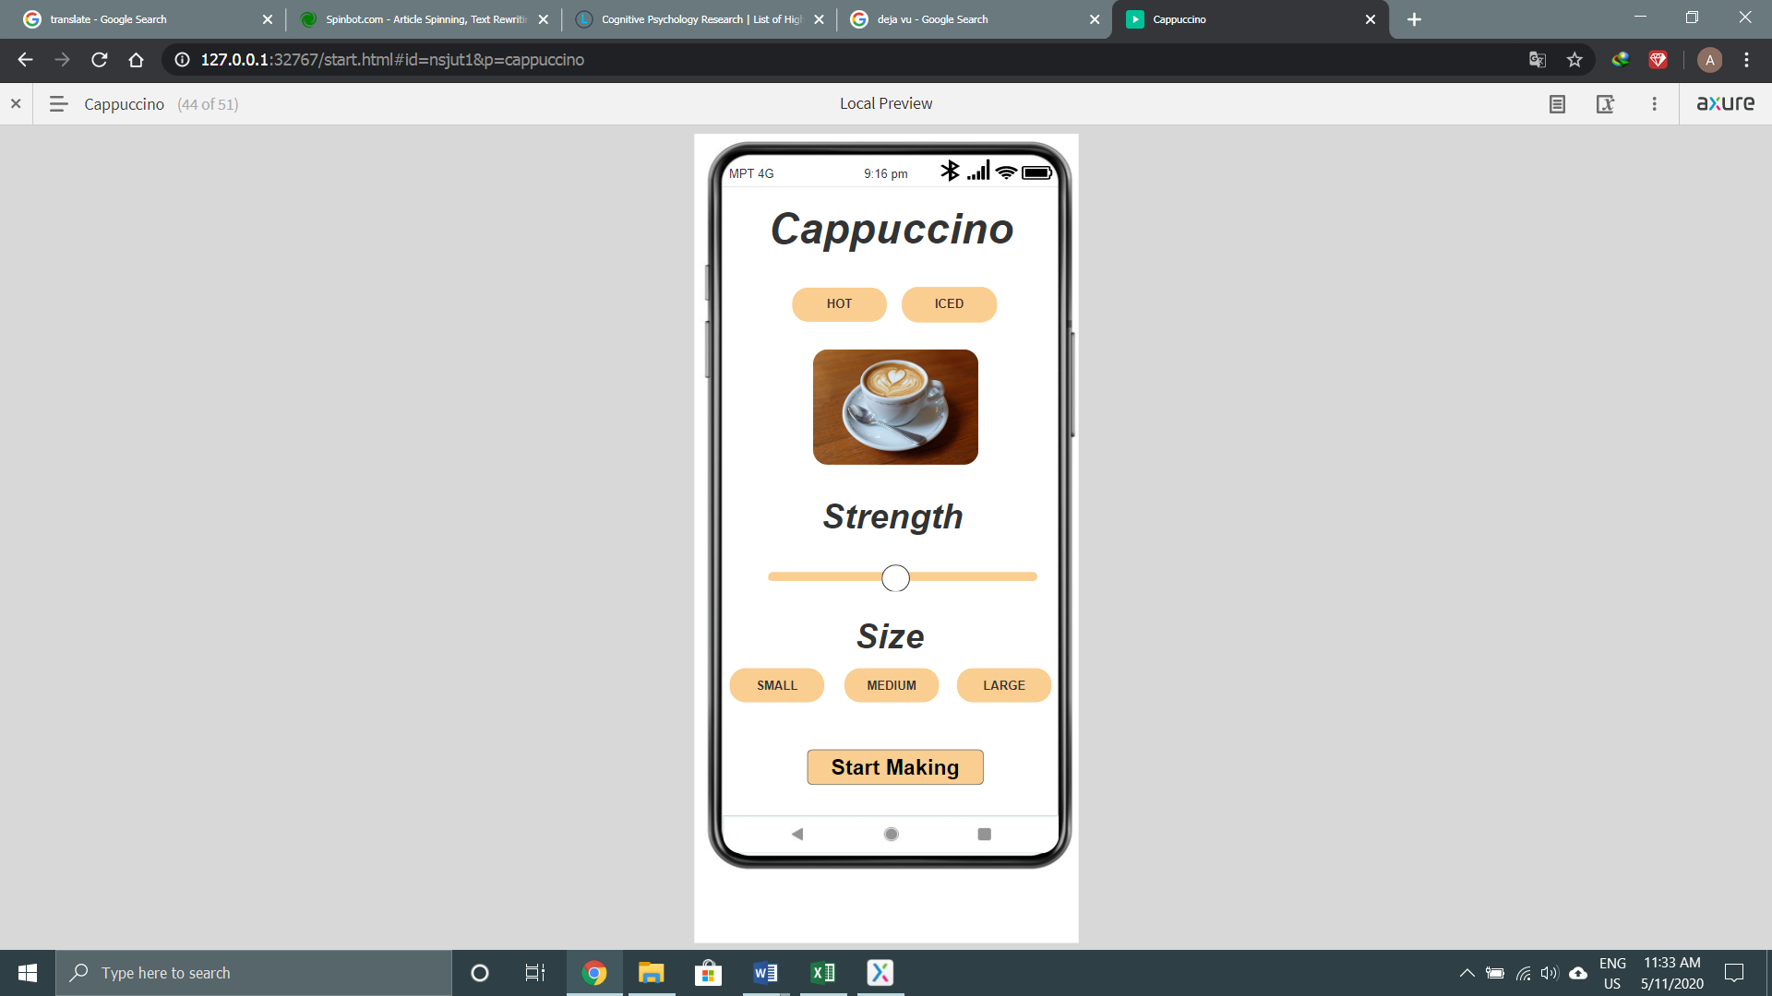

Figure (5.23)

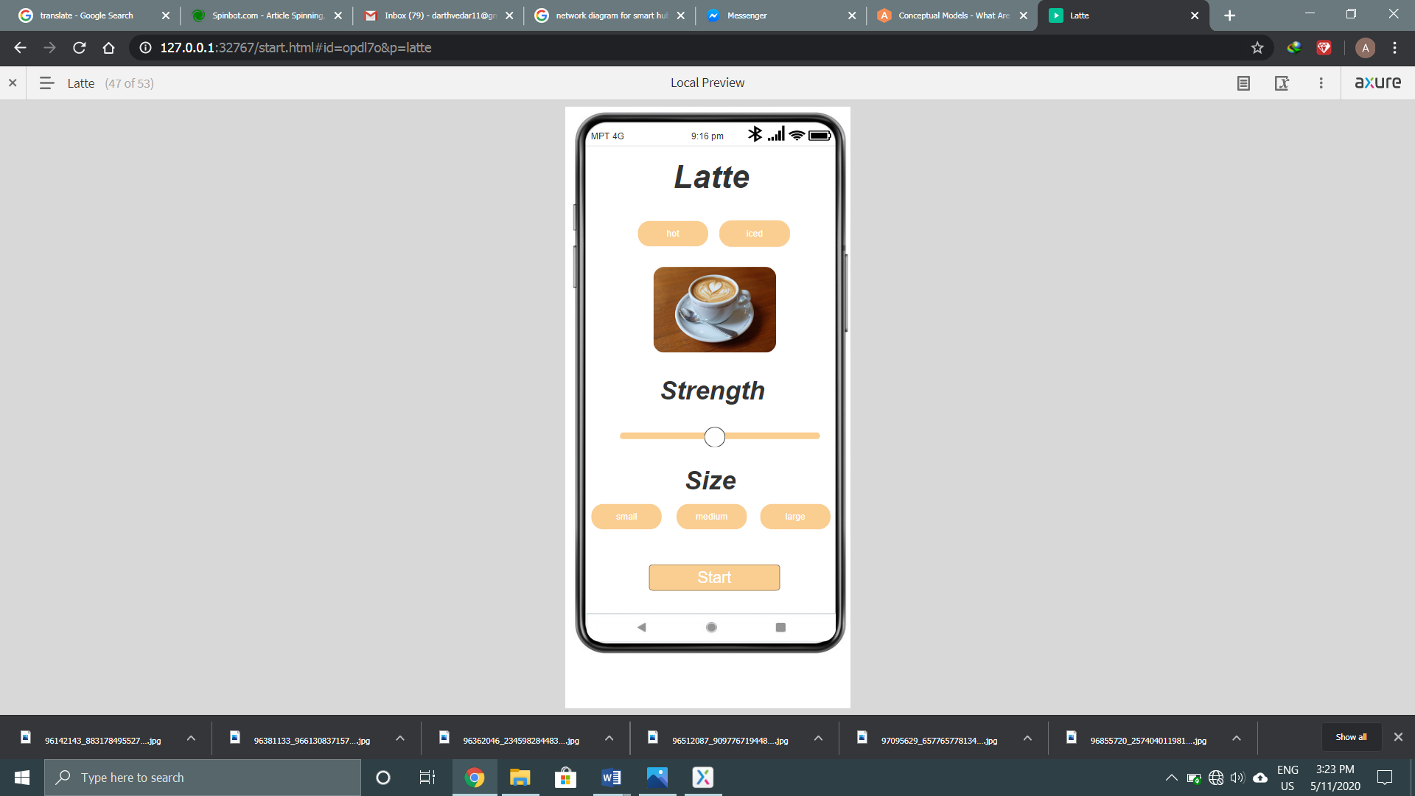

Figure (5.24)

This is the same as figure (5.22)

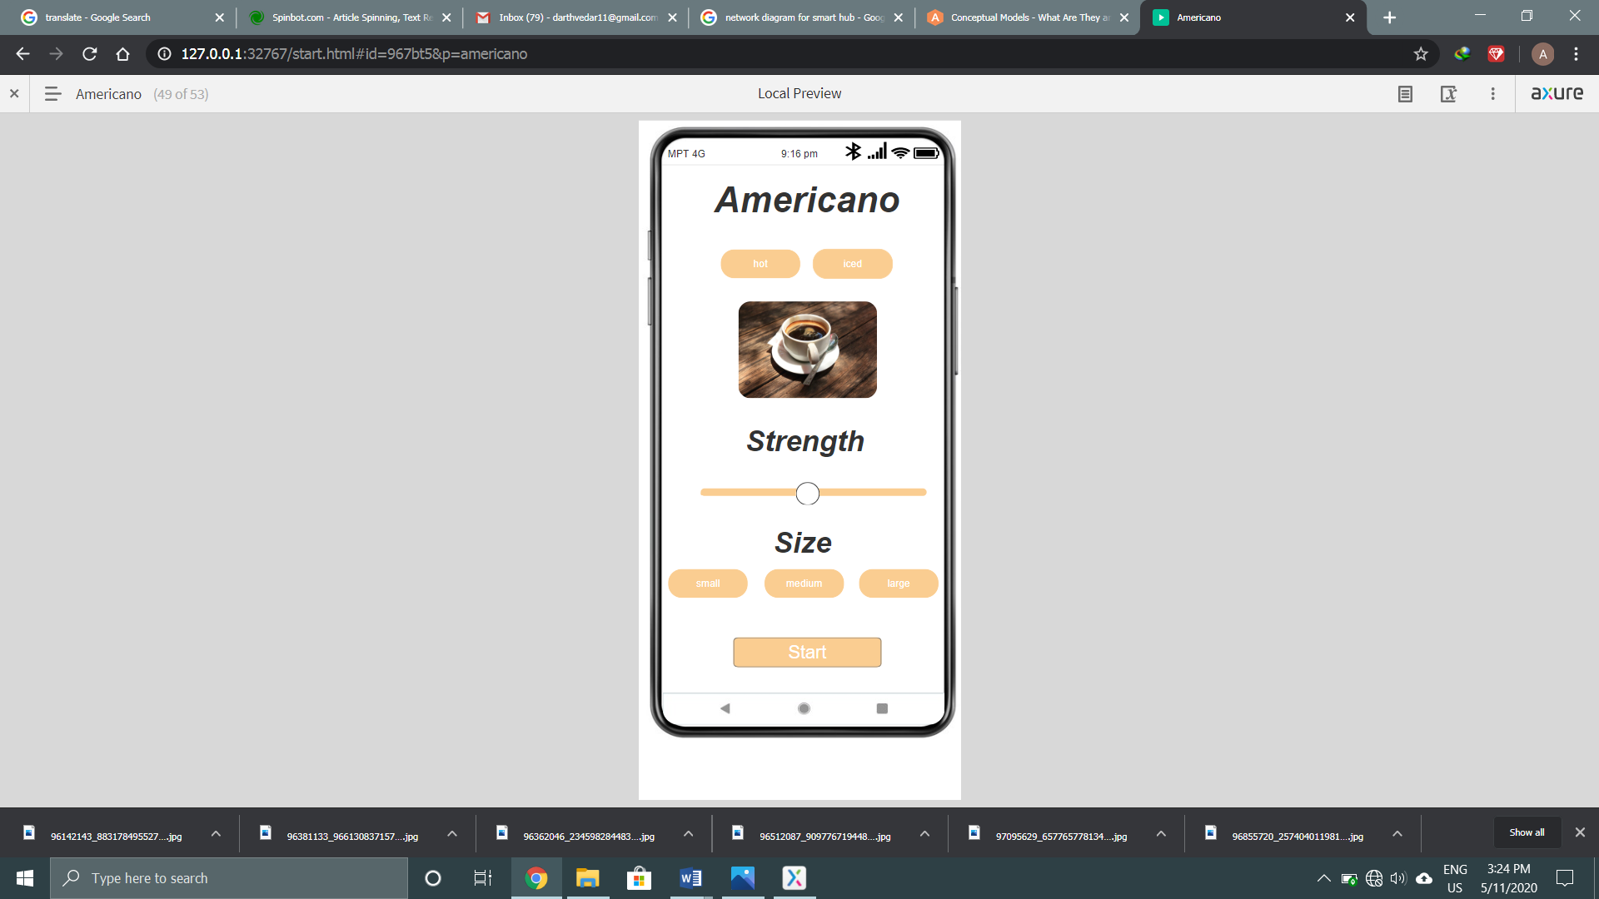

Figure (5.25)

This is the same as figure (5.22)

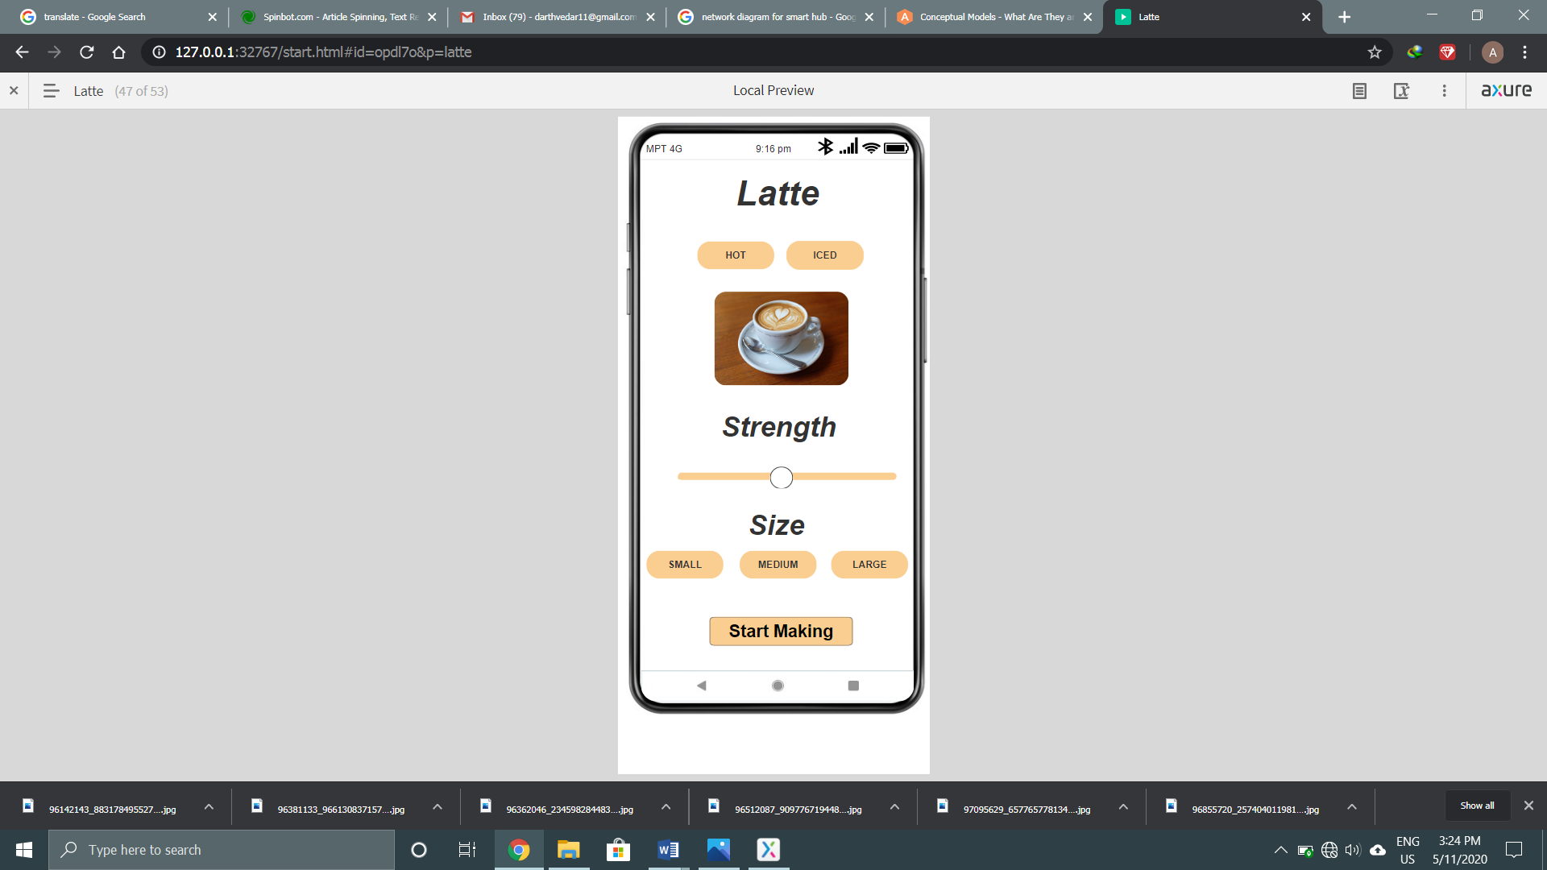

Figure (5.26)

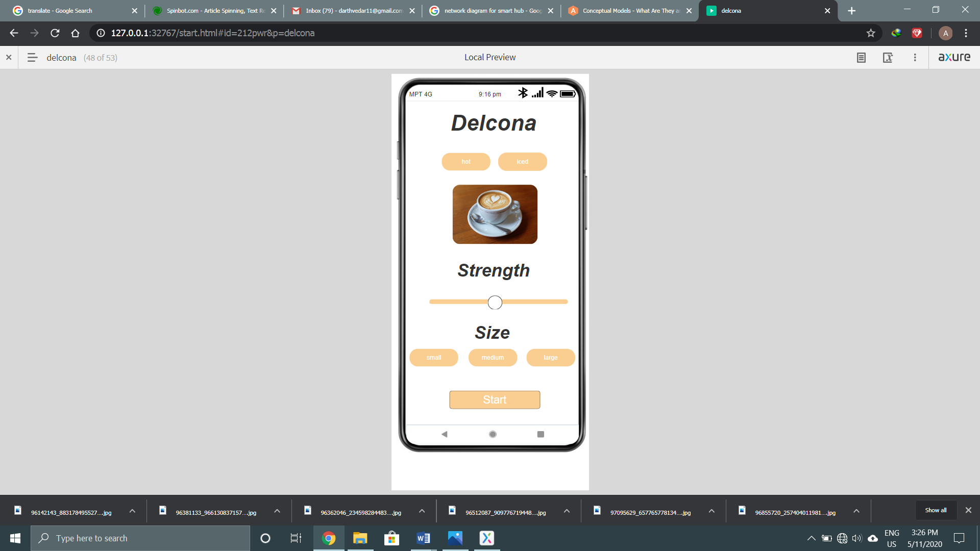

Figure (5.27)

This is the same as figure (5.22)

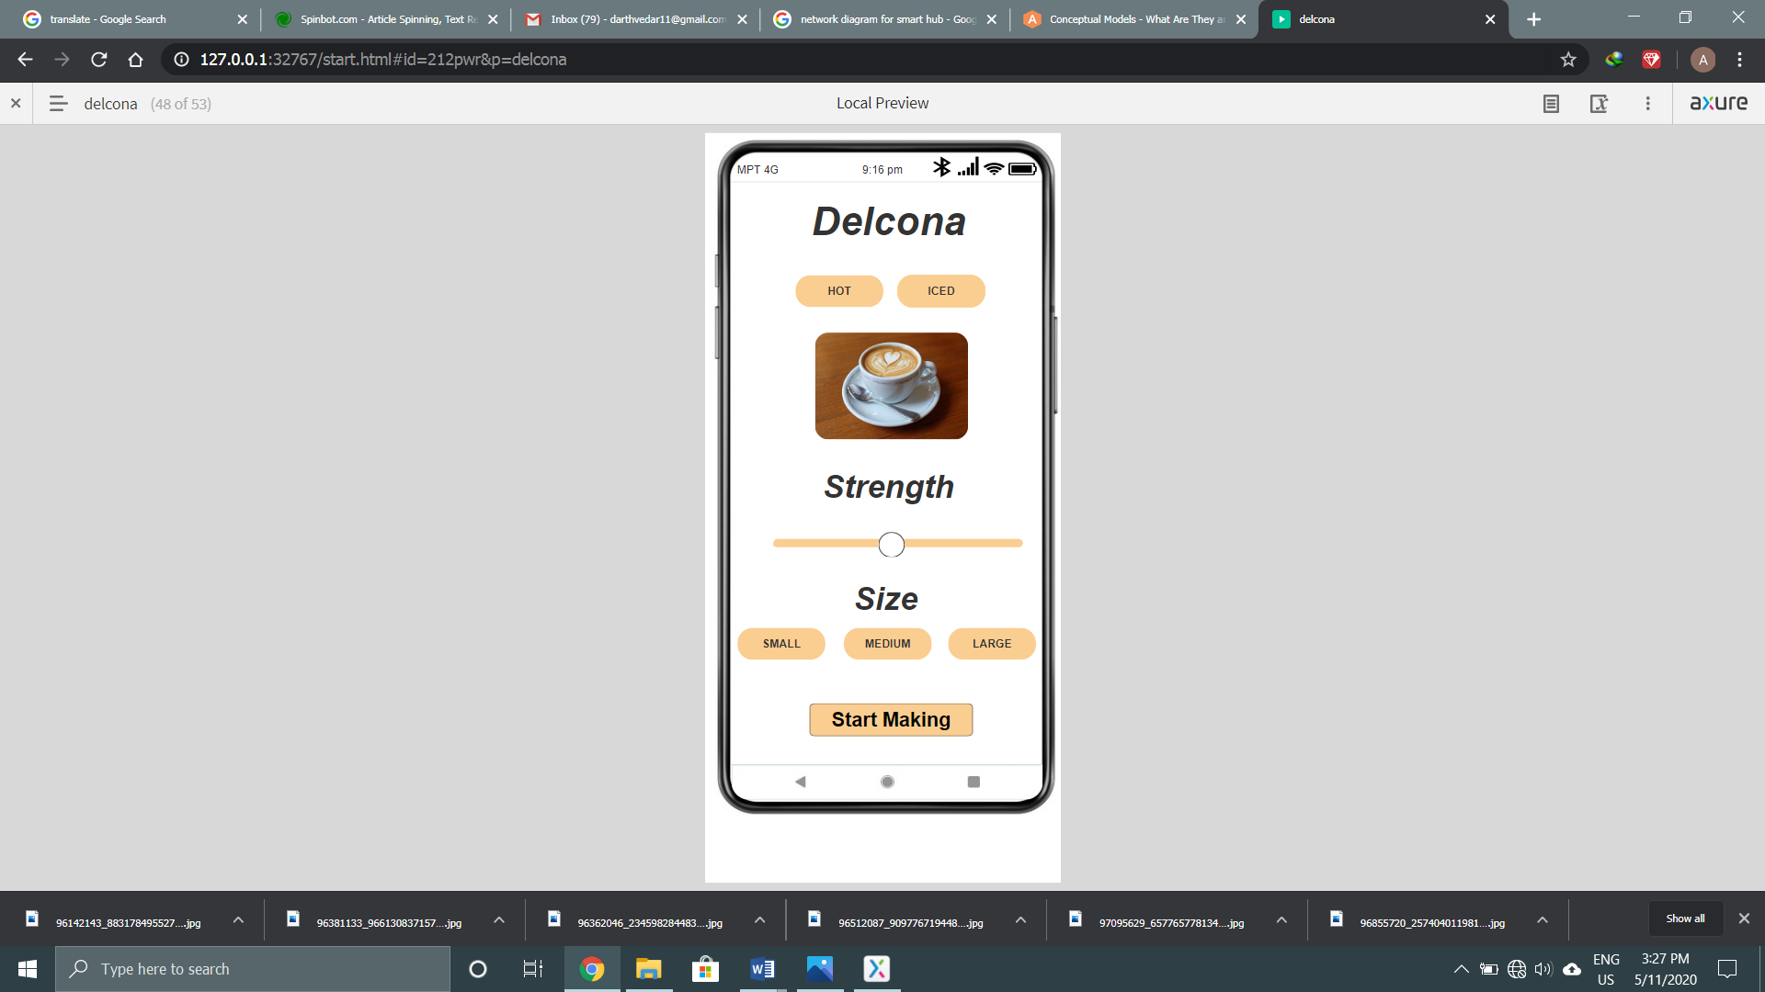

Figure (5.28)

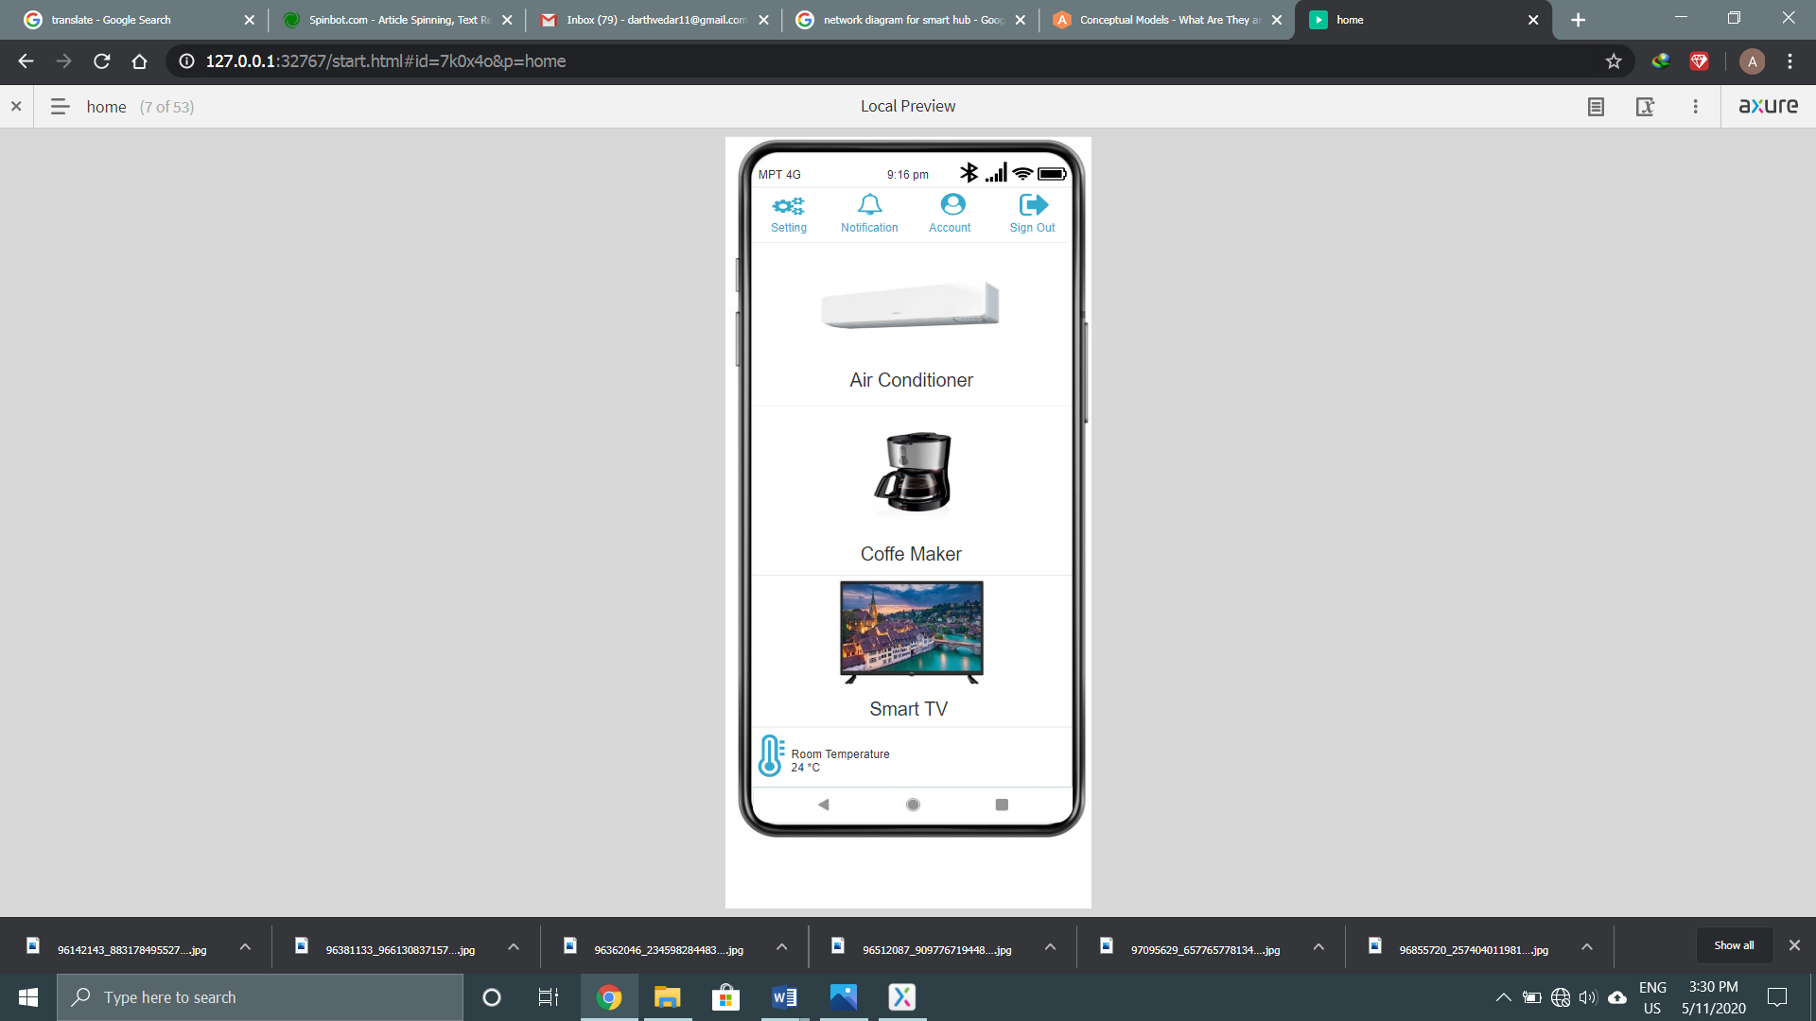

Figure (5.29)

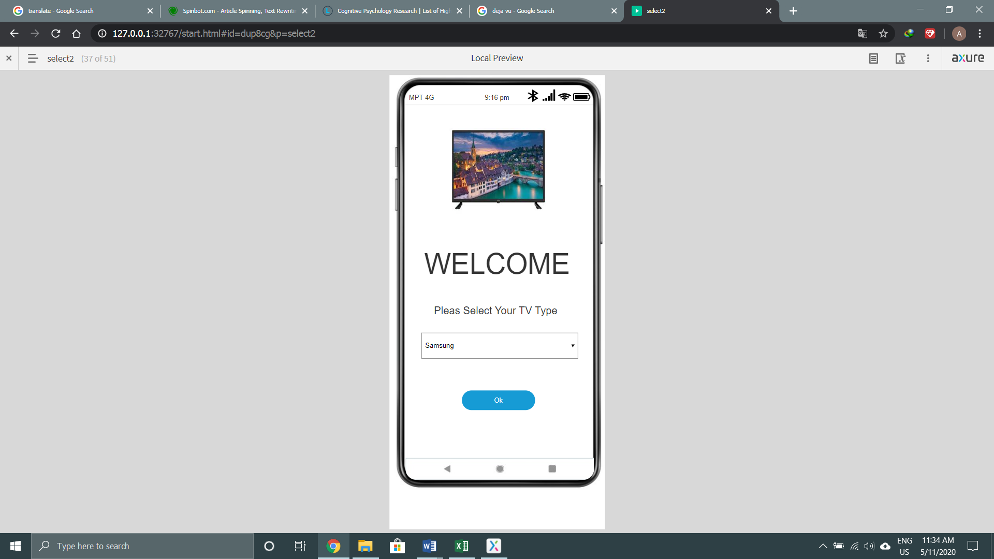

Figure (5.30)

This is the same as figure (5.5)

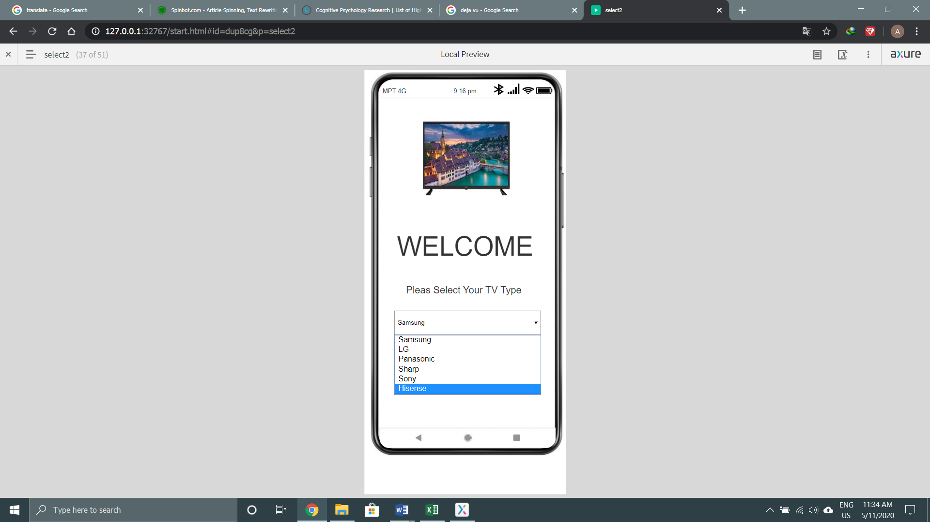

Figure (5.31)

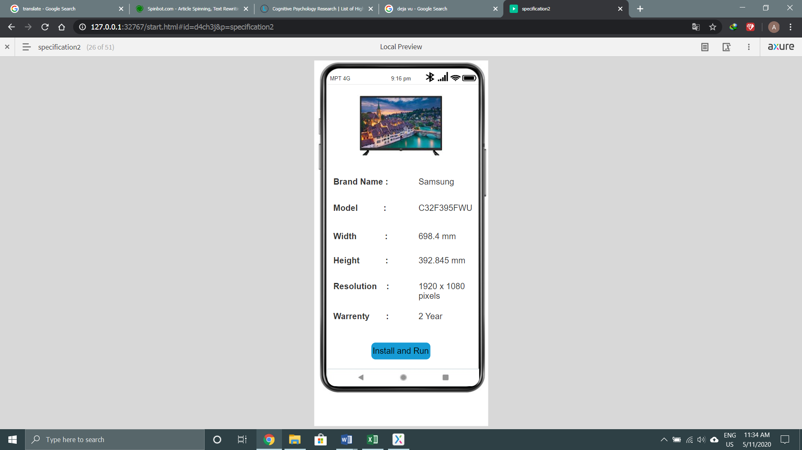

Figure (5.32)

This is the same as figure (5.7)

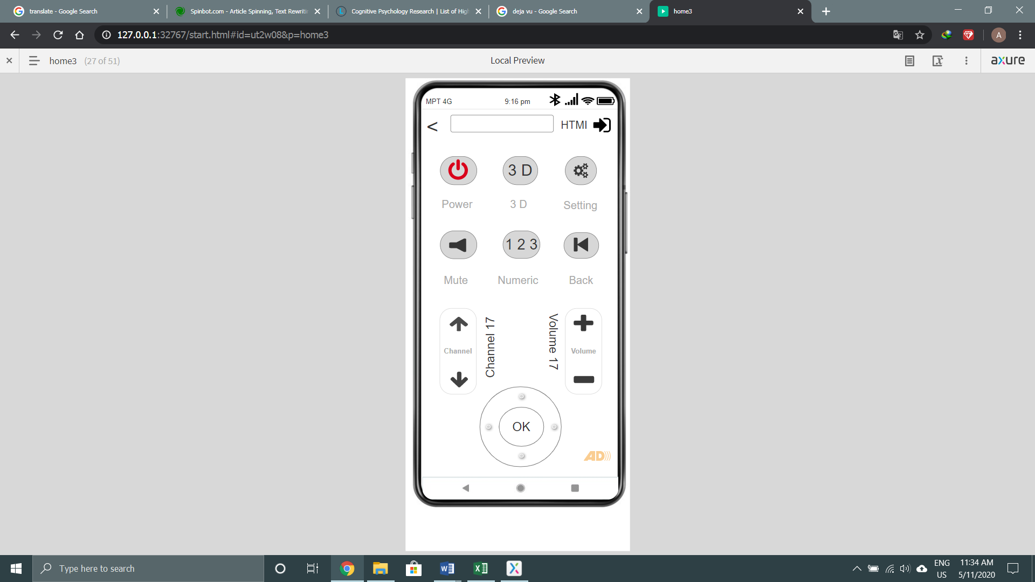

Figure (5.33)

This is the home page TV controller. User can power off, change to 3D, look into setting, can mute the sound, search the channel with numeric and can back. Moreover, he can change channel, increase or decrease volume and AD system is included. When user press the power button, the changes will be show in the figure (5.34). The change of channel and volume will show in figures (5.35) to (5.38).

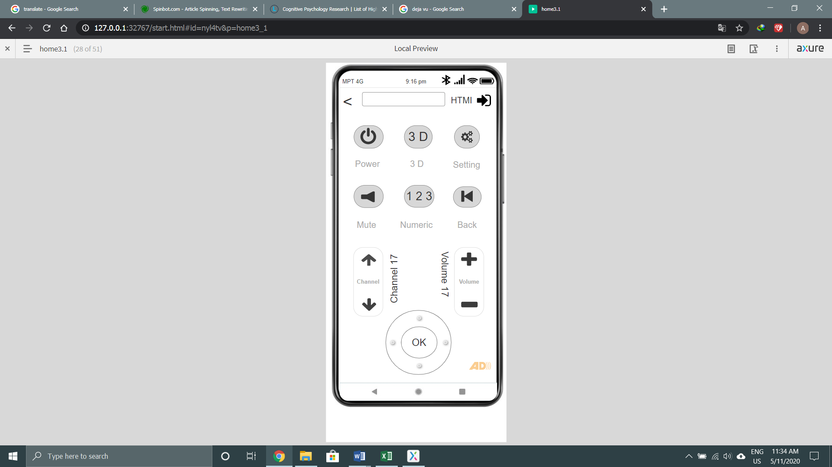

Figure (5.34)

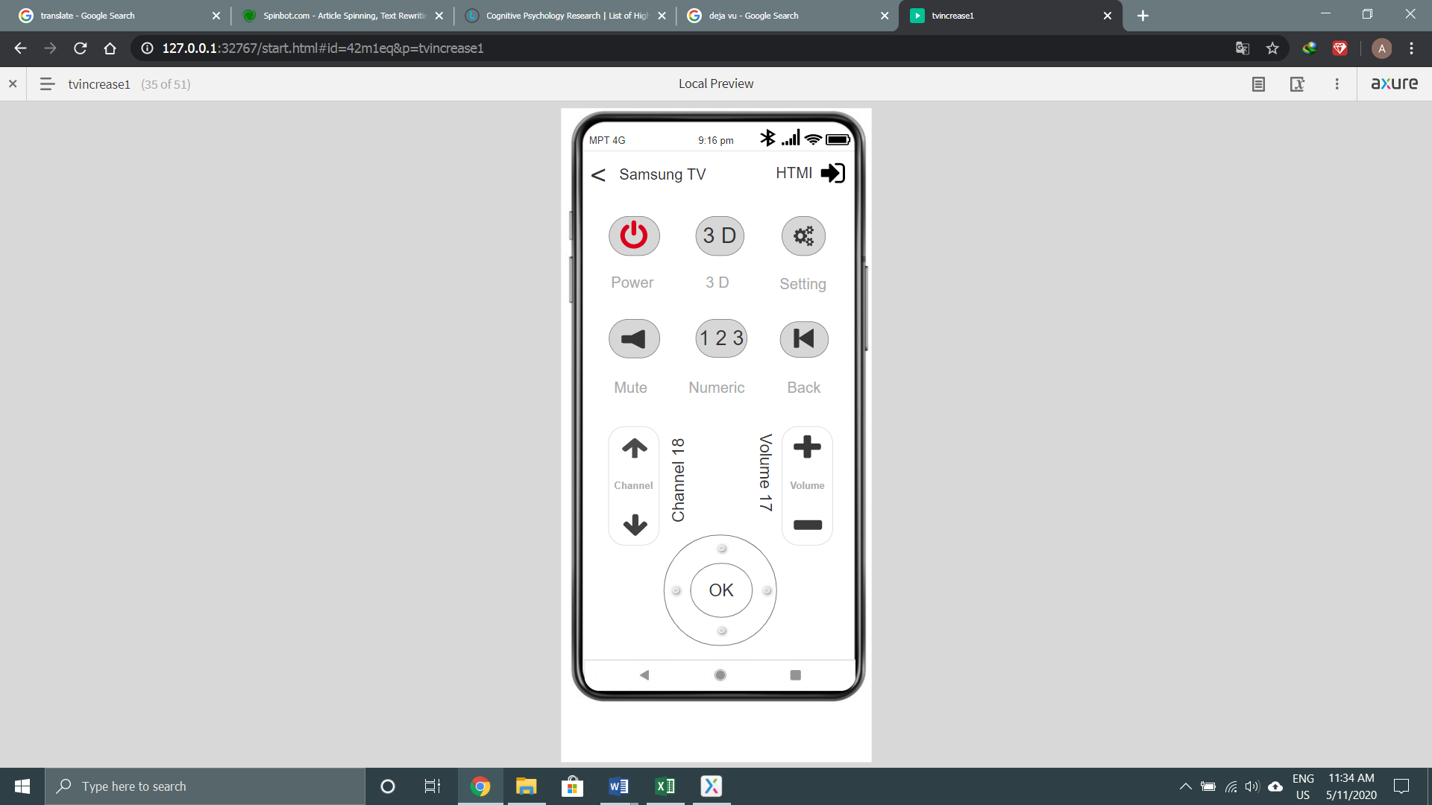

Figure (5.35)

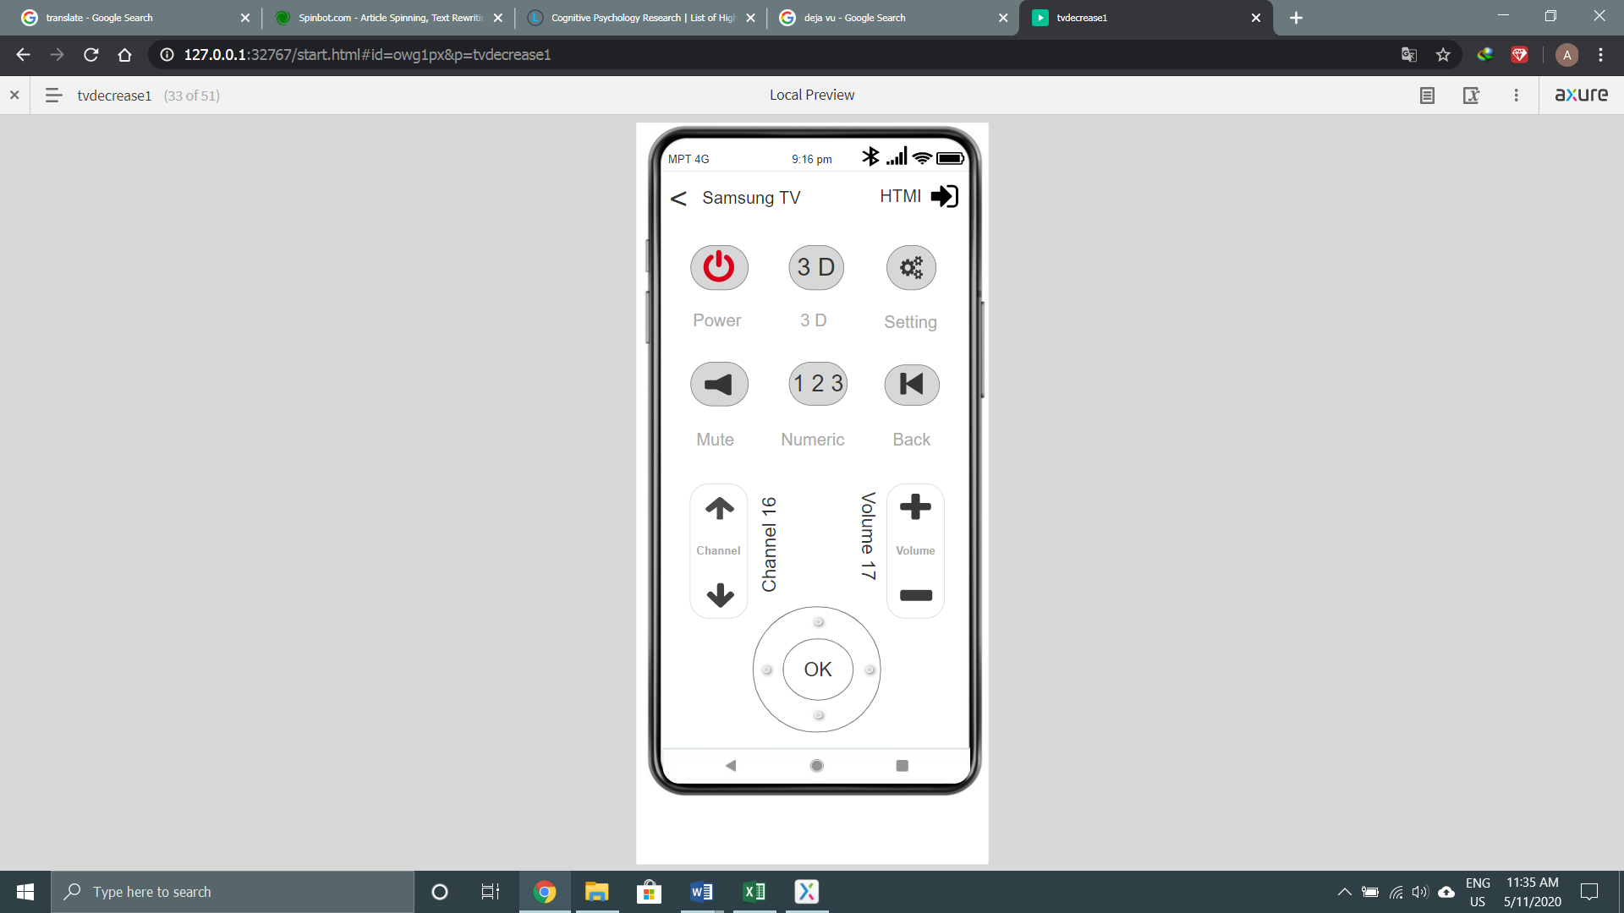

Figure (5.36)

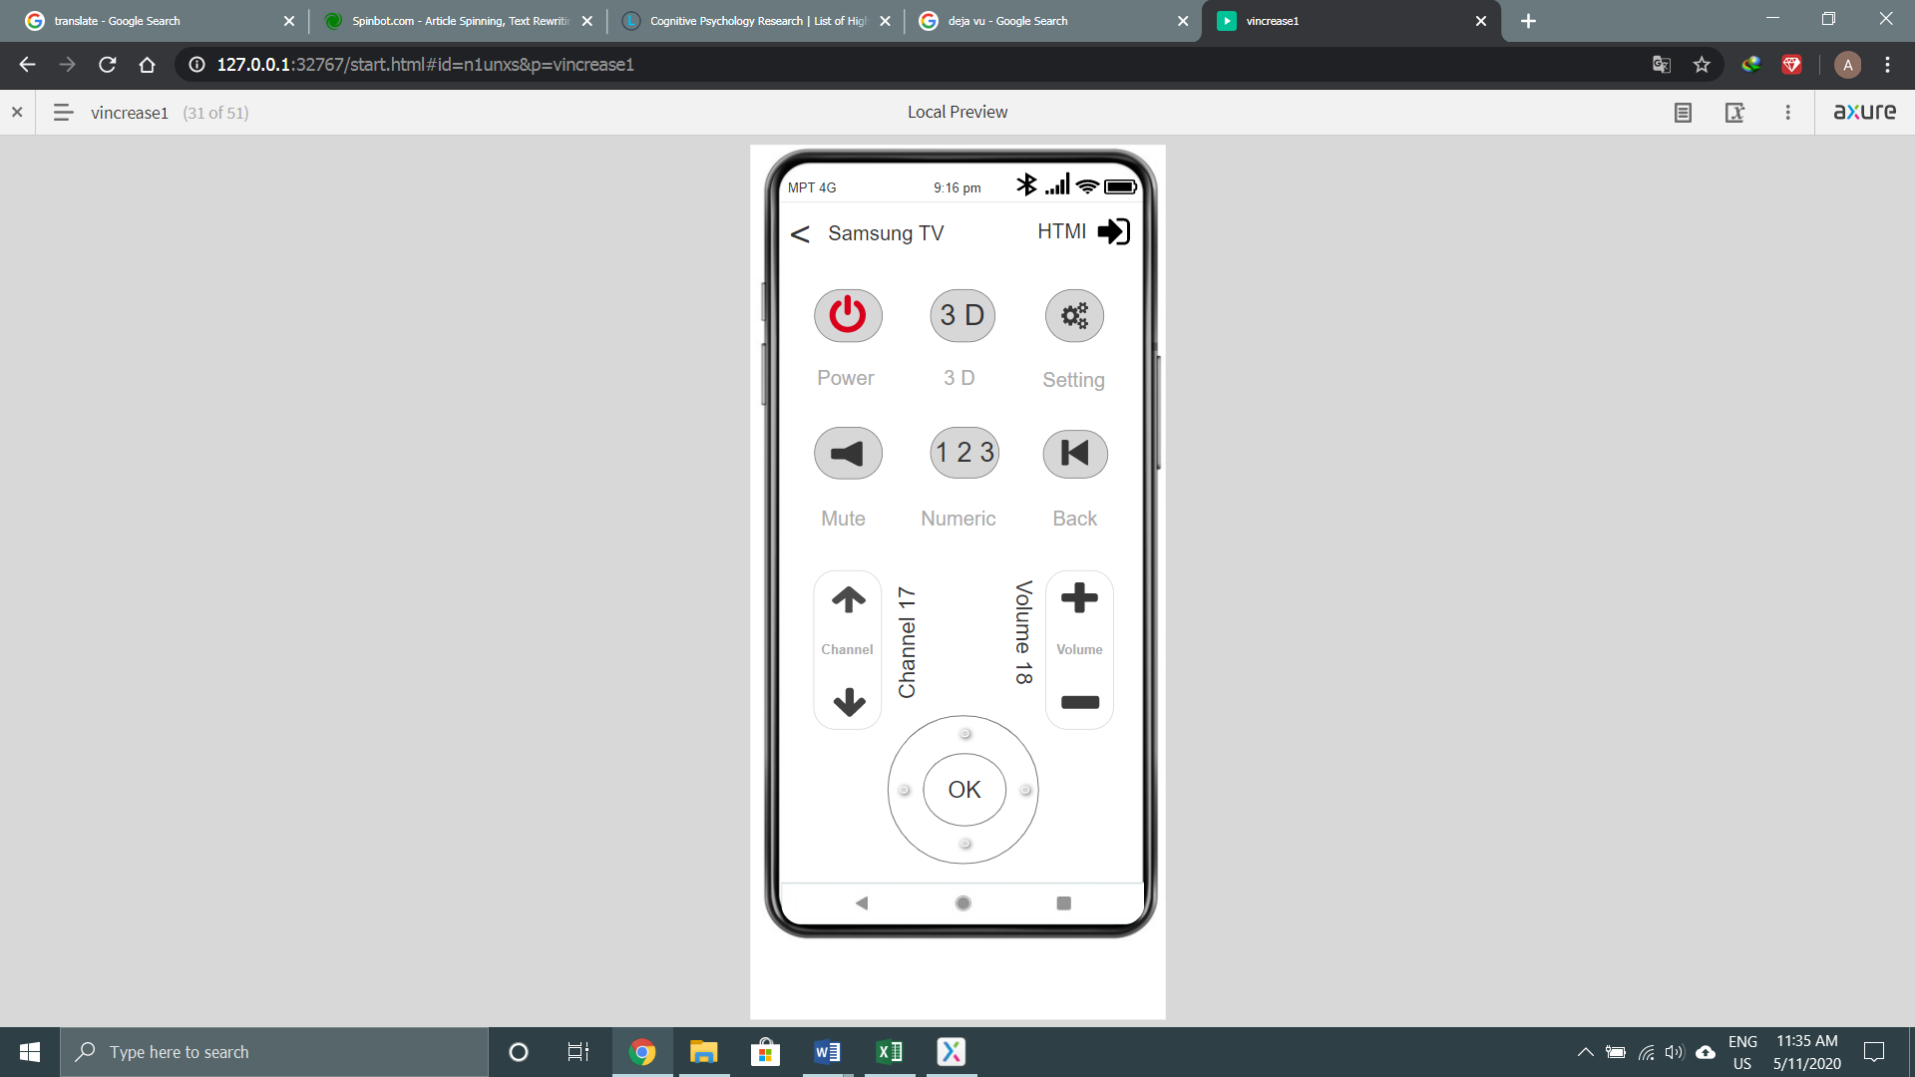

Figure (5.37)

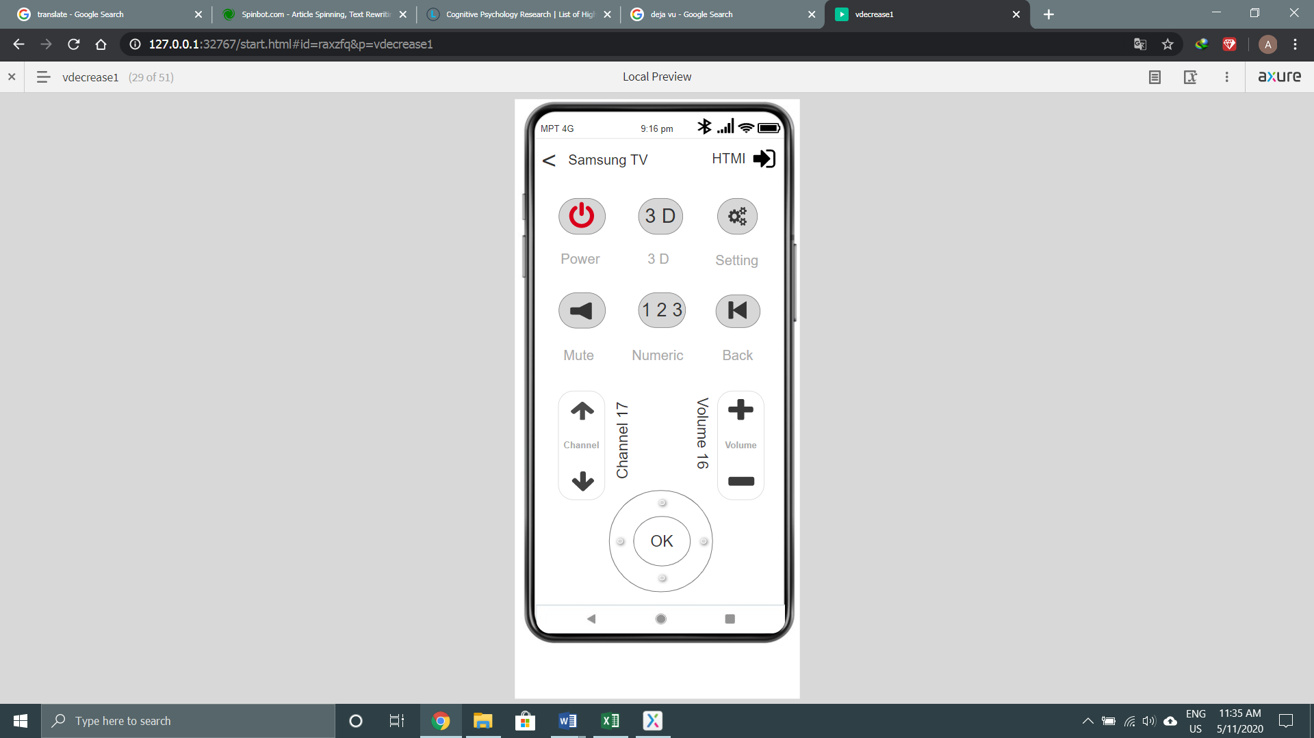

Figure (5.38)

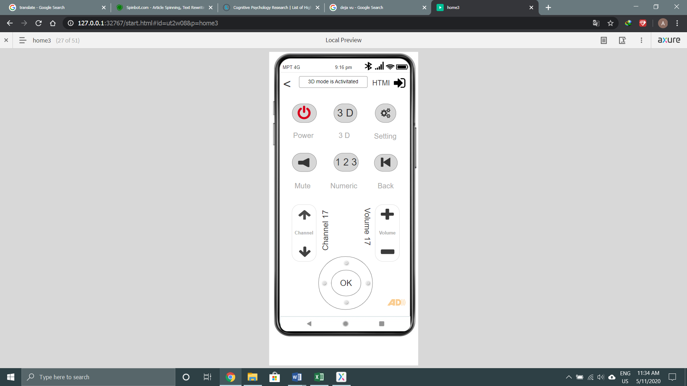

Figure (5.39)

When user press the 3D button, it will activate the 3D mode. The change is shown in the above figure.

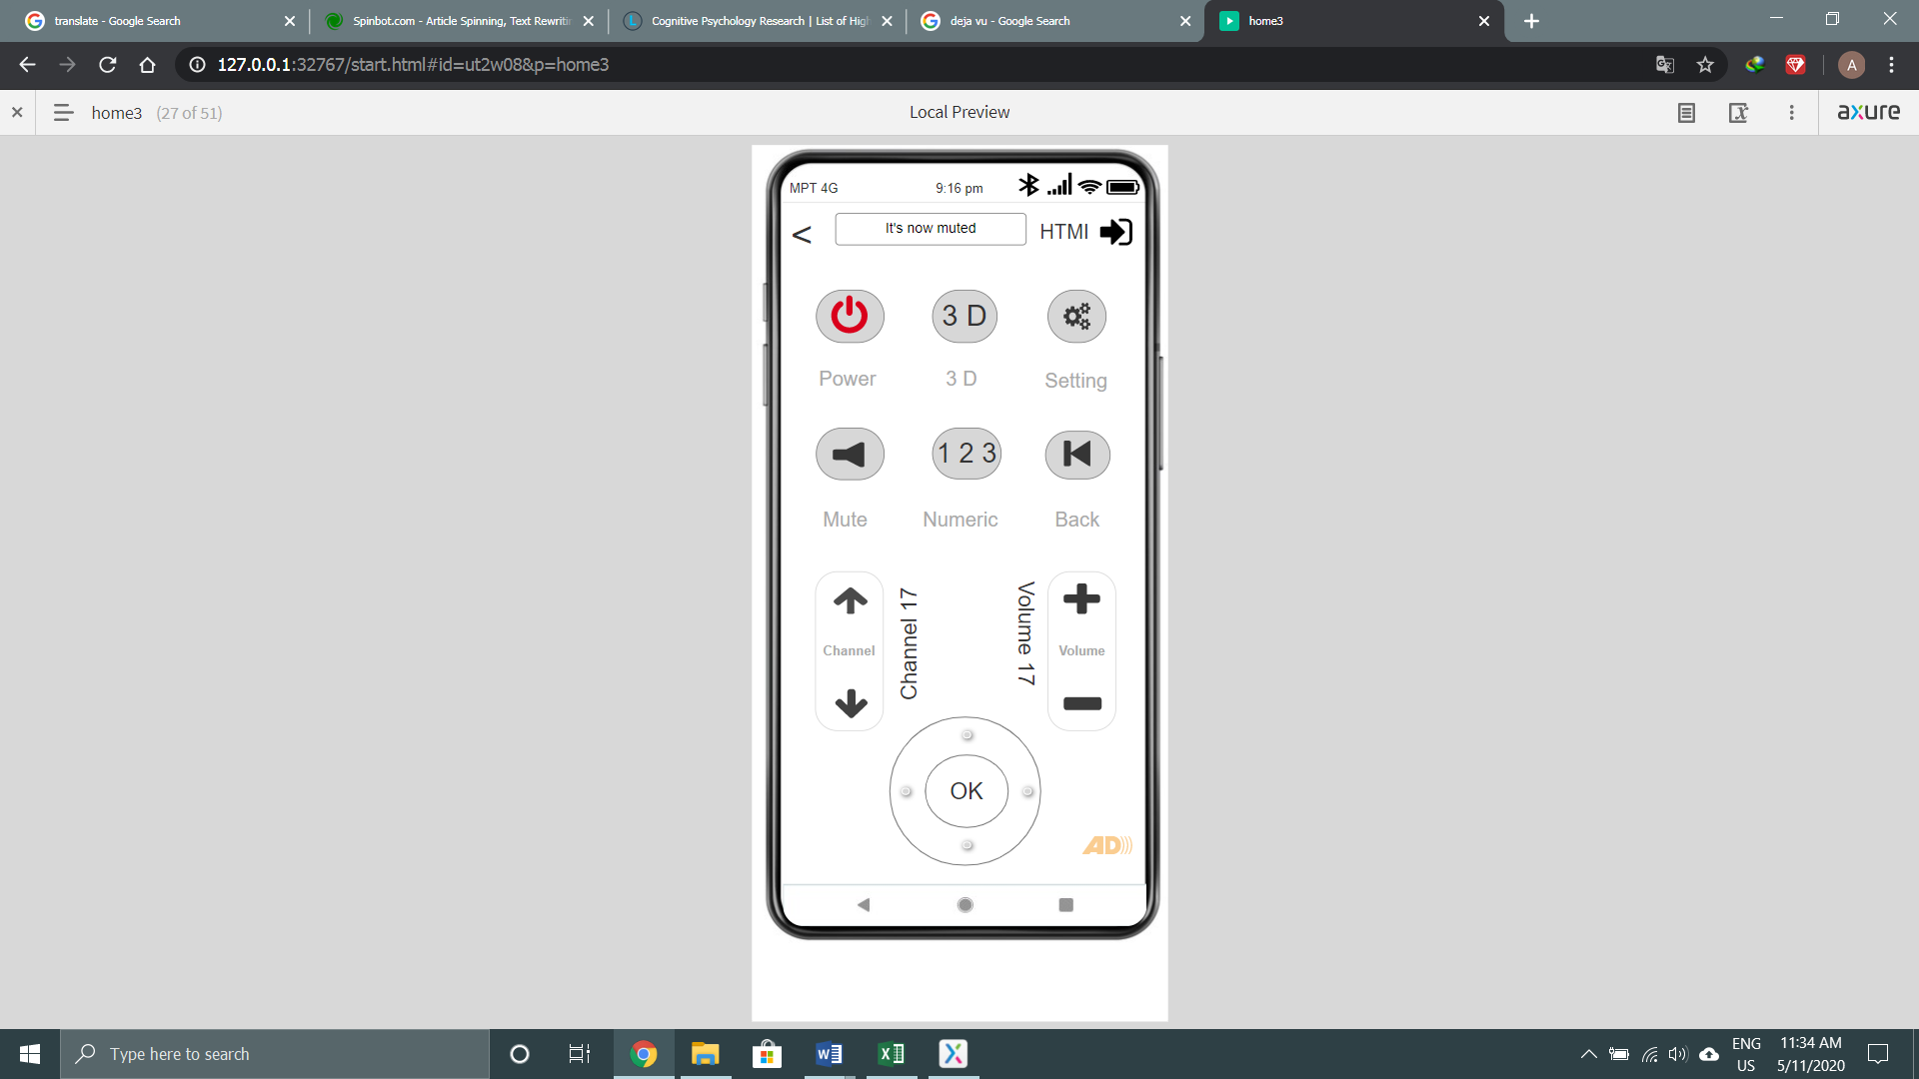

Figure (5.40)

When user press the mute, it will mute the sound system. The change is shown in the above figure.

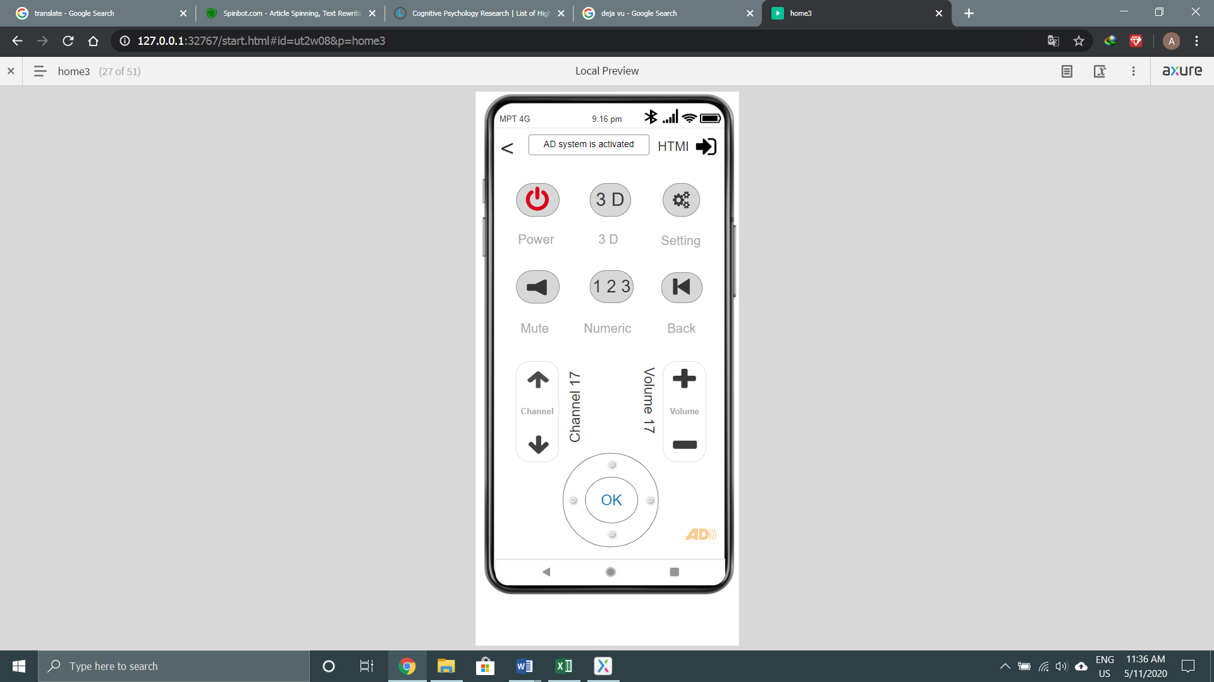

Figure (5.41)

When user press the AD, it will activate the AD mode. The change is shown in the above figure.

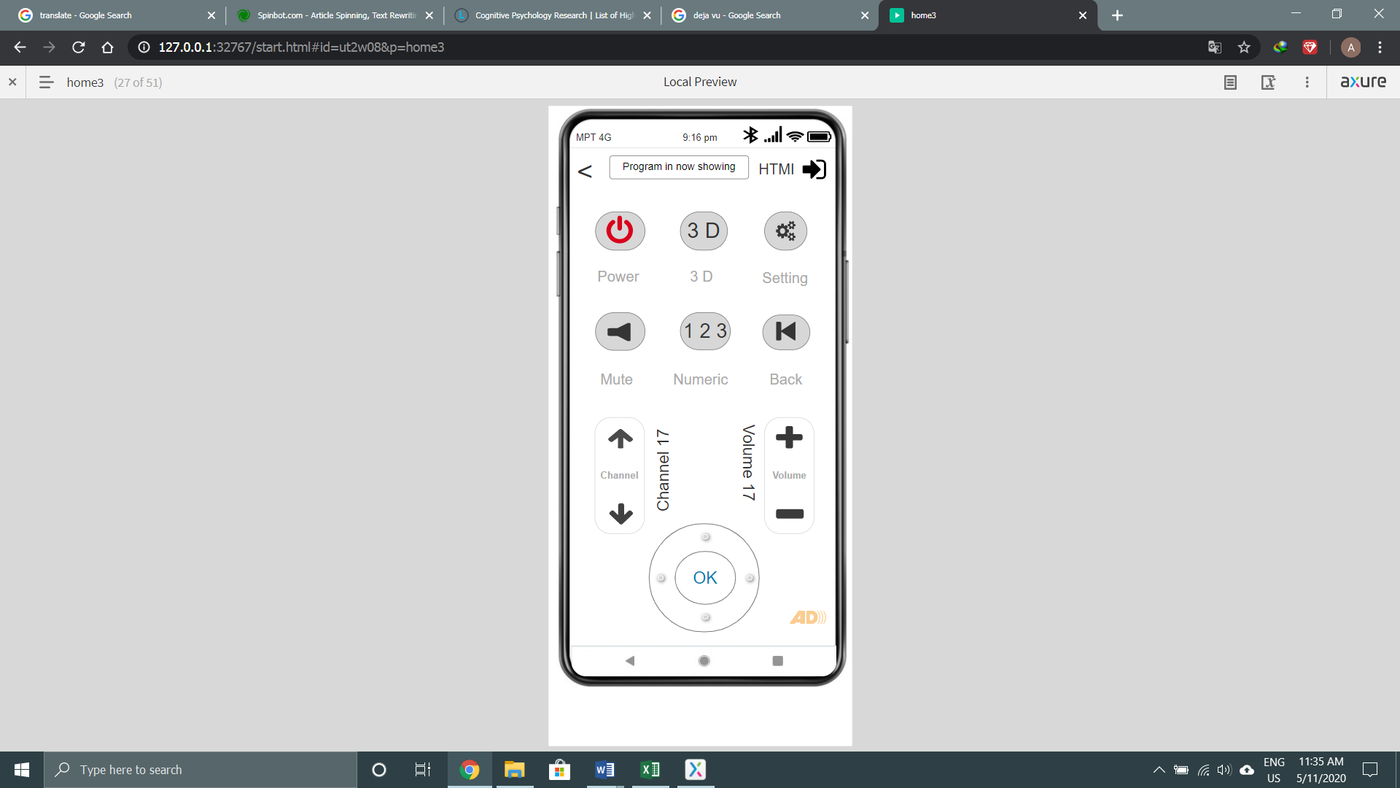

Figure (5.42)

When user press the ok button, it will run by the channel that user choose. The change is shown in the above figure.

These are the responsive form of the app desiplayin in the tablet mode. The description are already as shown in the mobile.

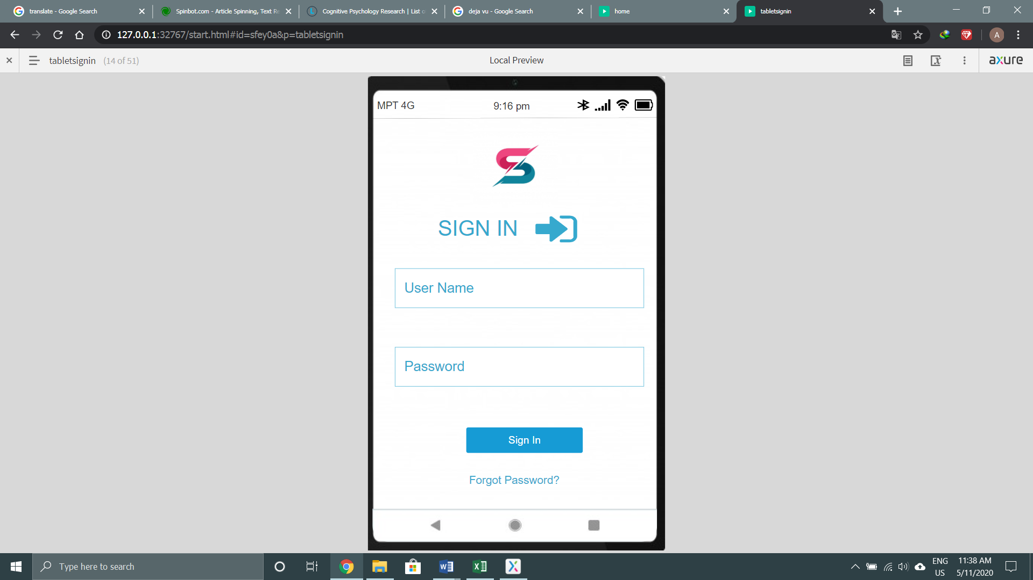

Figure (5.43)

The description is as same as figure (5.1)

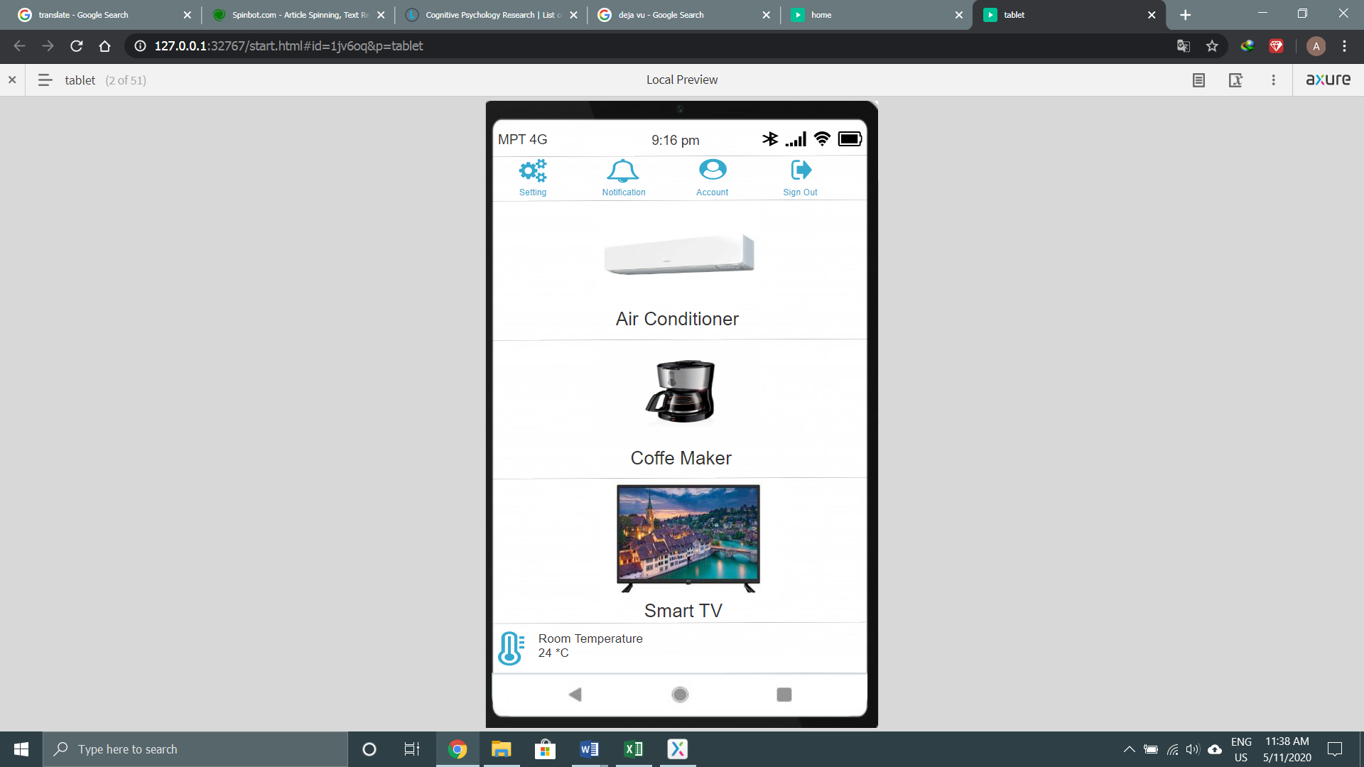

Figure (5.44)

The description is as same as figure (5.1)

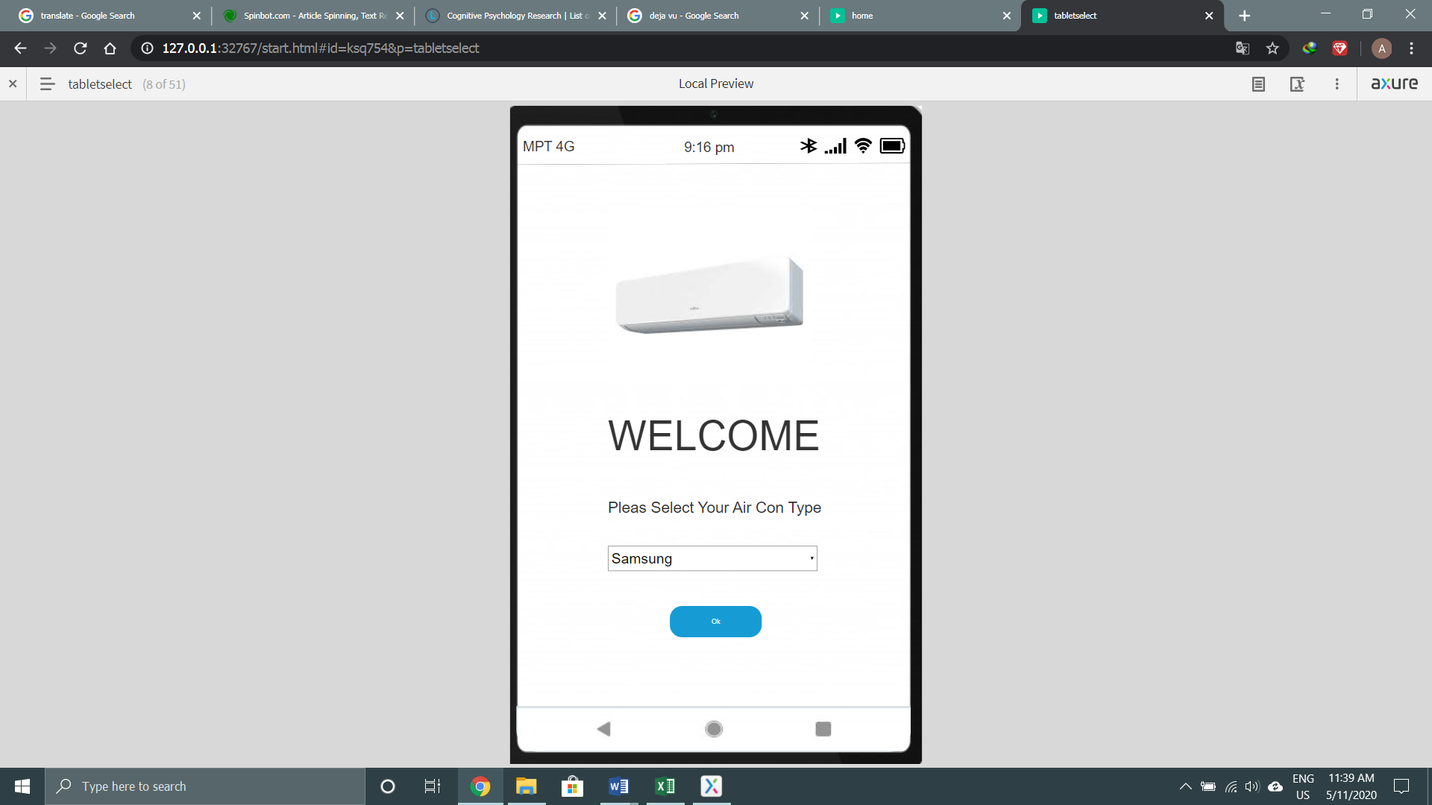

Figure (5.45)

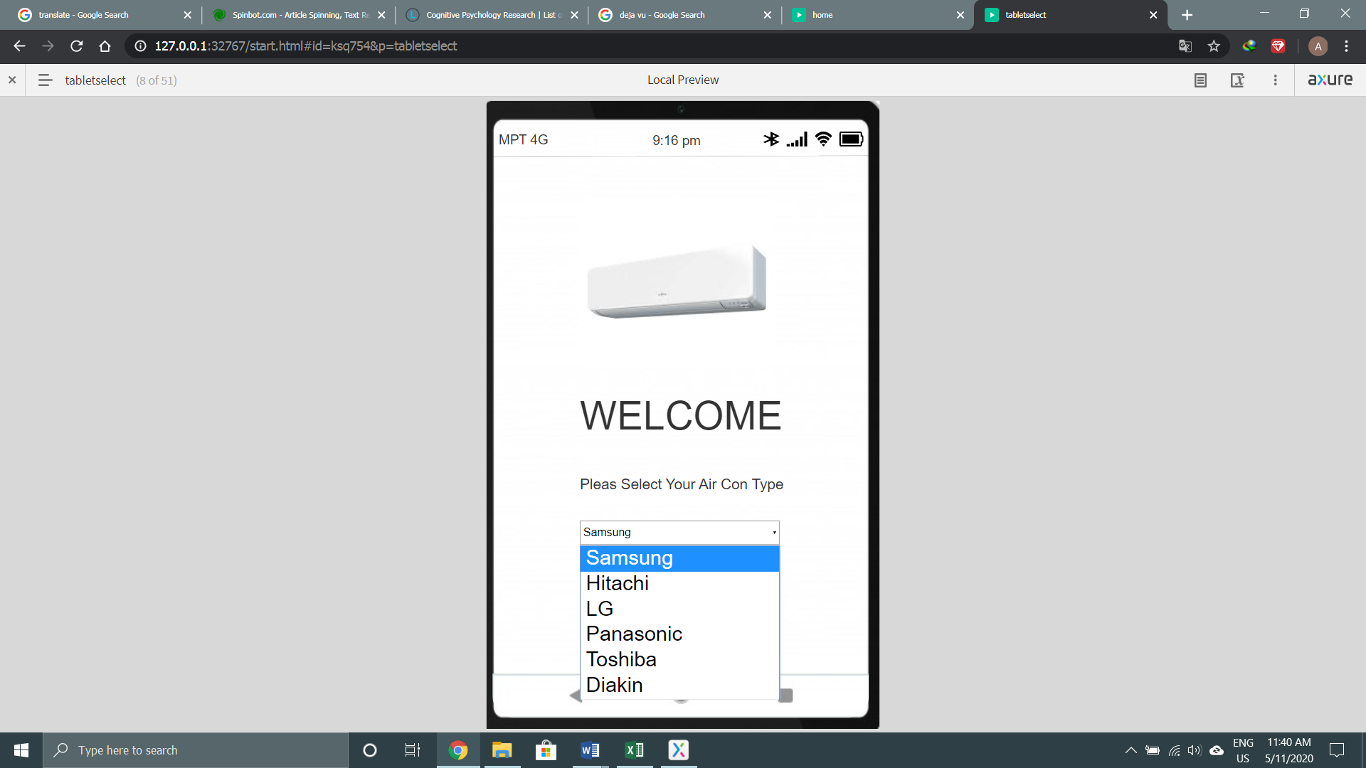

Figure (5.46)

The description is as same as figure (5.5)

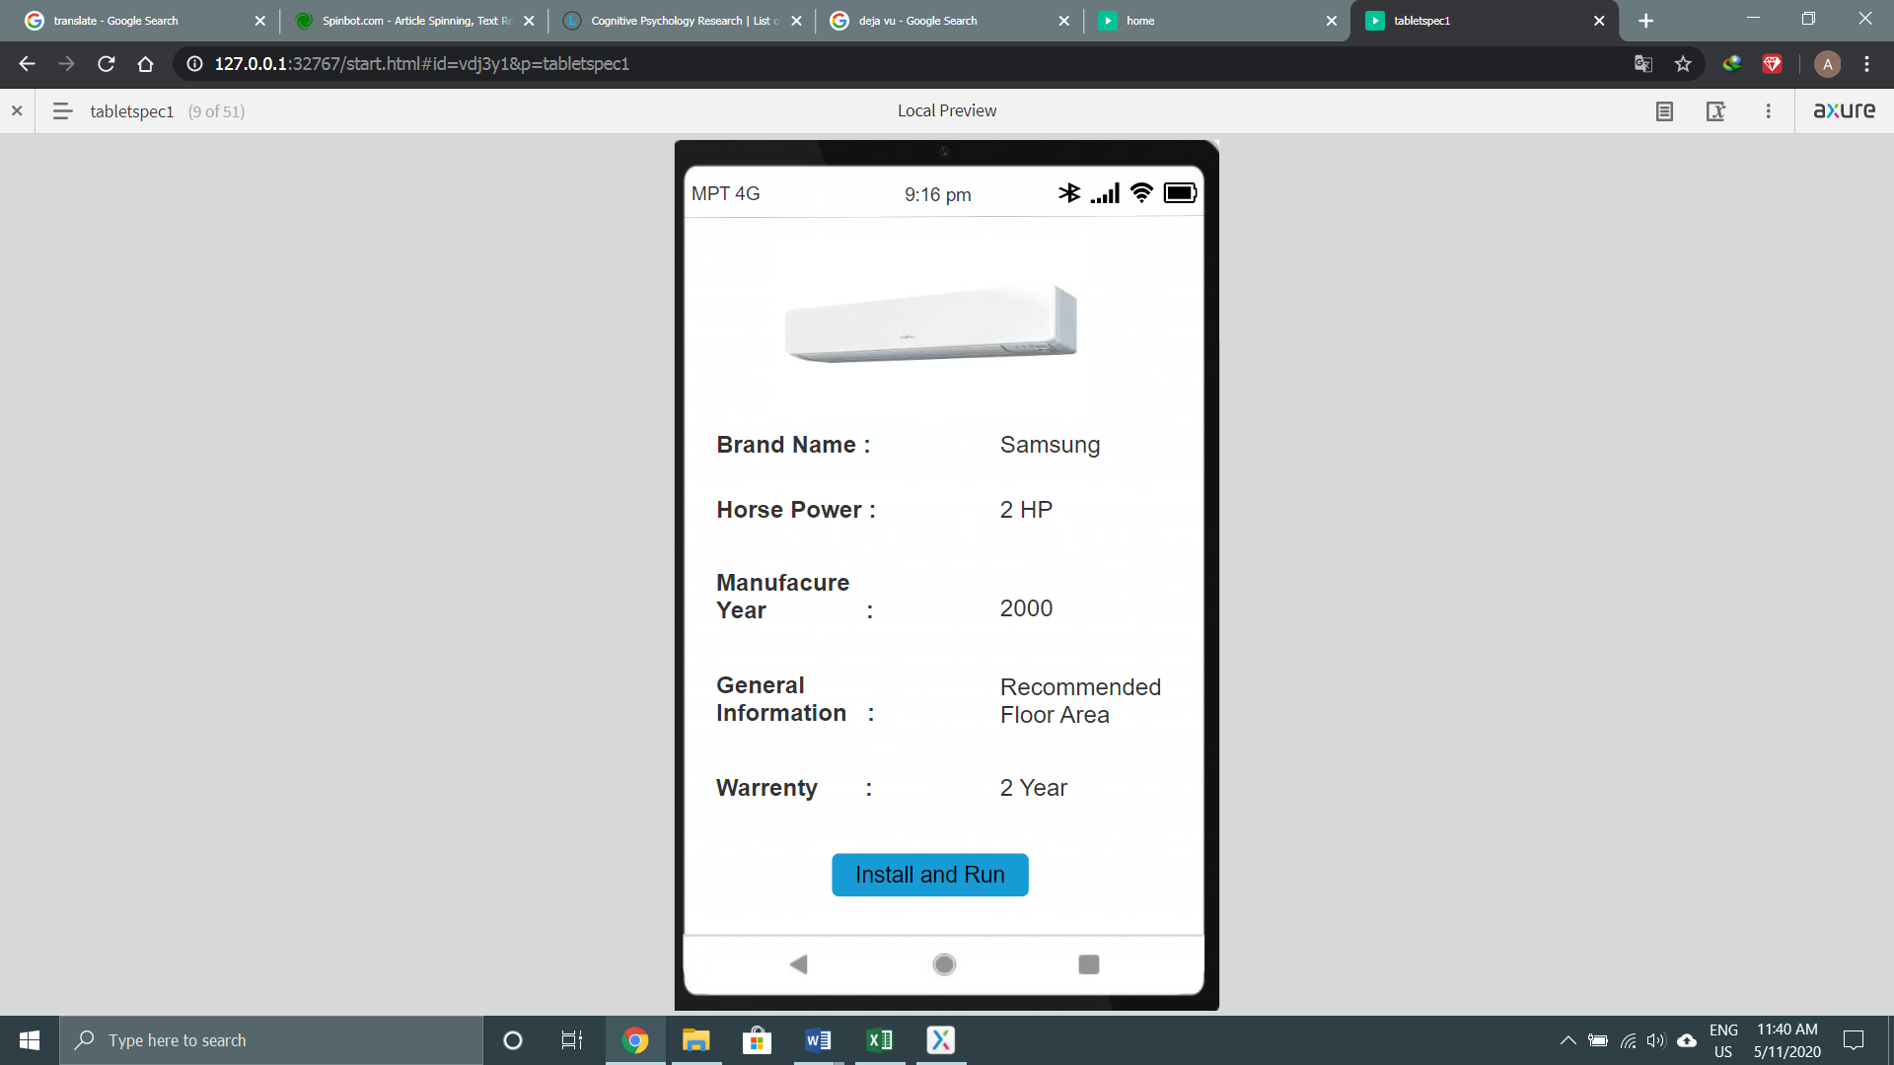

Figure (5.47)

The description is as same as figure (5.6)

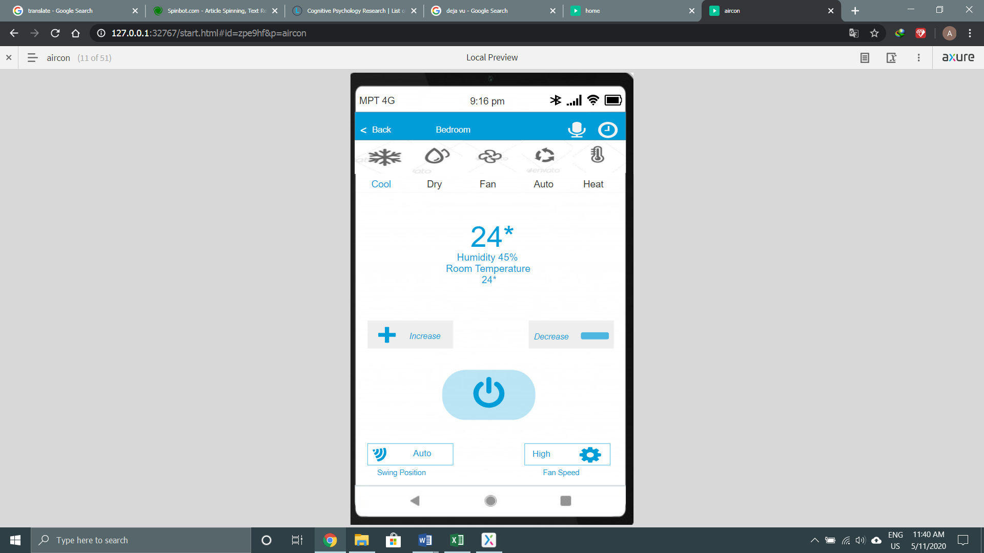

Figure (5.48)

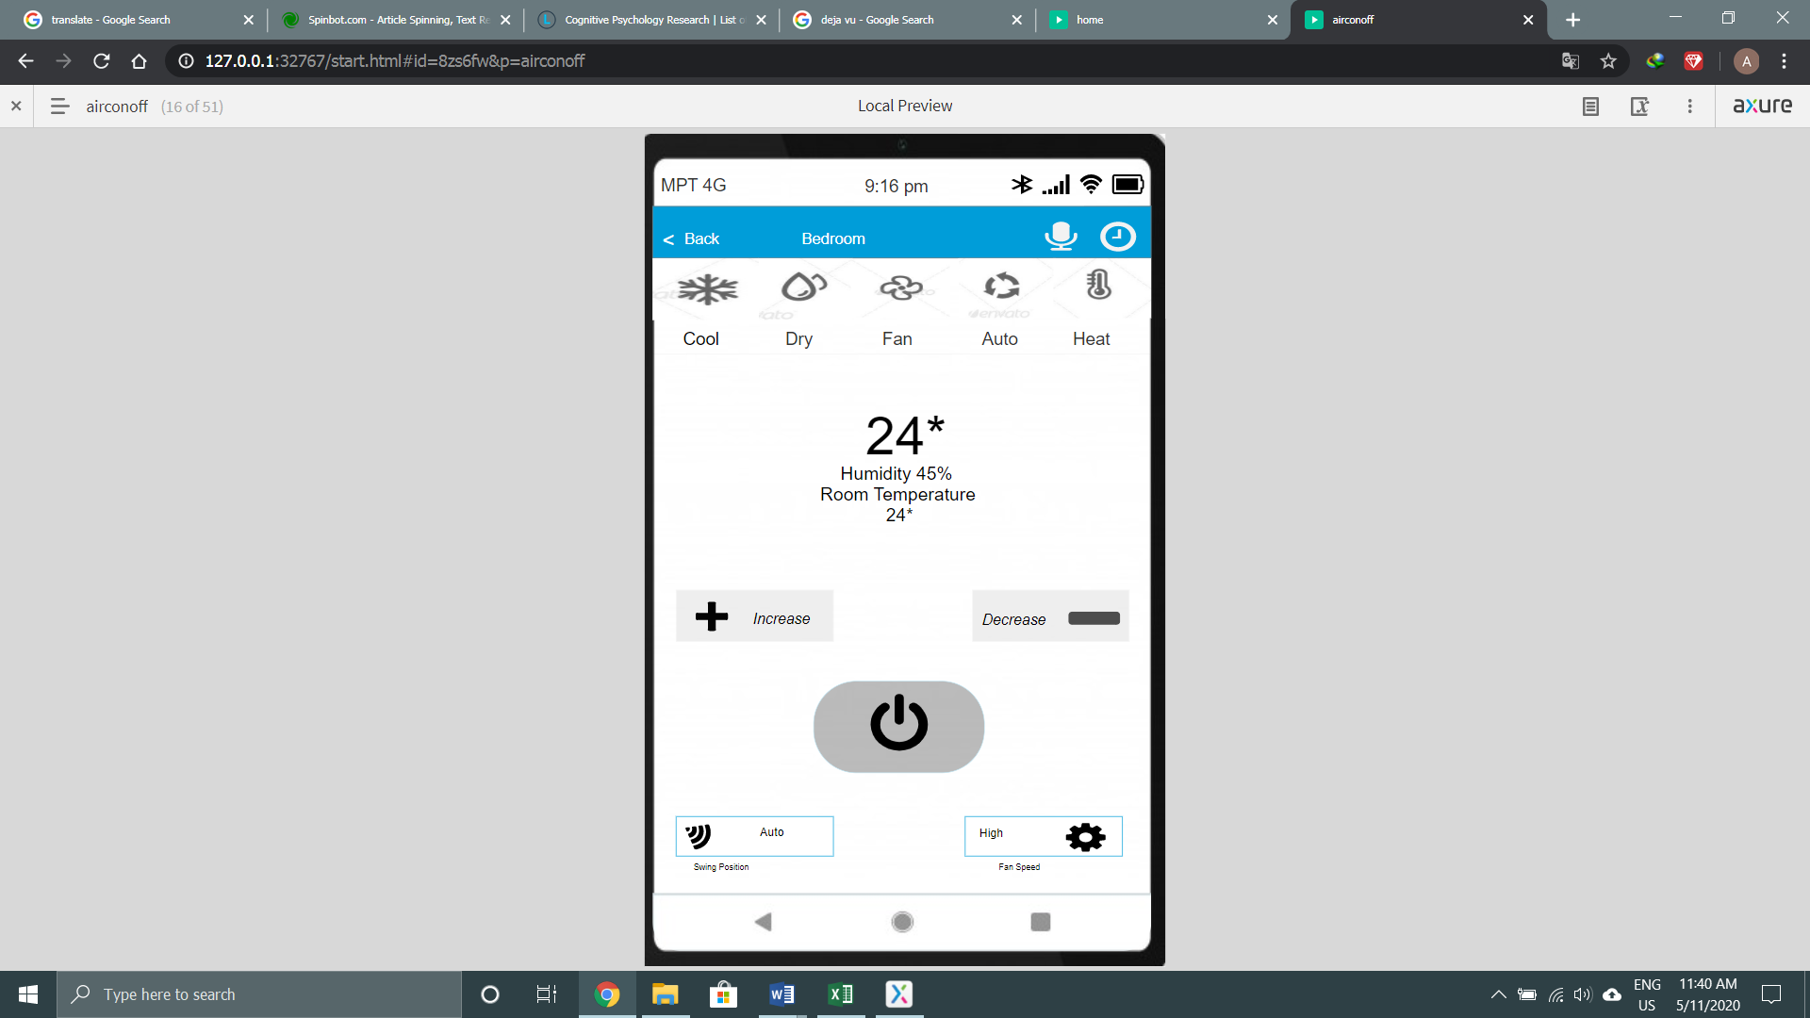

Figure (5.49)

The description is as same as figure (5.11)

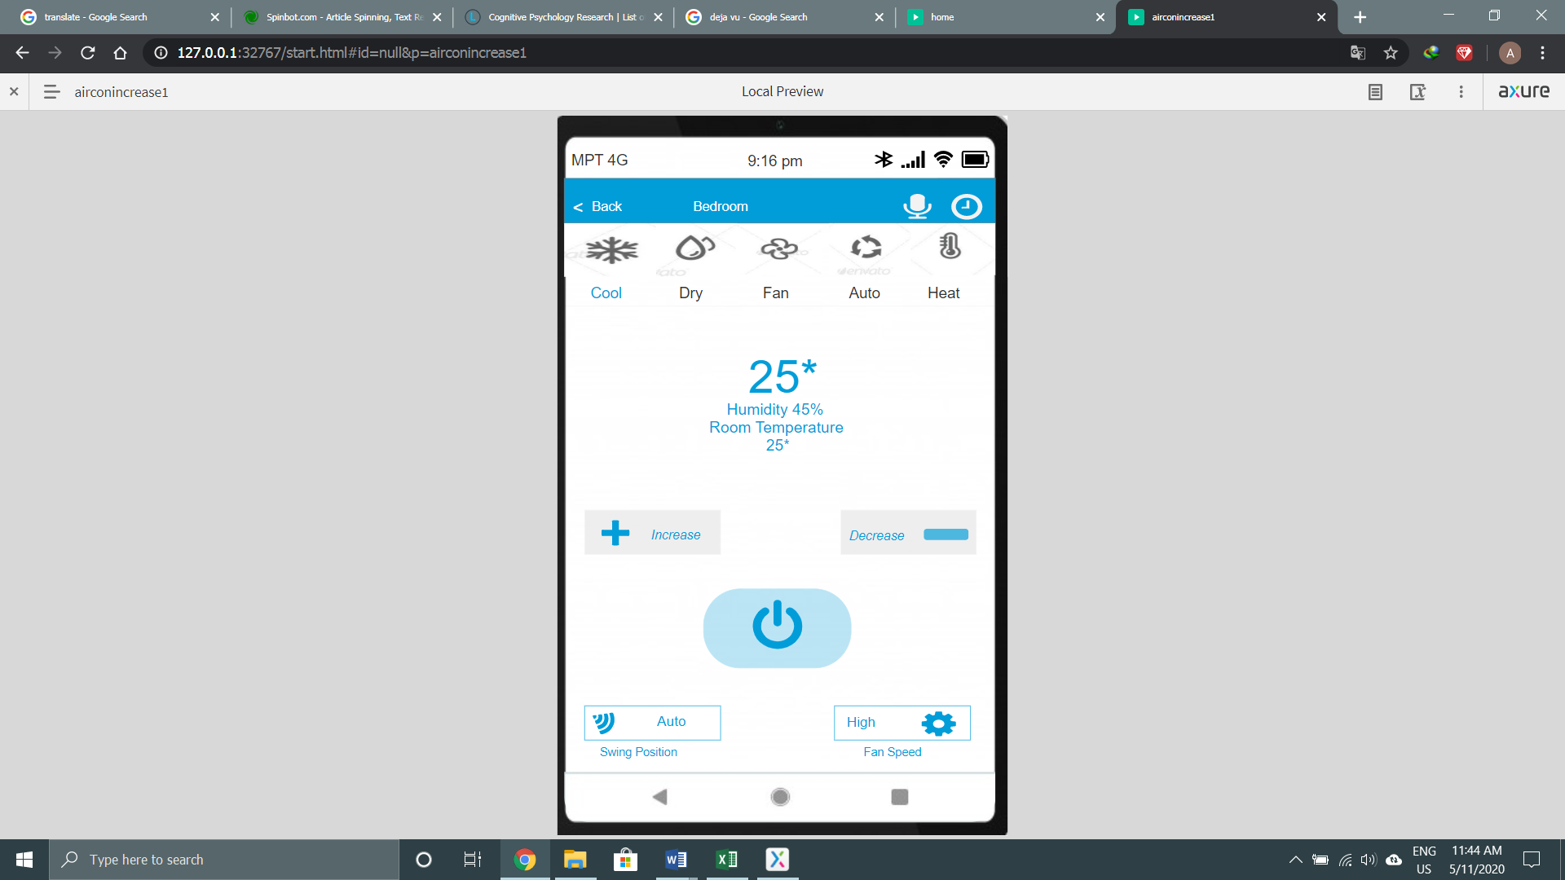

Figure (5.50)

The description is as same as figure (5.9)

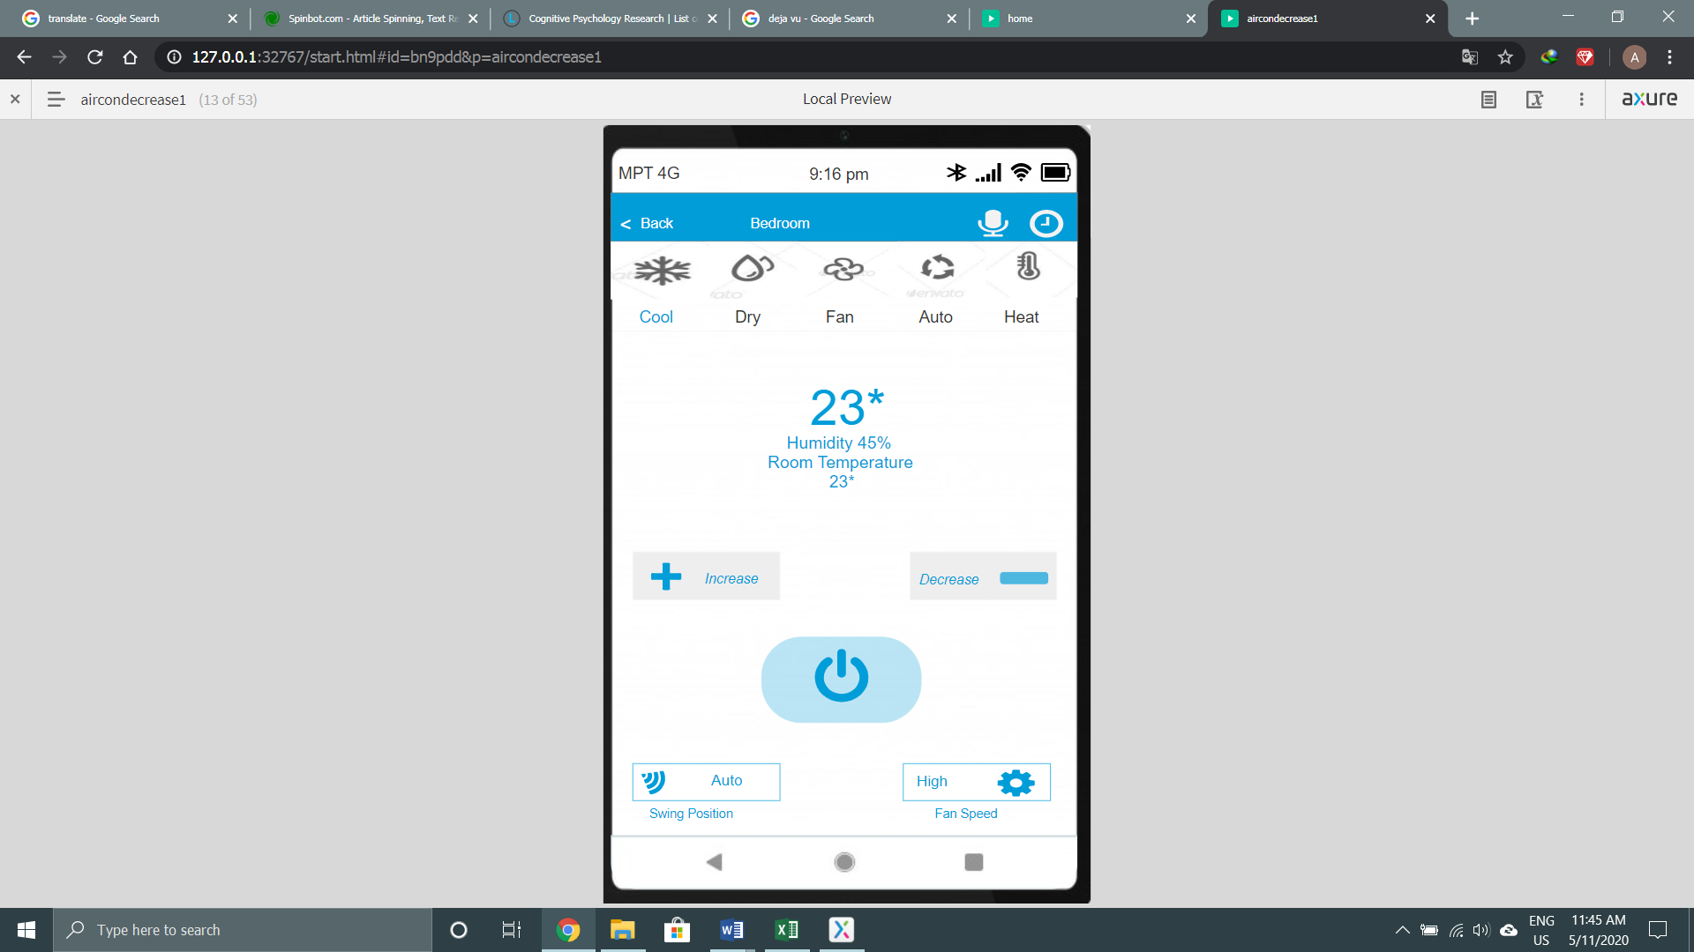

Figure (5.51)

The description is as same as figure (5.10)



Figure (5.52)

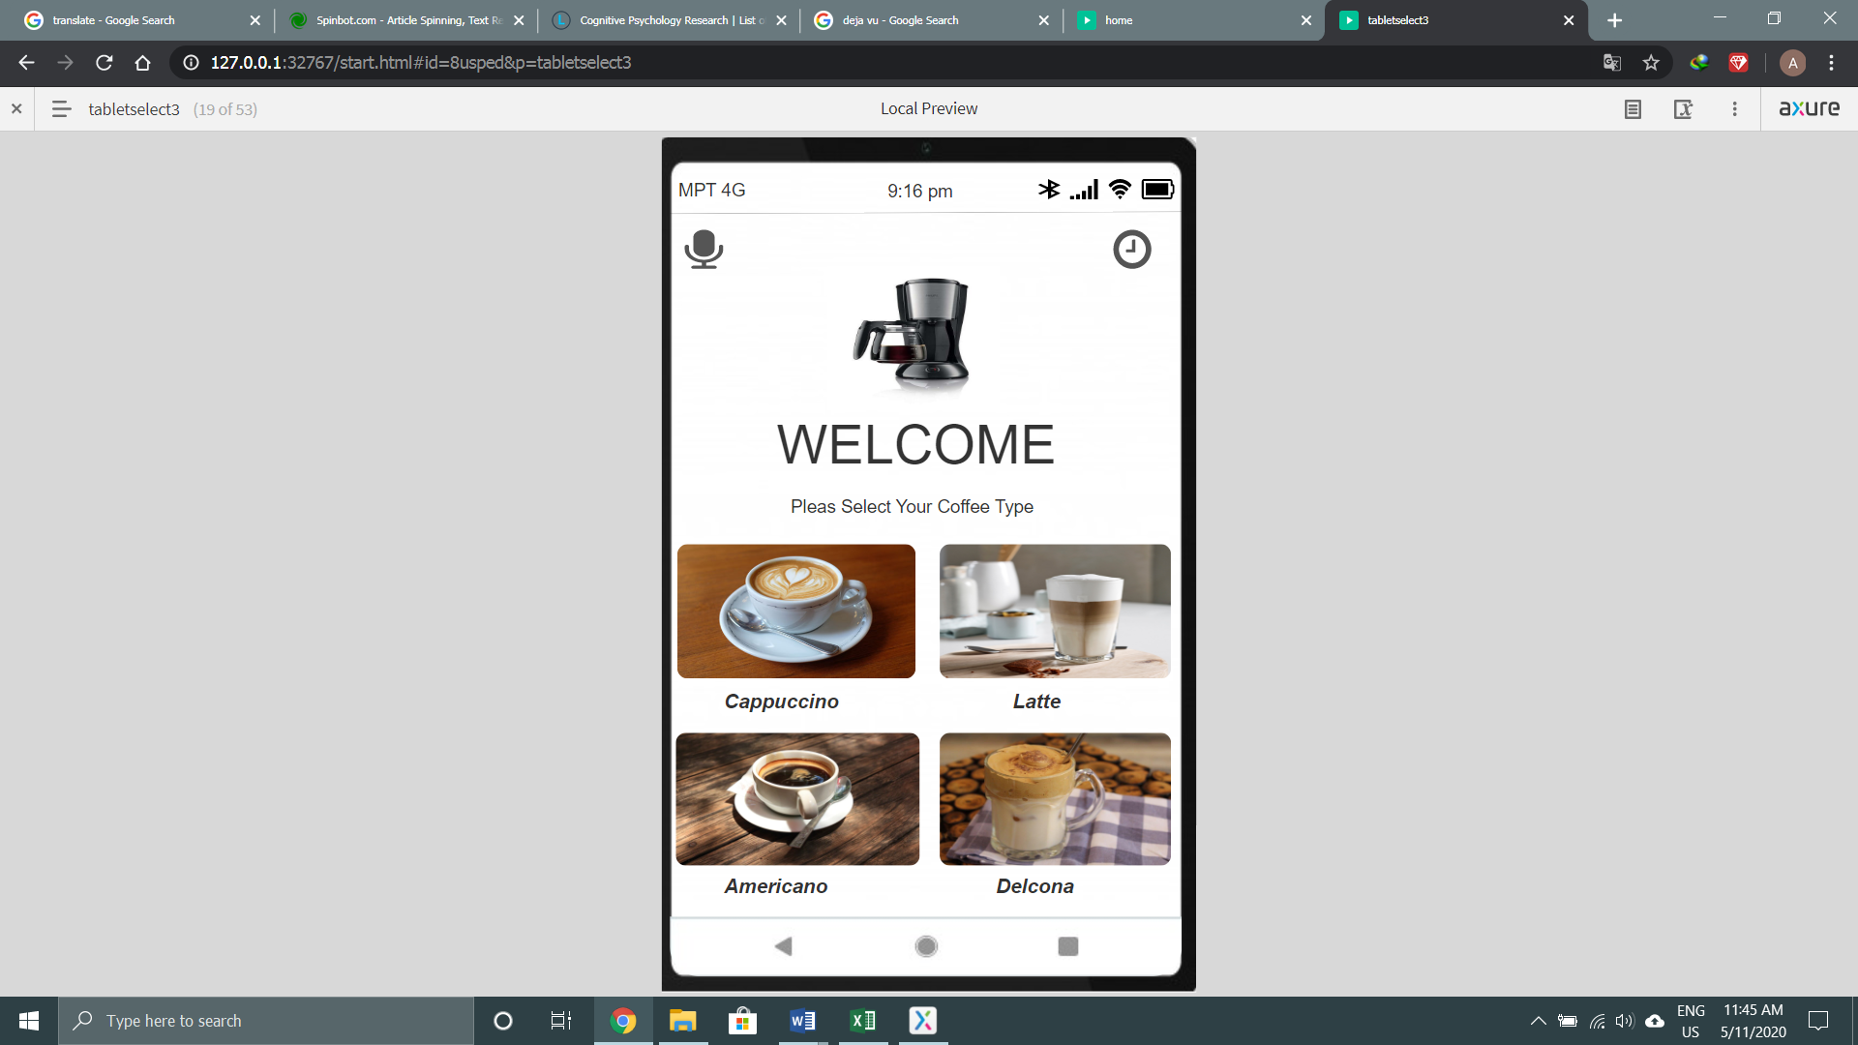

Figure (5.53)

The description is as same as figure (5.17)

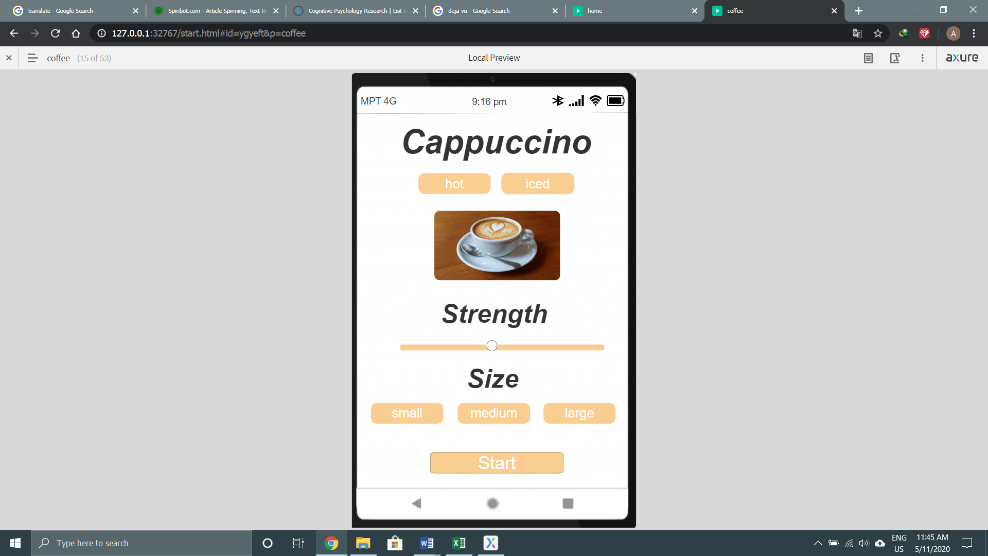

Figure (5.54)

The description is as same as figure (5.22)

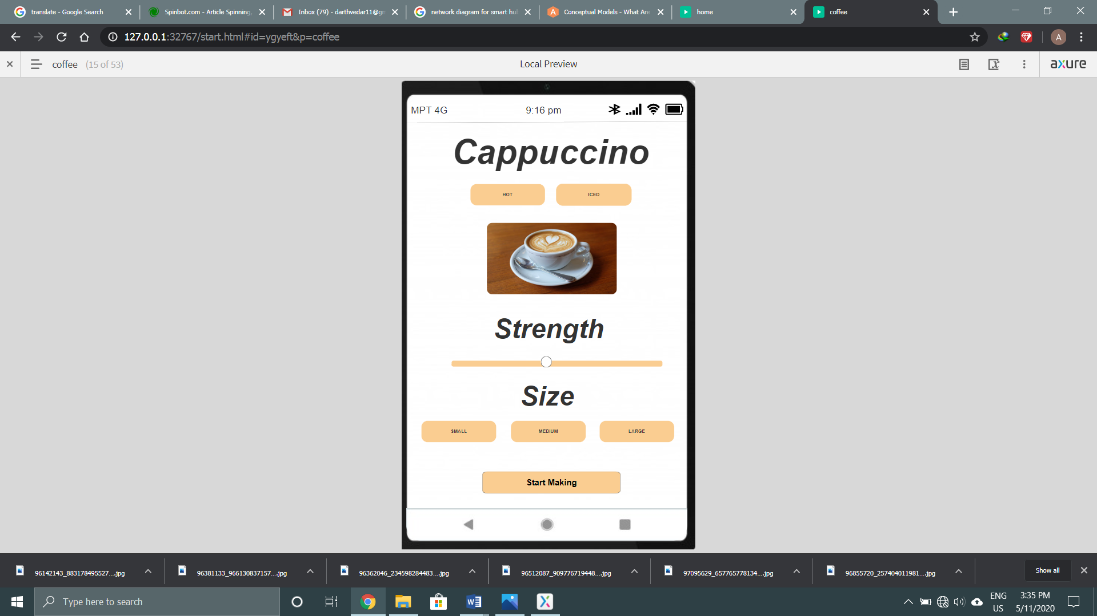

Figure (5.55)

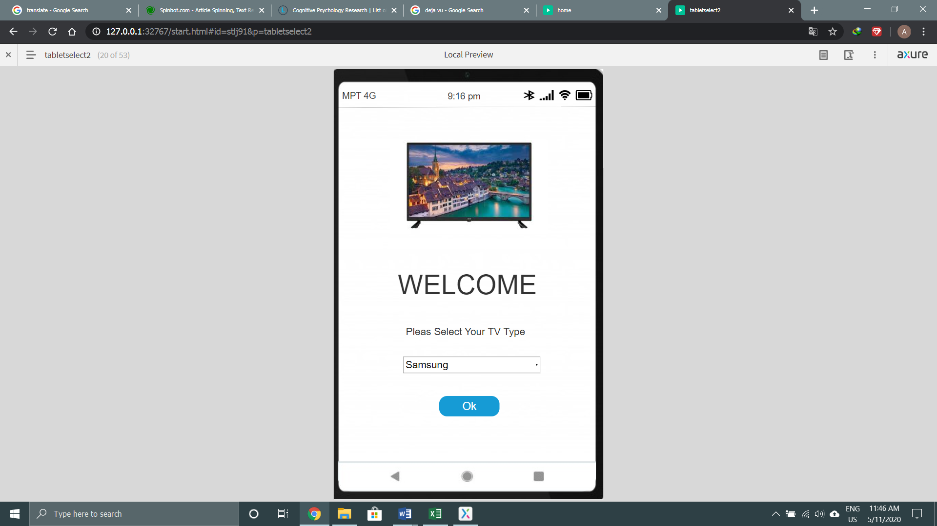

Figure (5.56)

The description is as same as figure (5.30)

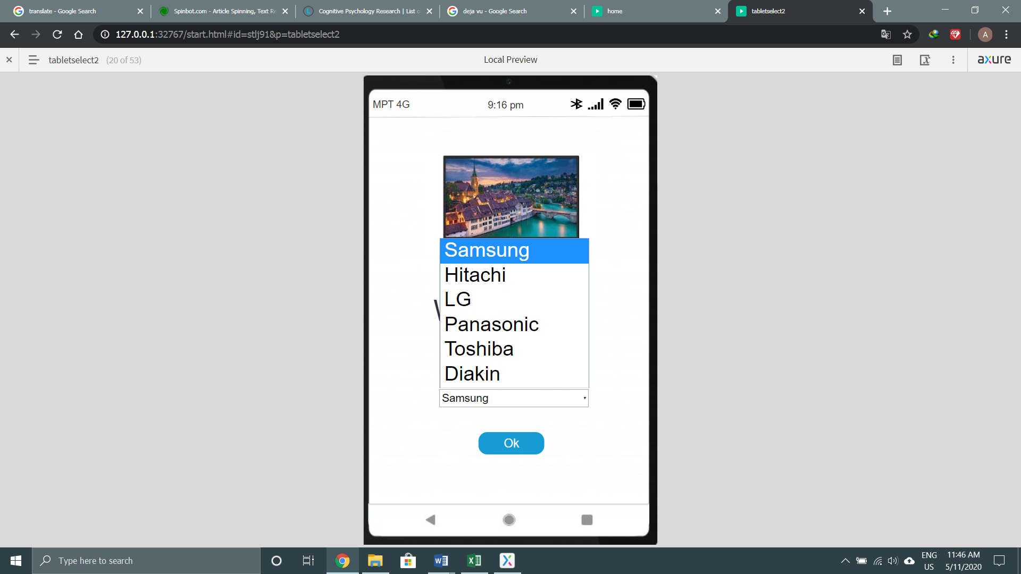

Figure (5.57)

The description is as same as figure (5.31)

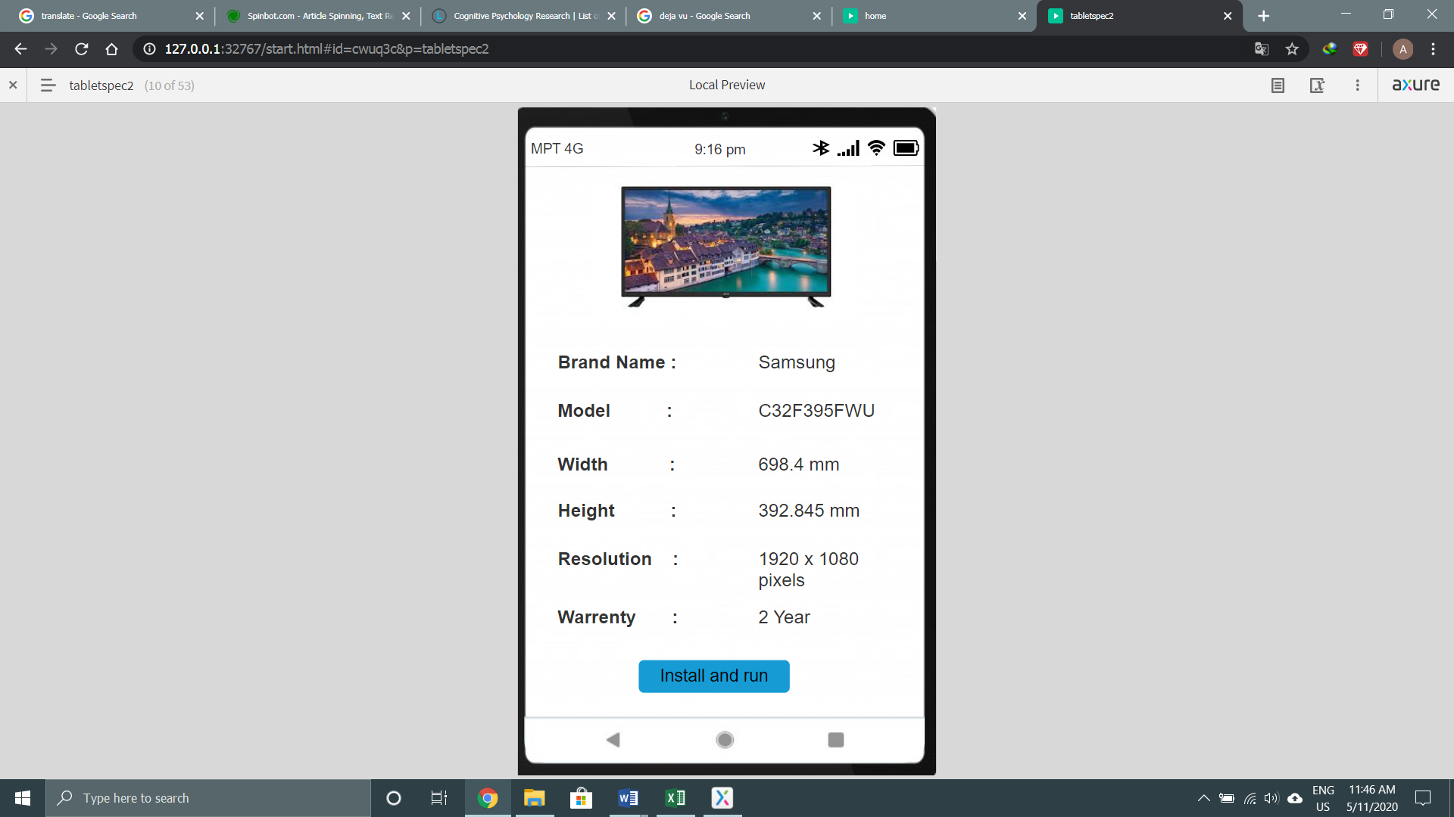

Figure (5.58)

The description is as same as figure (5.32)

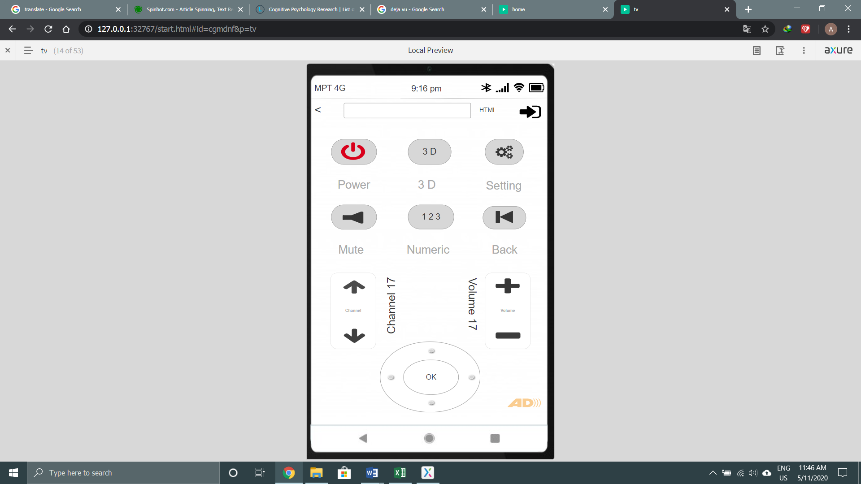

Figure (5.59)

The description is as same as figure (5.33)

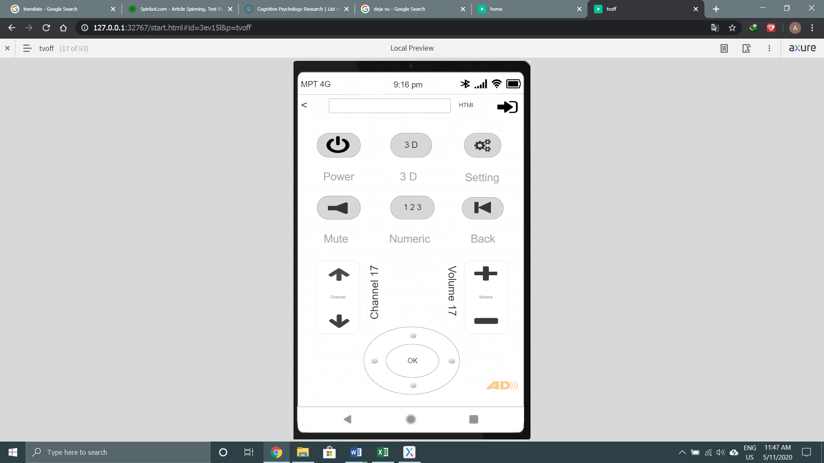

Figure (5.60)

The description is as same as figure (5.34)

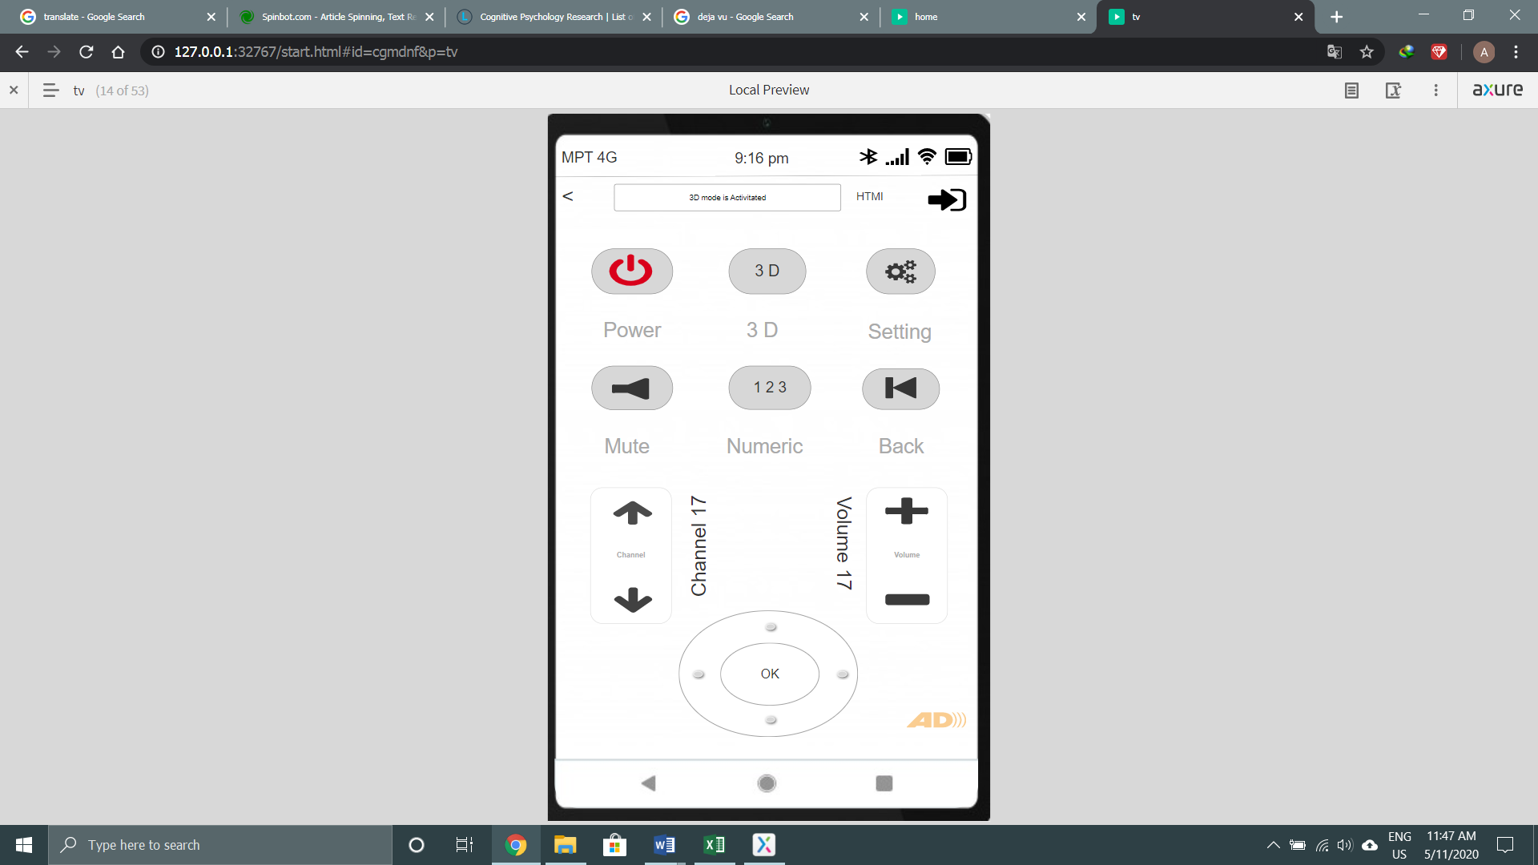

Figure (5.61)

The description is as same as figure (5.39)

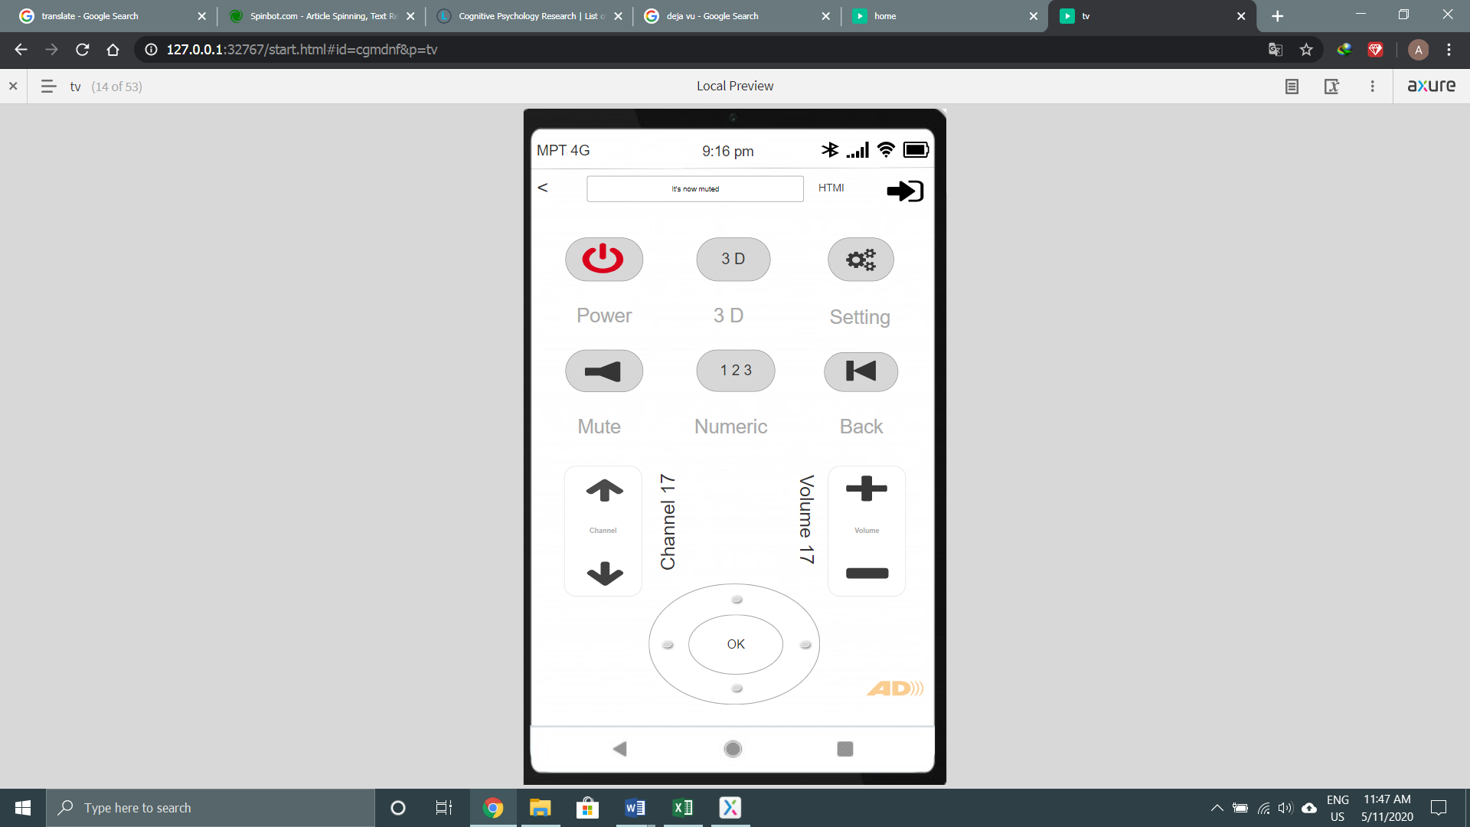

Figure (5.62)

The description is as same as figure (5.40)

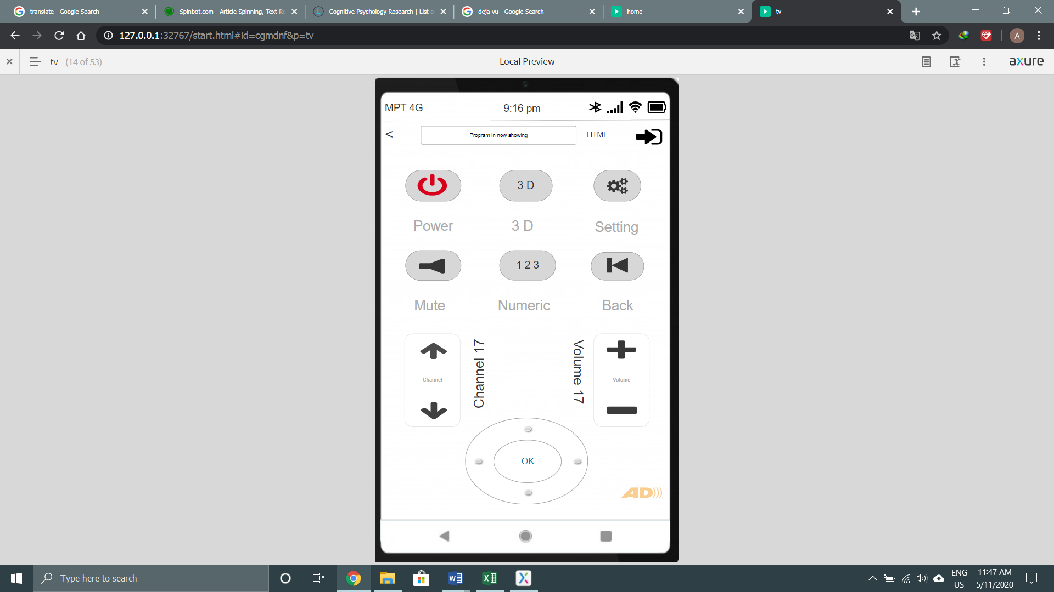

Figure (5.63)

The description is as same as figure (5.42)

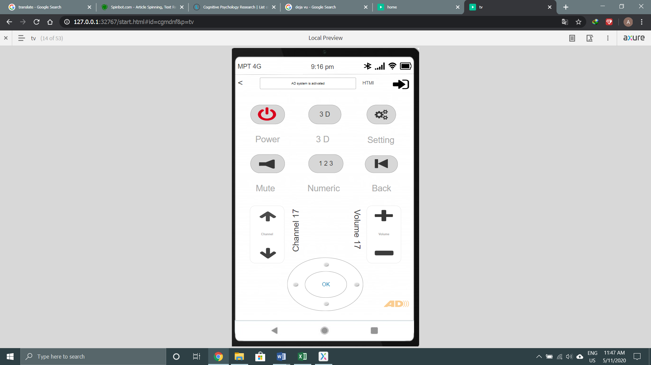

Figure (5.64)

The description is as same as figure (5.41)

# 6. Evaluation

## 6.1 Design Evaluation

### 6.1.1. Visibility of System Status

|  |  |  |
| --- | --- | --- |
| Air Con | Coffee Maker | TV |
| Figure (6.1) | Figure (6.2) | Figure (6.3) |
|  |  |  |

### 6.1.2. Match between system and the real world

|  |  |  |
| --- | --- | --- |
| Air Con | Coffee Maker | TV |
| Figure (6.4) | Figure (6.5) | Figure (6.6) |
|  |  |  |

### 6.1.3. User Control and freedom

|  |  |  |
| --- | --- | --- |
| Air Con | Coffee Maker | TV |
| Figure (6.7) | Figure (6.8) | Figure (6.9) |
|  |  |  |

### 6.1.4. Consistency and Standards

|  |  |  |
| --- | --- | --- |
| Air Con | Coffee Maker | TV |
| Figure (6.10) | Figure (6.11) | Figure (6.12) |
|  |  |  |

### 6.1.5. Help and documentation

|  |  |  |
| --- | --- | --- |
| Air Con | Coffee Maker | TV |
| Figure (6.13) | Figure (6.14) | Figure (6.15) |
|  |  |  |

## 6.2 Cognitive Walkthrough

**Users:** Grandma who is not familiar with era of smart hub

**Task:** Using voice command

**Correct action sequence:** Find the icon that looks like the microphone

Then long press the logo long with the finger

And say word

**Question asked in the walkthrough:** Will she able to find the Logo?

Will she understand the steps?

Will she need the tutorial video?

**Finding:** She seem to find to follow the steps and find the logo then press it

**Recommendation:** so, I put the functions where easy to find and use.

**Users:** father who have trouble of reading and understanding

**Task:** Using disability

**Correct action sequence:** go to the setting

Find accessibility

Choose what kind of trouble that you have

**Question asked in the walkthrough:** Does he know how to open setting?

Can he make what he wants?

Will she need the tutorial video?

**Finding:** he finds the setting easily and know what to choose kind of disability help

**Recommendation:** so, I put the accessibility to help the disability

## 6.3 Personal Evaluation

In final, I managed to learn lots of knowledge and experiment. Among those, the most useable is the Jakob Nielsen design principles and android design principle. I used those principles to develop the design of my prototype. Those principle fit to my design. It can examine my user interface and identify of usability issues. In that way, I was able to design the good interface for the users and make good use of the design. And if I have chance, I would like to study more of the principles. I don’t have much time on the course work. But if I have, I have more functions left to put on the prototype and work for improvement of the design. I want to try dynamic function and real life function for disable person.

# Bibliography

Bill Moggridge, B. V., 1980. *Interaction Design Fooundation.* [Online]   
Available at: https://www.interaction-design.org/literature/topics/user-centered-design  
[Accessed 22 4 2020].

Chen Wai, F. X., 2008. *researchgate.* [Online]   
Available at: https://www.researchgate.net/publication/251980988_The_comparison_of_user-centered_design_and_goal-directed_design  
[Accessed 23 4 2020].

Cherry, K., 2004. *verywellmind.* [Online]   
Available at: https://www.verywellmind.com/cognitive-psychology-4157181  
[Accessed 29 4 2020].

Dalrymple, G., 1999. *gcdtech.* [Online]   
Available at: https://gcdtech.com/blog/goal-directed-design/  
[Accessed 23 4 2020].

Gladkiy, S., n.d. *uxplanet.* [Online]   
Available at: https://uxplanet.org/user-centered-design-process-and-benefits-fd9e431eb5a9  
[Accessed 22 4 2020].

Google, 2005. *developer.* [Online]   
Available at: https://developer.android.com/design  
[Accessed 25 4 2020].

Ireland, I. N., 2000. *nibusinessinfo.* [Online]   
Available at: https://www.nibusinessinfo.co.uk/content/advantages-user-centred-design  
[Accessed 23 4 2020].

Ireland, I. N., 2000. *nibusinessinfo.* [Online]   
Available at: https://www.nibusinessinfo.co.uk/content/importance-ergonomics  
[Accessed 25 4 2020].

Nielsen, J., 1998. *nngroup.* [Online]   
Available at: https://www.nngroup.com/articles/ten-usability-heuristics/  
[Accessed 27 4 2020].

Nielsen, J., 2008. *uxness.* [Online]   
Available at: http://www.uxness.in/2015/02/10-heuristic-principles-jakob-nielsens.html  
[Accessed 27 4 2020].

Powell-Morse, A., 2010. *airbrake.* [Online]   
Available at: https://airbrake.io/blog/sdlc/conceptual-model  
[Accessed 28 4 4].

RIVA, M. D. L., 2004. *careerfoundry.* [Online]   
Available at: https://careerfoundry.com/en/blog/ui-design/the-importance-of-consistency-in-ui-design/  
[Accessed 26 4 2020].

Vaughn, C., 2001. *granify.* [Online]   
Available at: https://www.granify.com/blog/using-goal-directed-design-process-improve-customer-experience  
[Accessed 23 4 2020].

webfx, 1996. *webfx.* [Online]   
Available at: https://www.webfx.com/web-design/why-responsive-design-important.html  
[Accessed 26 4 2020].

# References

Bill Moggridge, B. V., 1980. *Interaction Design Fooundation.* [Online]   
Available at: https://www.interaction-design.org/literature/topics/user-centered-design  
[Accessed 22 4 2020].

Chen Wai, F. X., 2008. *researchgate.* [Online]   
Available at: https://www.researchgate.net/publication/251980988_The_comparison_of_user-centered_design_and_goal-directed_design  
[Accessed 23 4 2020].

Cherry, K., 2004. *verywellmind.* [Online]   
Available at: https://www.verywellmind.com/cognitive-psychology-4157181  
[Accessed 29 4 2020].

Dalrymple, G., 1999. *gcdtech.* [Online]   
Available at: https://gcdtech.com/blog/goal-directed-design/  
[Accessed 23 4 2020].

Gladkiy, S., n.d. *uxplanet.* [Online]   
Available at: https://uxplanet.org/user-centered-design-process-and-benefits-fd9e431eb5a9  
[Accessed 22 4 2020].

Google, 2005. *developer.* [Online]   
Available at: https://developer.android.com/design  
[Accessed 25 4 2020].

Ireland, I. N., 2000. *nibusinessinfo.* [Online]   
Available at: https://www.nibusinessinfo.co.uk/content/advantages-user-centred-design  
[Accessed 23 4 2020].

Ireland, I. N., 2000. *nibusinessinfo.* [Online]   
Available at: https://www.nibusinessinfo.co.uk/content/importance-ergonomics  
[Accessed 25 4 2020].

Nielsen, J., 1998. *nngroup.* [Online]   
Available at: https://www.nngroup.com/articles/ten-usability-heuristics/  
[Accessed 27 4 2020].

Nielsen, J., 2008. *uxness.* [Online]   
Available at: http://www.uxness.in/2015/02/10-heuristic-principles-jakob-nielsens.html  
[Accessed 27 4 2020].

Powell-Morse, A., 2010. *airbrake.* [Online]   
Available at: https://airbrake.io/blog/sdlc/conceptual-model  
[Accessed 28 4 4].

RIVA, M. D. L., 2004. *careerfoundry.* [Online]   
Available at: https://careerfoundry.com/en/blog/ui-design/the-importance-of-consistency-in-ui-design/  
[Accessed 26 4 2020].

Vaughn, C., 2001. *granify.* [Online]   
Available at: https://www.granify.com/blog/using-goal-directed-design-process-improve-customer-experience  
[Accessed 23 4 2020].

webfx, 1996. *webfx.* [Online]   
Available at: https://www.webfx.com/web-design/why-responsive-design-important.html  
[Accessed 26 4 2020].